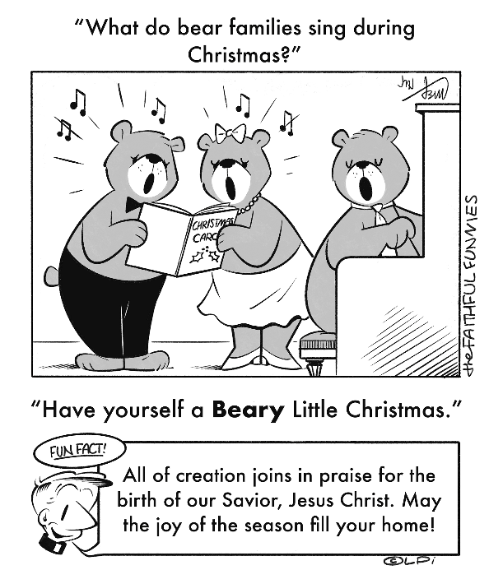
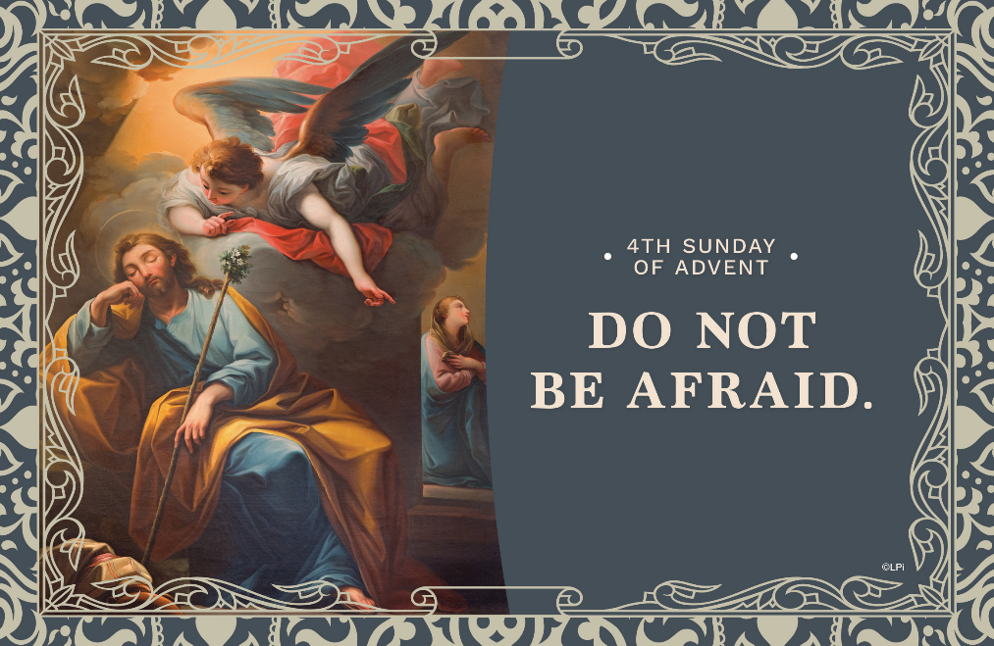
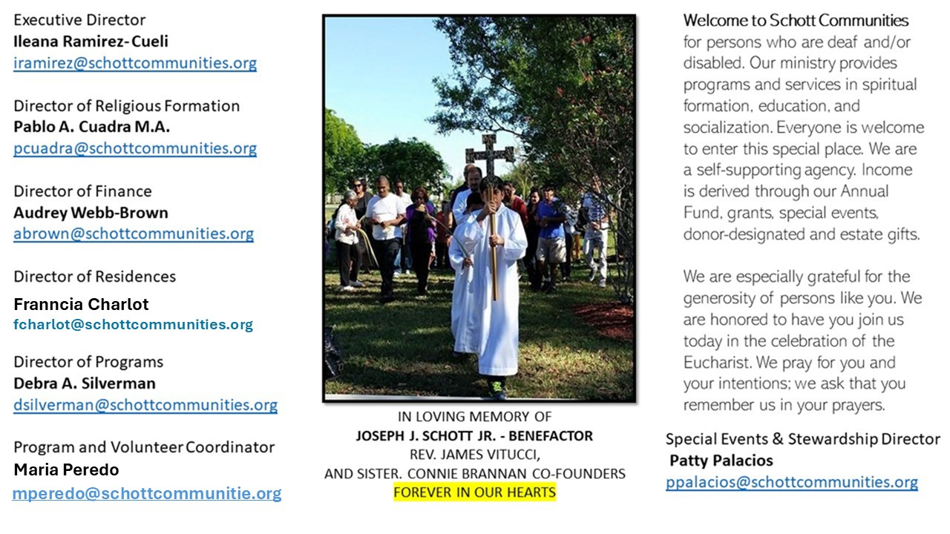

21 de diciembre de 2025
IV Domingo de Adviento
Mateo 1:18-24

En este último domingo de Adviento, Emmanuel, Dios con nosotros, está por nacer. Esta es la Buena Noticia que debe alegrarnos: comprender que el nacimiento de Jesús es la garantía de que Dios cumple su promesa con la llegada de su Hijo al mundo. El Evangelio nos da la oportunidad de contemplar el paso de la historia de la salvación en la humanidad. Dios se mezcla entre nosotros, se une a nuestros triunfos y fracasos. Ya no hay nada que temer: Jesús llega para iluminar nuestras tinieblas. “La virgen concebirá y dará a luz un hijo, y le pondrán por nombre Emmanuel, que significa: Dios con nosotros” (Mateo 1:23).

También la liturgia de hoy nos permite admirar a José, esposo de la Virgen, y tomar ejemplo de su valor, de su capacidad para guardar silencio y de su forma de actuar ante ella. José tomó la difícil decisión, en medio de la situación que vivía, de no difamar a María y repudiarla en secreto. Protegerla a ella y al niño fue su prioridad. “Tú eres el que pondrás el nombre al hijo que ella dará a luz. Y lo llamarás Jesús, porque él salvará a su pueblo de sus pecados” (Mateo 1:21). Gracias a esa prudencia y justo silencio de José, Jesús pudo nacer de María. ¿Cómo es mi prudencia ante los acontecimientos que atravieso en mi vida? ¿Sé guardar secretos para no destruir la vida de los demás? ¿He guardado espacios de silencio en este Adviento que me ayuden a mi crecimiento espiritual?

December 21, 2025
Fourth Sunday of Advent
Matthew 1:18-24

A priest friend recently told me a remarkable story. One of his cousins reported having a vivid dream in which an angel told him the family needed to exhume their grandmother’s body from a cemetery in New York and return it to her birthplace in Romania. She had been dead nearly 10 years. As you might expect, the family thought it was, well, crazy. But astonishingly they exhumed her body. It was incorrupt, showing no signs of decomposition. That experience sparked healing, faith, and reconciliation throughout the family.
In this Sunday’s Gospel, Joseph also receives a dream. He’s confused, afraid. But in the quiet of sleep, God speaks: “Do not be afraid to take Mary your wife into your home” (Matthew 1:20). When he wakes, Joseph acts. He doesn’t overanalyze or dismiss the message. He trusts, and acts.
God still speaks — not necessarily through literal dreams but through those deeper intuitions of the heart. St. Ignatius of Loyola taught that God’s voice draws us into peace, courage, and love. But we have to listen to it. Advent is a time for stillness. As we prepare for Christ’s coming, we’re invited to enter that quiet space where God’s voice can be heard.
When and how do you become most receptive to God? Is it in silence? In prayer? In nature? At Mass? This week, go there. Be still. Listen. And like Joseph, have the courage to act on what God shows you.

— Father John Muir

— Father John Muir

St. Jude Chapel, Sunday, December 21st, 2025
Monsignor Roberto Garza
Celebrant

Saint John of Kanty | December 23
Saint John, sometimes called John Cantius, was born in the Polish town of Kanty in 1390. Not much is recorded about his early life, however, he was a bright young man who did well in his studies at the university in Krakow. He earned his doctorate in philosophy and went on to be ordained and earn a doctorate in theology as well. Saint John of Kanty died on December 24, 1473. He was canonized in 1767.


Christian Giving
December 14th, 2025
$TBA

We sincerely thank you and bless you for your generosity.
A bequest is a powerful tool to help the Deaf or Disabled.

Mass Intentions
“For the repose of the Souls in Purgatory
Requested by Schott Communities


Follow us on Facebook
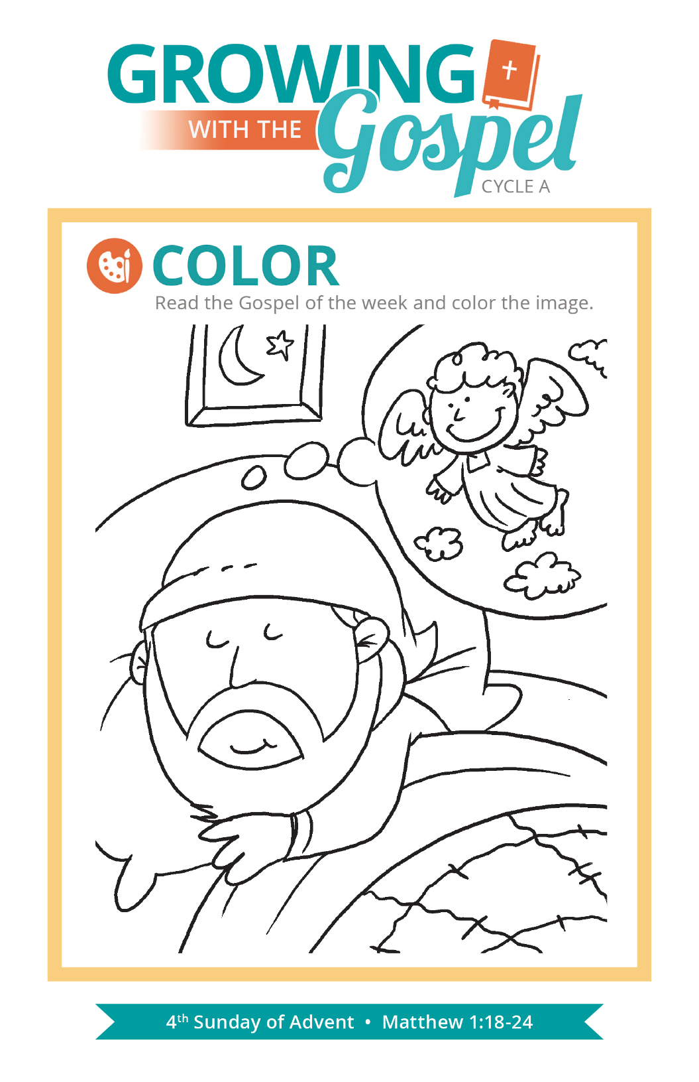
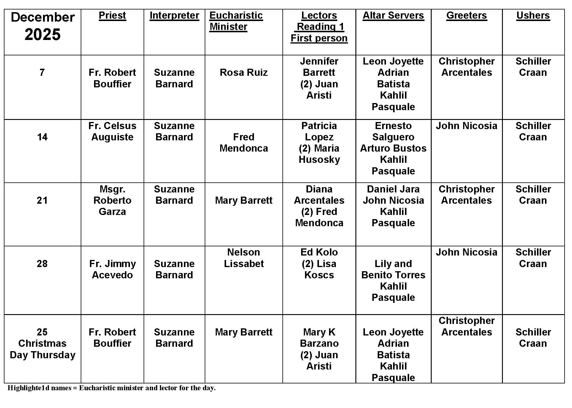
Tithing vs. Stewardship

Question:
What is the difference between tithing and stewardship?

Answer:
Both tithing and stewardship are part of a spiritual way of life that calls us to use all of our resources for the service of the Gospel. Everything we are and everything we have comes from God. Offering back to God what He has given us is part of how we worship and give thanks to God.

Tithing is the practice of giving back 10 percent of what we earn. It comes from the Old English word for “ten.” The first Scriptural example of tithing came from Abraham who gave a tenth of his possessions to the priest Melchizedek. He did so as an act of thanksgiving to God.

Stewardship as a way of life calls us to use well all that we have and all that we are, placing all things in service of others and God. Stewardship helps us see the good we can accomplish by making God and our spiritual life the most important values in our life. Whatever we accumulate in this life stays here. We can’t take it with us! Both tithing and stewardship help us remember that nothing is mine or even ours … all belongs to God.

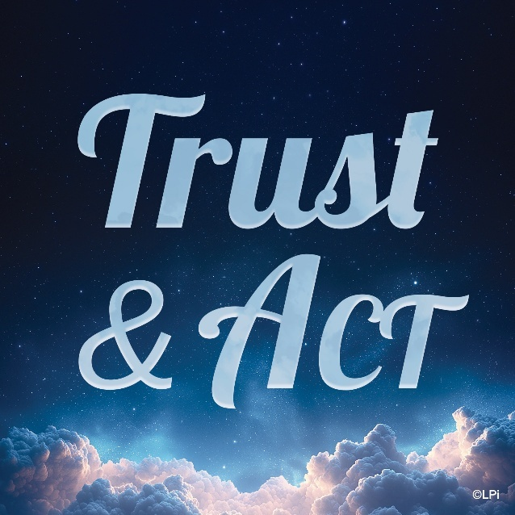
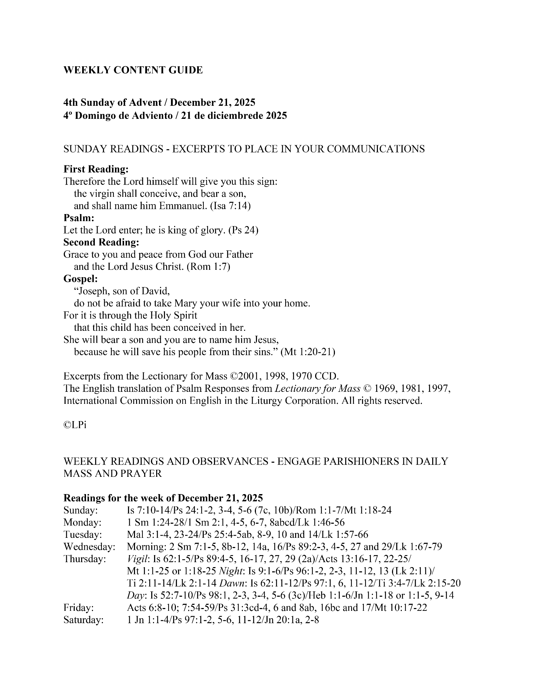
Are you in need of prayer? Do you have a prayer request? You can send your prayer requests to pcuadra@schottcommunities.org or call 954-434-3306 ext. 108

A copy of our prayer list can be found in the lobby of our chapel. To request a copy of our prayer list please email us at pcuadra@schottcommunities.org
To request a Mass please contact Pablo A. Cuadra at 954-434-3306 or e-mail at pcuadra@schottcommunities.org
Update: Celebrating a wedding anniversary soon? Let us know a week in advance and we can assist you with the renewal of your wedding vows.

Prayer to St. Michael the Archangel:
"St. Michael the Archangel, defend us in battle. Be our defense against the wickedness and snares of the Devil. May God rebuke him, we humbly pray, and do thou, O Prince of the heavenly hosts, by the power of God, thrust into hell Satan, and all the evil spirits, who prowl about the world seeking the ruin of souls. Amen"

