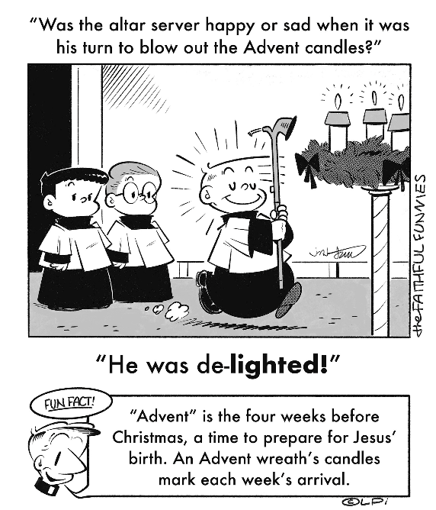
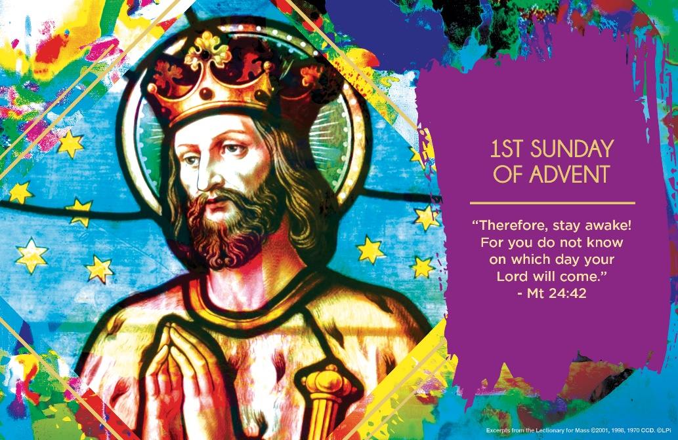
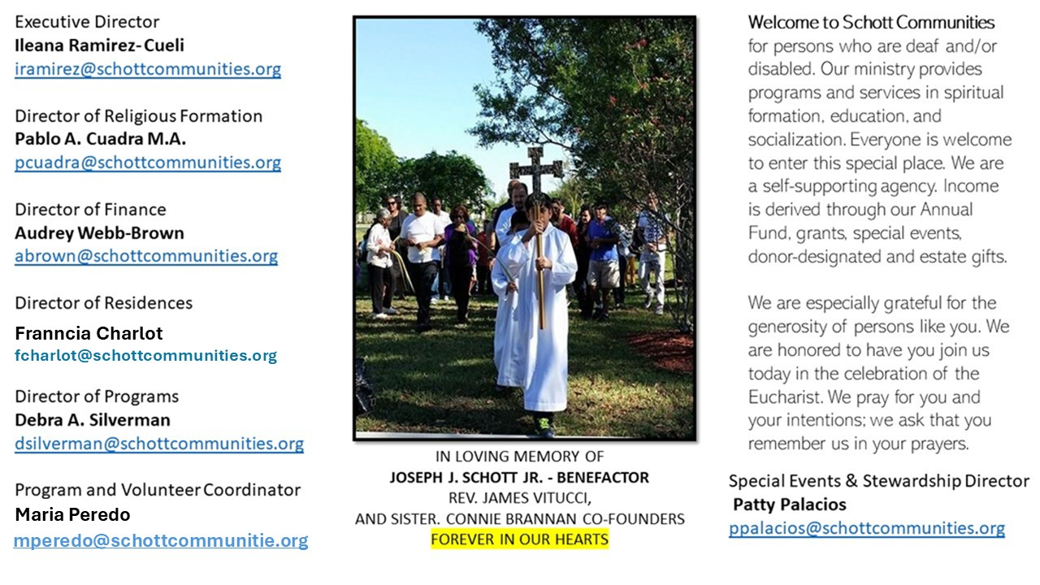

30 de noviembre de 2025
I Domingo de Adviento
Mateo 24:37-44

El Adviento es un tiempo litúrgico de mucha esperanza. Hoy damos comienzo al ciclo A, y será el Evangelio de Mateo el que nos ayude a caminar durante este tiempo de gracia. Mateo, llamado también Leví, fue uno de los que Jesús quiso tener entre sus doce apóstoles. Él nos ayudará a ver que la esperanza está más cerca que nunca; que el anuncio de paz consiste en: Estén alerta, no se duerman, vigilen hasta entrada la noche. “Por eso estén despiertos, porque no saben en qué día vendrá el Señor” (Mateo 24:42). Un año más ha llegado, y se nos invita no a tener miedo, sino más bien a tener la intención de despertar, prestar atención y velar, para descubrir y seguir cómo será el paso de Dios en mi vida en este Adviento.

Esperanza y vigilia es lo que la Iglesia nos propone en este jubileo, y el Adviento es el momento de estar despiertos, como los pastores que supieron escuchar la noticia de que, en la ciudad de David, había nacido un Salvador. ¿De qué formas estaré despierto o despierta en este Adviento?
Puede ser que reciba a Cristo de una forma diferente a otros años, con un espíritu de vigilancia y compromiso hacia mi familia y mi comunidad. Jesús, ayúdame a girar mi corazón hacia ti, para que al hacerlo pueda ver con una mirada nueva la búsqueda de la verdad y la justicia que tanto necesitamos en la familia y en la sociedad. ¡Ven, Señor!

November 30, 2025
First Sunday of Advent
Matthew 24:37-44

A few years ago, my house was broken into on Super Bowl Sunday. Turns out, it’s a great day for burglars. If the TV isn’t on, people are probably watching the game somewhere else, so … easy pickins’. I’ll never forget walking into my bedroom and realizing someone had been there. My stuff was thrown all over the floor. The closet was torn apart. It was disorienting and disturbing — someone had invaded the space I thought was secure. After that, I bought an alarm system. And every Super Bowl Sunday since, I’m extra careful to lock the doors and keep the lights on. That experience made me more alert. Not scared. Just attentive.That’s much like the spiritual place Jesus wants us to be on this first Sunday of Advent. He doesn’t start the season with soft candlelight and cozy manger scenes. He starts with two brutal images: a flood and a thief. In other words, chaos and violation.
Why? Because life will flood us. Chaos will come. And in the midst of it, Christ will come like a thief — not to steal from us, but to steal us back. He is the intruder we should want. The one who breaks in, not to ransack, but to rescue.
Christ presents himself as the thief but also the new Noah. He builds the ark of the Church to carry us through the flood. And he invites us to join him. How? By participating fully in our parishes. By making our homes places of prayer. By guarding our hearts with truth. By refusing to let spiritual complacency leave us exposed. By repentance.
This Advent, don’t just stay vaguely “awake.” Prepare. Build. Watch. The flood will come. But so will he.

— Father John Muir

St. Jude Chapel, Sunday, November 30th, 2025
Father Jimmy Acevedo
Celebrant

St. Nicholas | Feast Day December 6
St. Nicholas of Bari (March 15, 270 – December 6, 343), the bishop of Myra in the fourth century, is the saint that Santa Claus is modeled after. Known for his kindness and generosity to the poor, the story has it that St. Nicholas once tossed bags of gold through the open window of a poor man’s house to help his daughters avoid a life of prostitution.
According to legend, the gold landed in stockings dangling on the corners of the beds, which is why many of us celebrate St. Nicholas Day by hanging stockings and filling them with candy, fruit, and small toys. Amen.


Christian Giving
November 23rd, 2025
$

We sincerely thank you and bless you for your generosity.
A bequest is a powerful tool to help the Deaf or Disabled.

Mass Intentions
“For the repose of the Souls in Purgatory
Requested by Schott Communities


Follow us on Facebook
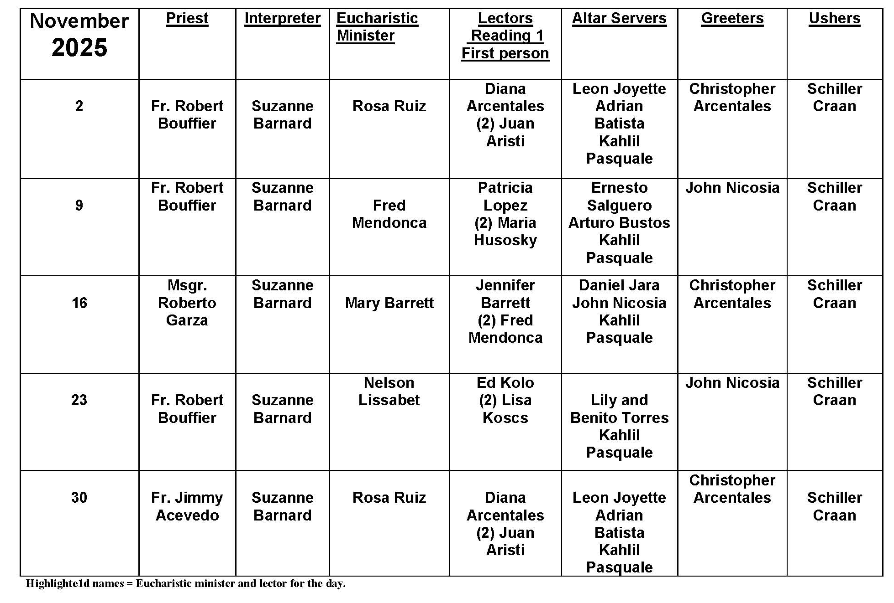
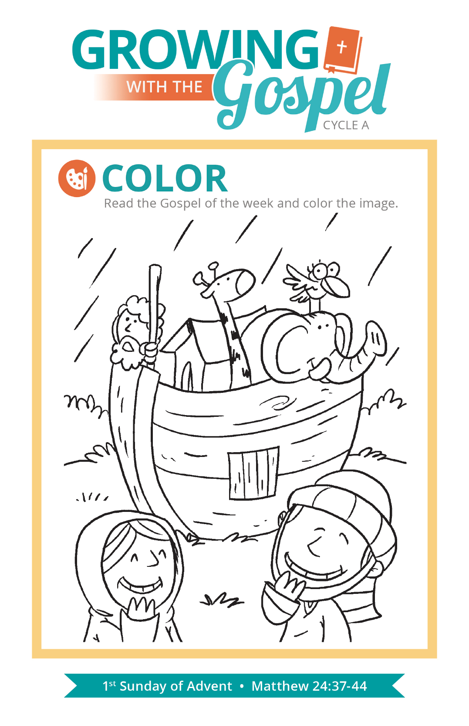
Strike our Chest: Penitential Act

Question: When we say the Penitential Act at Mass, why do we strike our chest three times?
Answer:
Our rituals and liturgical celebrations are filled with a variety of symbols, some of which also relate to our gestures and physical postures (e.g. kneeling, sitting, processing, making the Sign of the Cross). The custom of striking our breast three times during the “I Confess” of the Penitential Act of the Mass is one of those gestures that is loaded with symbolism.
The tradition of Christian’s striking the breast (above the heart) is rooted in the image of Sacred Scripture, especially texts like Psalm 51 which speak of a “humbled contrite heart” or how God heals broken hearts, binding up our wounds (see Psalm 147:3). Early Christian writers like Saint Augustine of Hippo and Saint Jerome also refer to this custom in their writings.
Ultimately, this practice is an expression of our sorrow for those times when we have been guilty of faults and a sign that we are willing to take responsibility for our sins and failings. That we all perform this gesture together is also an act of solidarity, recognizing that none of us, regardless of where we are on our journey of faith, is without fault and the need for grace and forgiveness.

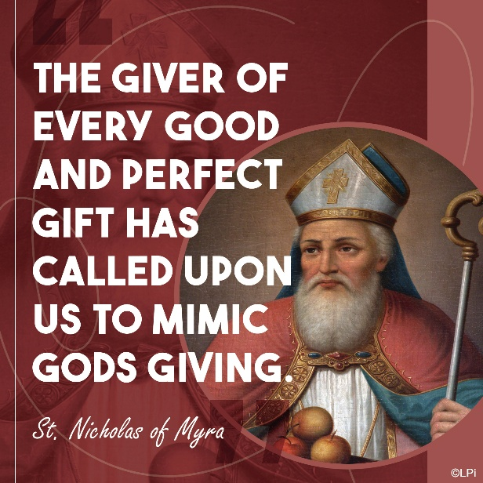
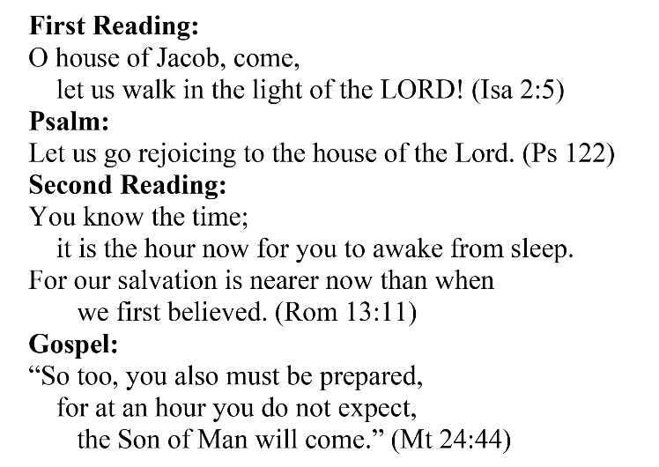
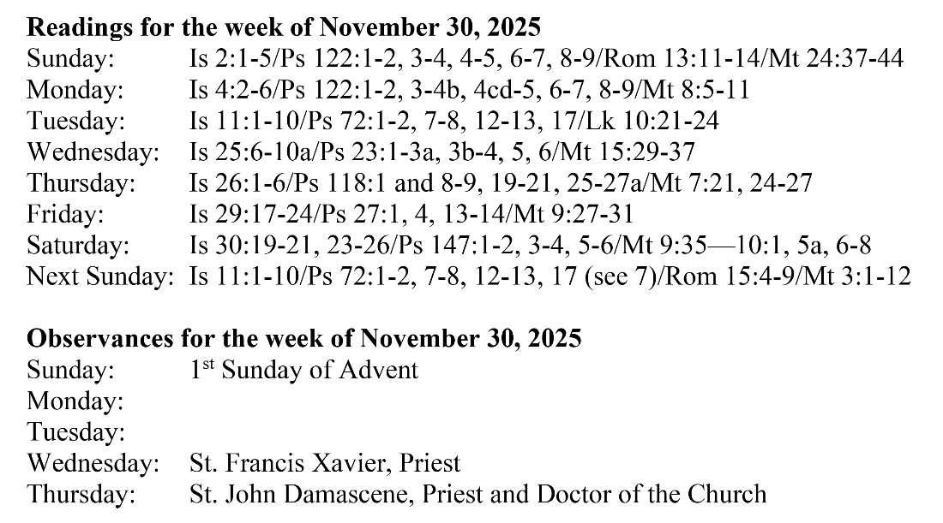
Are you in need of prayer? Do you have a prayer request? You can send your prayer requests to pcuadra@schottcommunities.org or call 954-434-3306 ext. 108

A copy of our prayer list can be found in the lobby of our chapel. To request a copy of our prayer list please email us at pcuadra@schottcommunities.org
To request a Mass please contact Pablo A. Cuadra at 954-434-3306 or e-mail at pcuadra@schottcommunities.org
Update: Celebrating a wedding anniversary soon? Let us know a week in advance and we can assist you with the renewal of your wedding vows.

Prayer to St. Michael the Archangel:
"St. Michael the Archangel, defend us in battle. Be our defense against the wickedness and snares of the Devil. May God rebuke him, we humbly pray, and do thou, O Prince of the heavenly hosts, by the power of God, thrust into hell Satan, and all the evil spirits, who prowl about the world seeking the ruin of souls. Amen"

