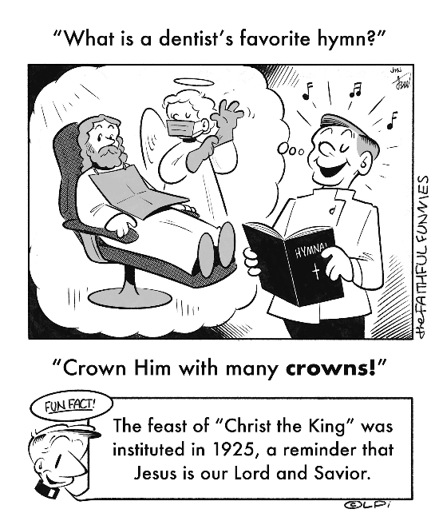
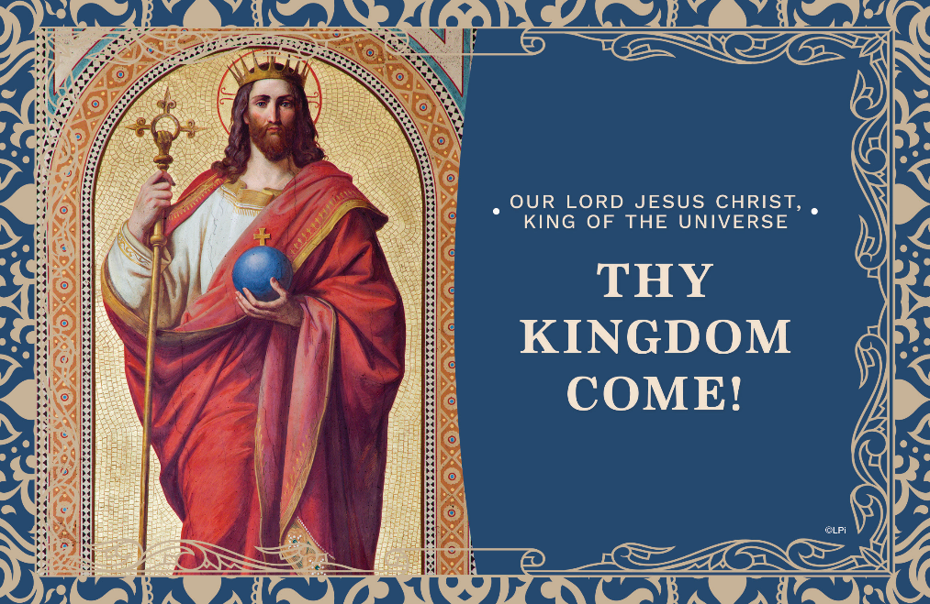
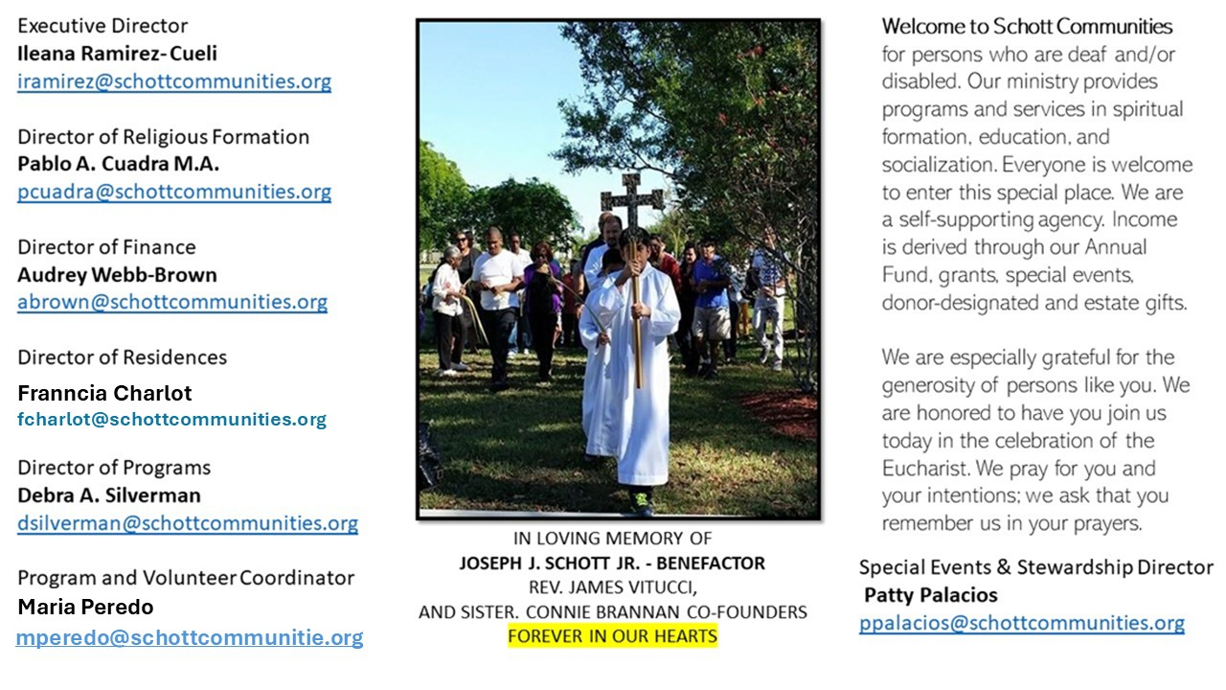

23 de noviembre de 2025
Nuestro Señor Jesucristo Rey del Universo
Lucas 23:35-43

Con la Solemnidad de Nuestro Señor Jesucristo, Rey del Universo, termina el año litúrgico.
La próxima semana daremos comienzo al Adviento, para luego celebrar con alegría la Navidad.
Con esta solemnidad, la Iglesia recuerda la soberanía de Jesucristo, Rey del Universo: "La entrada de Jesús en Jerusalén manifiesta la venida del Reino que el Rey-Mesías, recibido en su ciudad por los niños y por los humildes de corazón, va a llevar a cabo por la Pascua de su Muerte y de su Resurrección" (Catecismo de la Iglesia Católica, n. 570). Jesús, Tú eres nuestro Rey, desde la cruz donde cruelmente moriste por nosotros para salvarnos. ¡Bendito y adorado seas para siempre!

"Cuando nuestro Salvador estaba colgado en la gloriosa cruz, estaban con Él dos ladrones. ¿Qué se puede deducir de esto? Sin lugar a dudas, se trataba de una burla, de acuerdo con el plan tomado por los judíos, pero también era un cumplimiento de la profecía: ‘Le daré su parte entre los grandes y con los poderosos repartirá despojos, pues se entregó indefenso a la muerte y fue tenido por un malhechor’ (Isaías 53:12) ... Él pagó las deudas por nosotros, cargó con nuestros pecados y fue azotado por nosotros, según está escrito: ‘Por sus sufrimientos fuimos curados, pues Él cargó con nuestros pecados’ (Isaías 53:5). Y nos libró de las enfermedades del alma" (San Cirilo de Alejandría [375–444], Comentario al Evangelio de Lucas). ¡Que viva Cristo Rey!

November 23, 2025
Our Lord Jesus Christ, King of the Universe
Luke 23:35-43

Not long ago, I was called to a hospital to anoint a woman in her early 80s. She was dying, and visibly in pain. But what struck me most wasn’t her suffering — it was the atmosphere in the room. She had eight children and 30 foster kids, and many of them were gathered around her. You’d expect sorrow, fear, maybe even despair. But the room was filled with something else entirely — a quiet strength, a kind of sweetness. It was as if she was suffering not just with them, but for them. And they, in love, were suffering for her. The pain was real. But so was the peace. I didn’t want to run. I felt as if I was in a little paradise, beeping machines and all.
I think of that moment when I hear today’s Gospel. Jesus, hanging on the cross, doesn’t look like a king. But one of the crucified, dying men beside him sees through the suffering and says, “Jesus, remember me when you come into your kingdom” (Luke 23:42). That word — remember — literally means to make someone a member again. He’s asking to be joined to Christ, to become part of his Body. And Jesus says, “Today you will be with me in paradise.”
He doesn’t say, “I’ll take your suffering away.” He says, “You will be with me.”
That’s the strange power of Christ the King. He doesn’t rule by avoiding suffering. He reigns by entering into it, and transforming it with love.
What are you suffering right now in your life? Likely you want it to stop. But if we are willing to suffer with him — paradise begins even today.

— Father John Muir

St. Jude Chapel, Sunday, November 23rd, 2025
Father Robert Bouffier
Celebrant

Jesus is King
Dear Jesus,
I see the kingdom you love, the one full of the broken and forgotten.
I see the crown you wear — thorns out of love for me.
I pick you as my King.
Mold my heart to be a worthy member of your kingdom.
Amen.


Christian Giving
November 16th, 2025
$

We sincerely thank you and bless you for your generosity.
A bequest is a powerful tool to help the Deaf or Disabled.

Mass Intentions
“For the repose of the Souls in Purgatory
Requested by Schott Communities


Follow us on Facebook
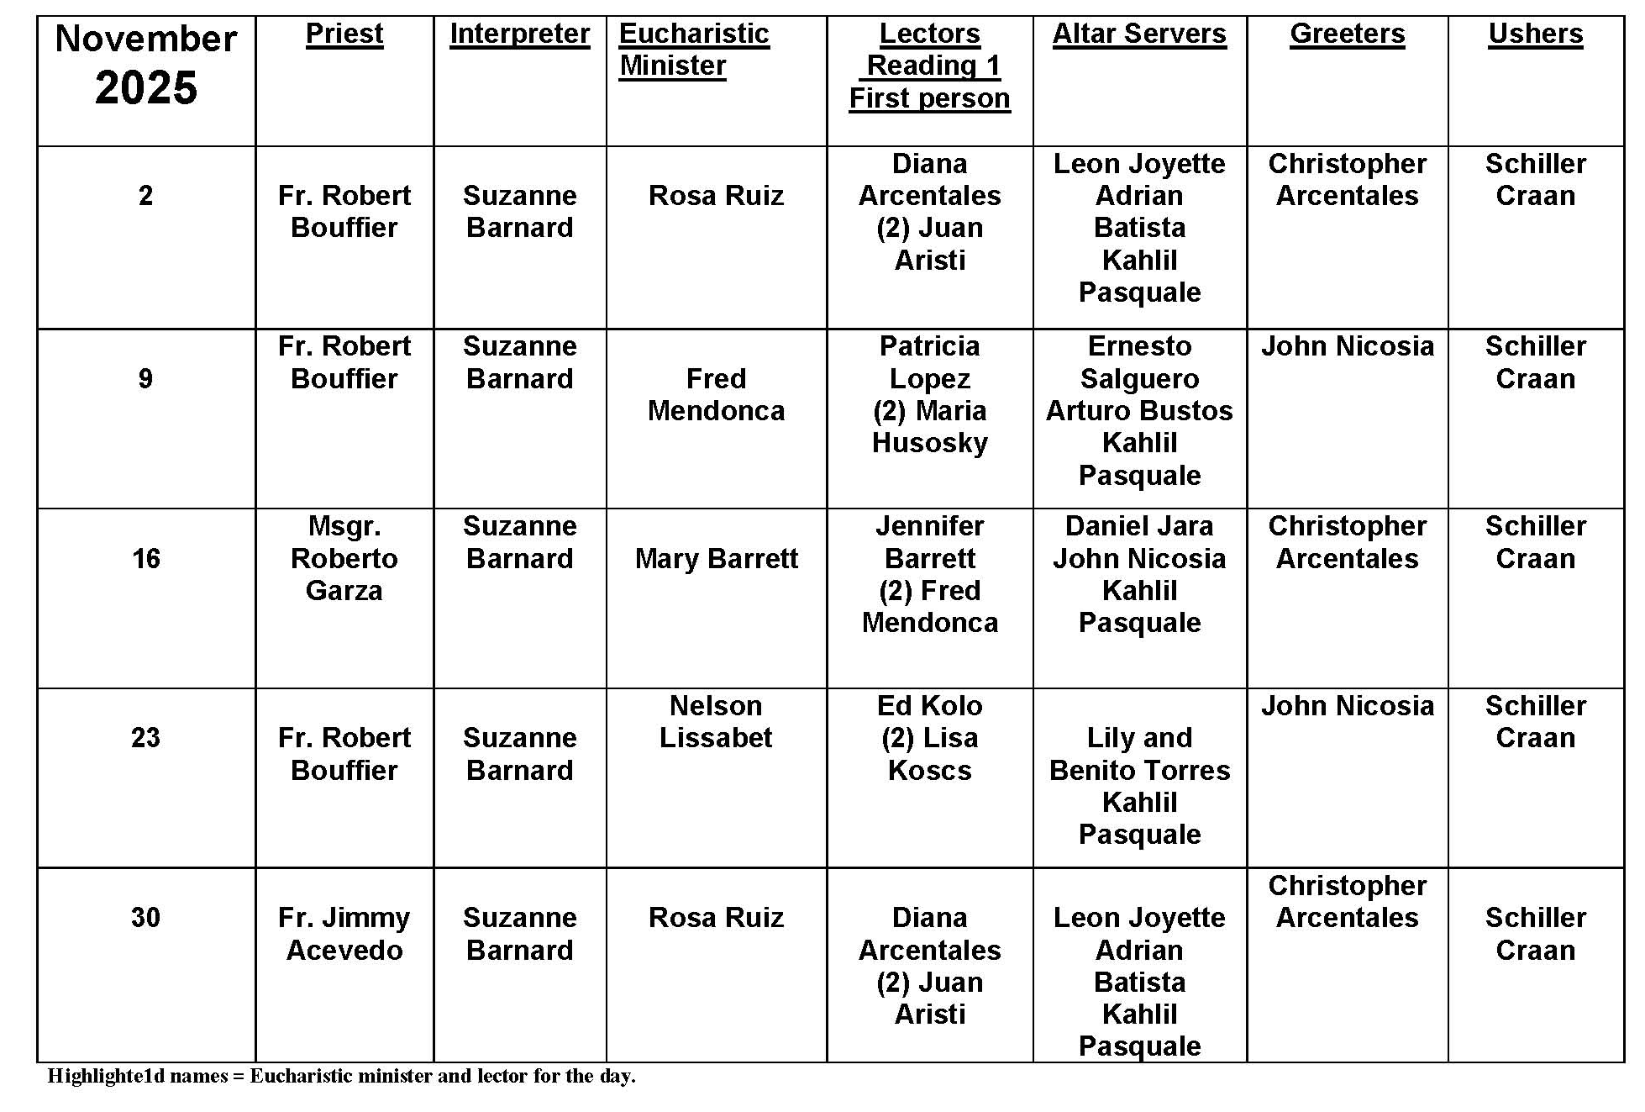
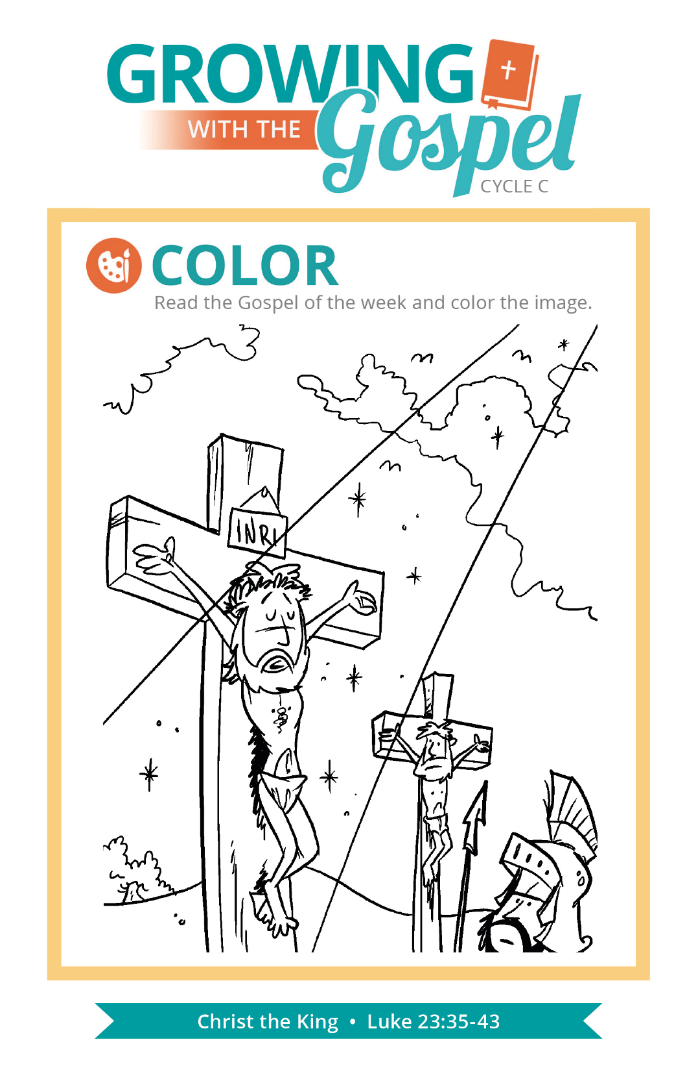
What is Eucharistic Adoration?

Question: What is Eucharistic Adoration?
Answer:
The practice of Eucharistic Adoration is a centuries old ritual and falls within a broader category of devotions and rituals that are associated with the Sacrament of the Eucharist. In a particular way, Eucharistic Adoration is an extension of the worship and adoration of the Blessed Sacrament that occurs in every Mass.
In a long-standing practice, a period of Eucharistic Adoration often ends with “benediction,” the blessing of the faith with the Blessed Sacrament.
Several parishes throughout the United States have introduced the practice of perpetual Eucharistic Adoration, while other communities have the custom of shorter periods of Eucharistic Adoration. Care should always be taken that these periods of adoration respect the instructions outlined in Holy Communion and Worship of the Eucharist Outside of Mass, the liturgical book that gives the instructions for the proper celebration of Eucharistic Adoration.
Although adoration of the Blessed Sacrament can never take the place of Eucharistic Communion, many Catholics find great comfort and consolation in their prayers before the Eucharist enshrined in the tabernacle or when it is exposed in the monstrance (both are equally valid, as the Christ is not more present in one than in the other). But when we consider our eucharistic devotions, it is always important to remember the fundamental connection these acts of devotion have the celebration of the Eucharist in the Mass and reception of Christ in Communion

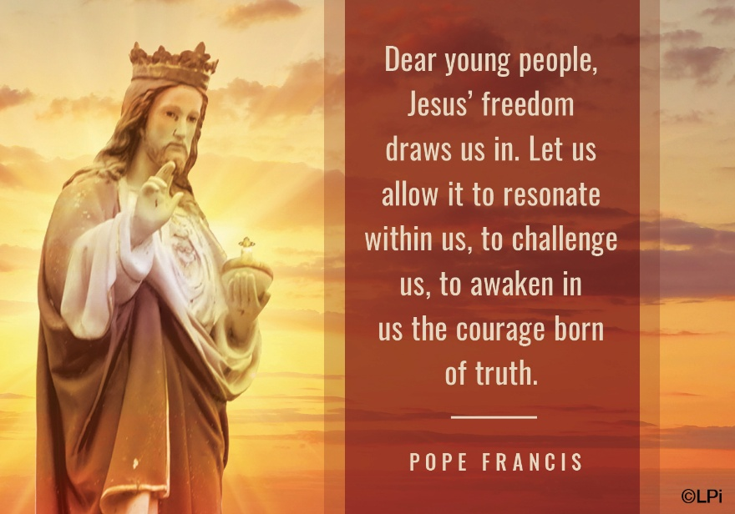
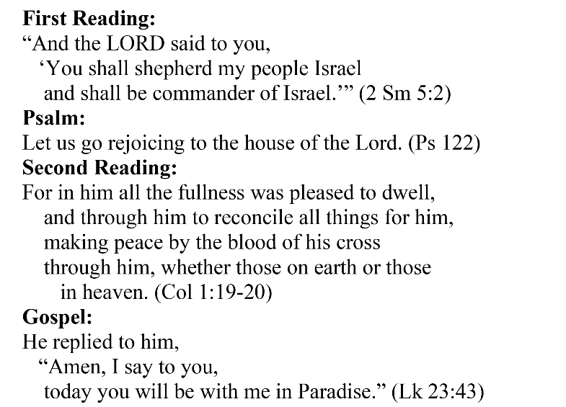
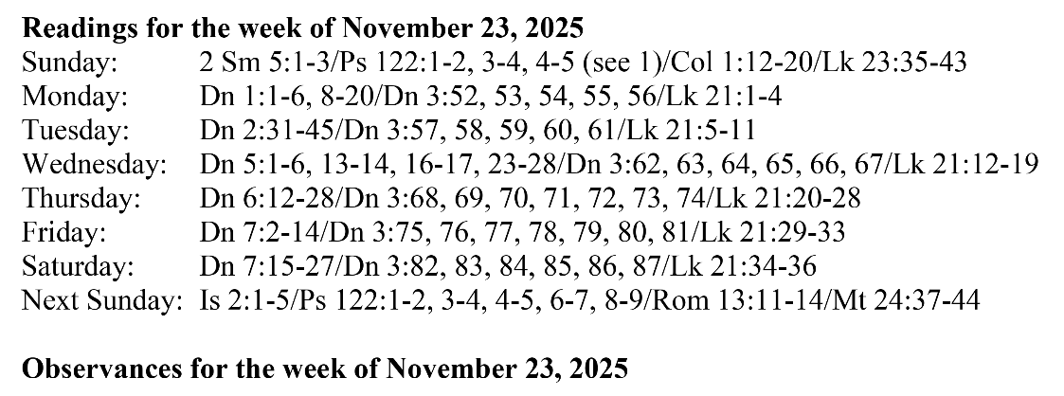
Are you in need of prayer? Do you have a prayer request? You can send your prayer requests to pcuadra@schottcommunities.org or call 954-434-3306 ext. 108

A copy of our prayer list can be found in the lobby of our chapel. To request a copy of our prayer list please email us at pcuadra@schottcommunities.org
To request a Mass please contact Pablo A. Cuadra at 954-434-3306 or e-mail at pcuadra@schottcommunities.org
Update: Celebrating a wedding anniversary soon? Let us know a week in advance and we can assist you with the renewal of your wedding vows.

Prayer to St. Michael the Archangel:
"St. Michael the Archangel, defend us in battle. Be our defense against the wickedness and snares of the Devil. May God rebuke him, we humbly pray, and do thou, O Prince of the heavenly hosts, by the power of God, thrust into hell Satan, and all the evil spirits, who prowl about the world seeking the ruin of souls. Amen"

