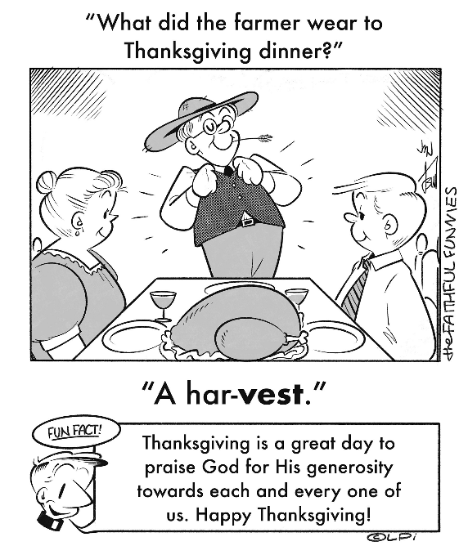
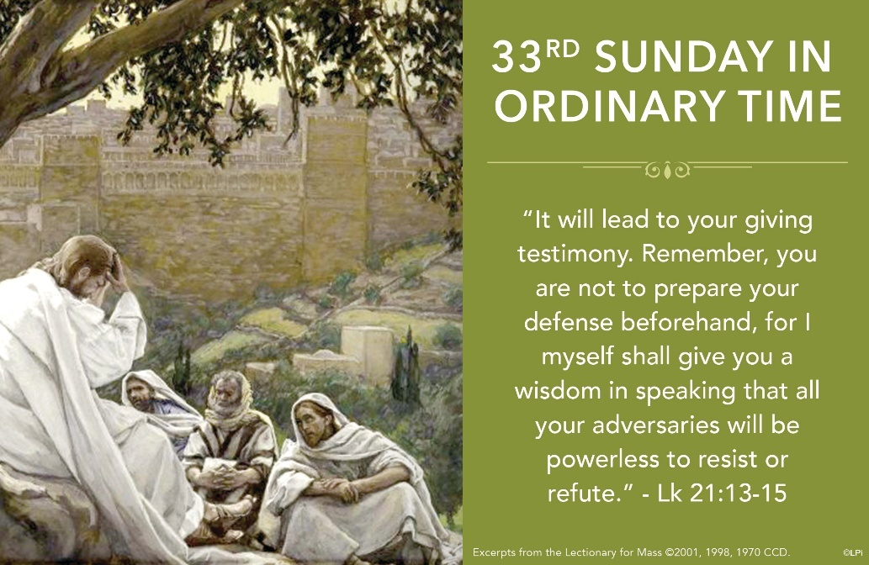
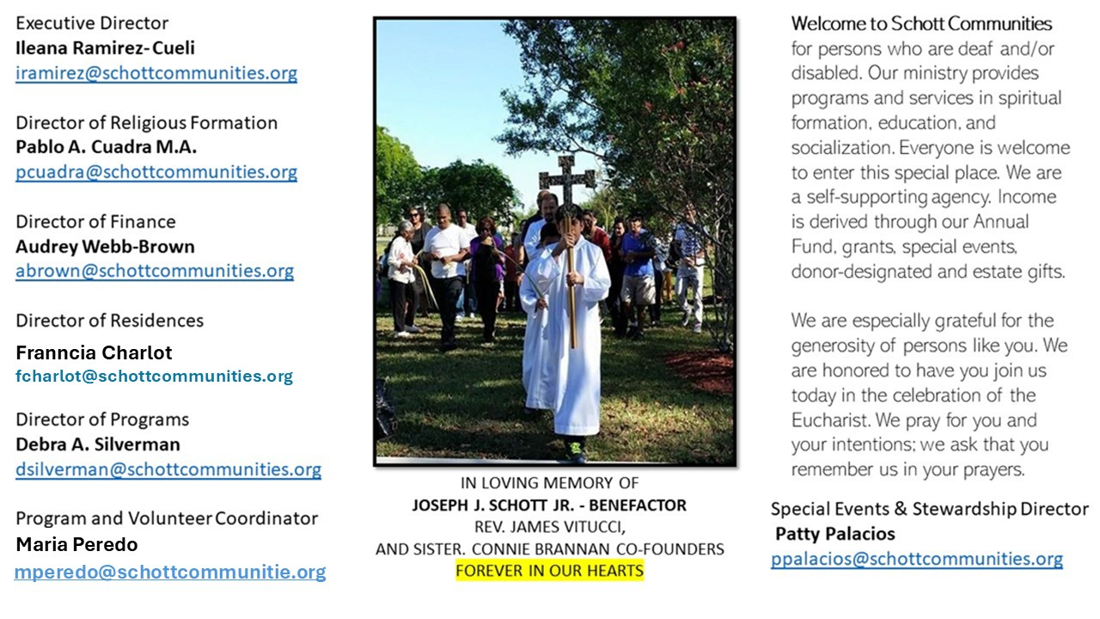

16 de noviembre de 2025
XXXIII Domingo del Tiempo Ordinario
Lucas 21:5-19
La perseverancia, ¿qué significa esta palabra tan importante? Es mantenernos firmes en nuestros planes y buenos propósitos. Perseverar en los estudios, en el trabajo y en las relaciones familiares requiere entusiasmo y energía cada día. Nada es fácil, y hoy Jesús nos invita a no tener miedo ante las adversidades y catástrofes que vemos actualmente, sino a superar las pruebas con fe y confianza en un Dios que no defrauda: "Con todo, ni un cabello de su cabeza se perderá". Y agrega otra frase que nos invita a despertar del letargo espiritual: "Manténganse firmes y se salvarán" (Lucas 21:18-19).
La liturgia de hoy nos ayuda a reflexionar sobre las muchas traiciones, hambres y guerras que azotan a nuestros hermanos y hermanas en el mundo. Sin embargo, a pesar de todo eso, caminamos con esperanza. Nada ni nadie puede arrebatarnos la seguridad de que Dios está caminando a nuestro lado. Pero no debemos dejarnos engañar dejando pasar el tiempo sin hacer nada por nuestro bien y el de los demás. "El engaño es creernos dueños del tiempo. El tiempo no es nuestro. Del tiempo existe solo un soberano: Jesucristo. No os dejéis engañar en la confusión. El cristiano se mueve por este camino del momento, con la oración y el discernimiento. Pero deja el tiempo a la esperanza. El cristiano sabe esperar al Señor en cada momento; pero espera en el Señor al final de los tiempos" (Papa Francisco).

November 16, 2025
Thirty-Third Sunday in Ordinary Time
Luke 21:5-19

When I was a kid growing up in New England, I’d occasionally go on a whale watch. Once we went out with calm waters and clear skies. But on the way back in, the sea got rough. I was just a kid, and I remember thinking we should turn left or right toward the shoreline I could see. But the pilot of the boat kept going straight — right into the waves — focused on a small, discouragingly distant lighthouse. Even when it flickered in and out of sight, he stayed the course. He knew where he was going.
That image comes to mind when I hear Jesus’ words in today’s Gospel regarding false messiahs: “Do not follow them” (Luke 21:8). In times of chaos or uncertainty, there are always voices offering easier routes, promising false safety, claiming to speak for God. But Jesus isn’t found in the loudest voice or the nearest shoreline. He is steady, like a lighthouse in the storm.
The tribulation of which Jesus speaks — it’s real. It happened to the Temple, it happened to him, it happens in the Church, and it will come to each of us. But the command is not to panic. It’s to endure. To keep steering toward him. Faith isn’t about having all the answers or dodging every wave. It’s about knowing where the lighthouse is — and trusting it enough to keep going, especially when false safety beckons us to stop.

— Father John Muir

St. Jude Chapel, Sunday, November 16th, 2025
Monsignor Roberto Garza
Celebrant

St. Rose-Philippine Duchesne

Saint Rose-Philippine Duchesne was a French Roman Catholic religious sister and missionary who served France during the French Revolution before immigrating to the USA. She established the First Sacred Heart convent in North America and dedicated her life in service to the poor.


Christian Giving
November 9th, 2025
$

We sincerely thank you and bless you for your generosity.
A bequest is a powerful tool to help the Deaf or Disabled.

Mass Intentions
“For the repose of the Souls in Purgatory
Requested by Schott Communities


Follow us on Facebook
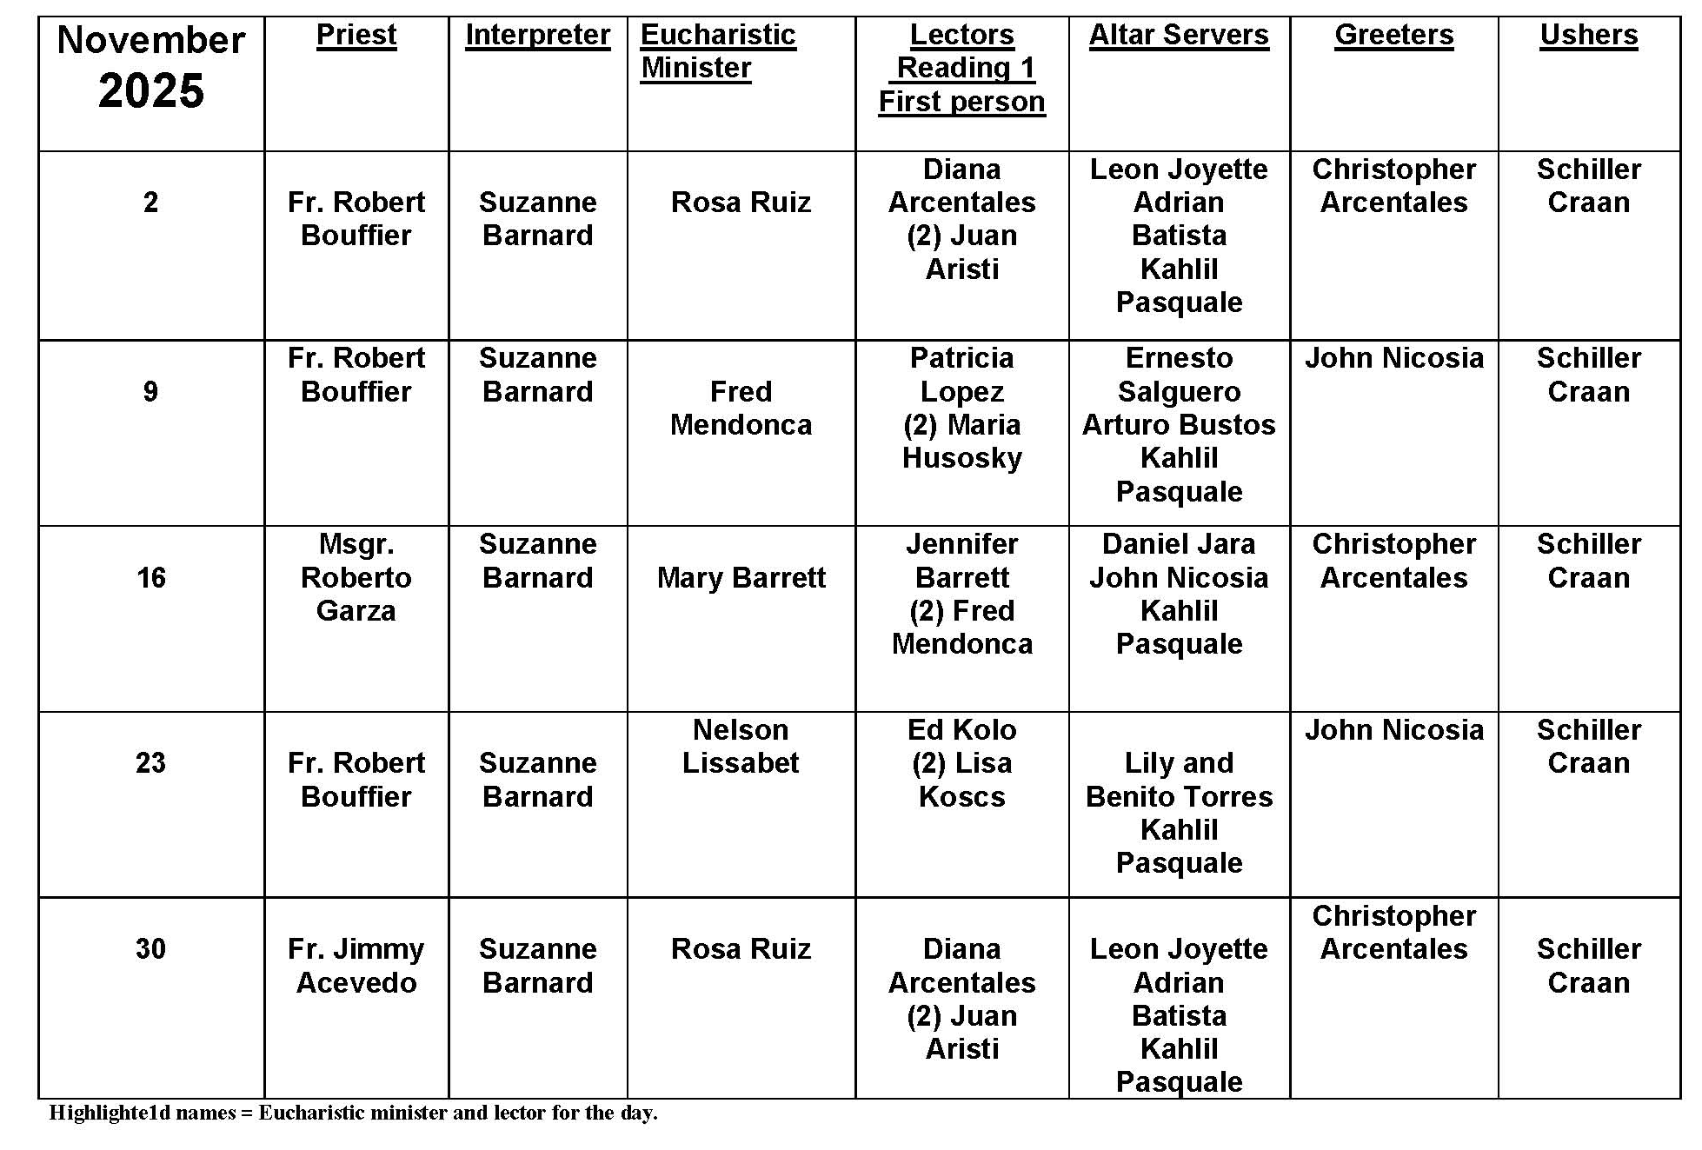
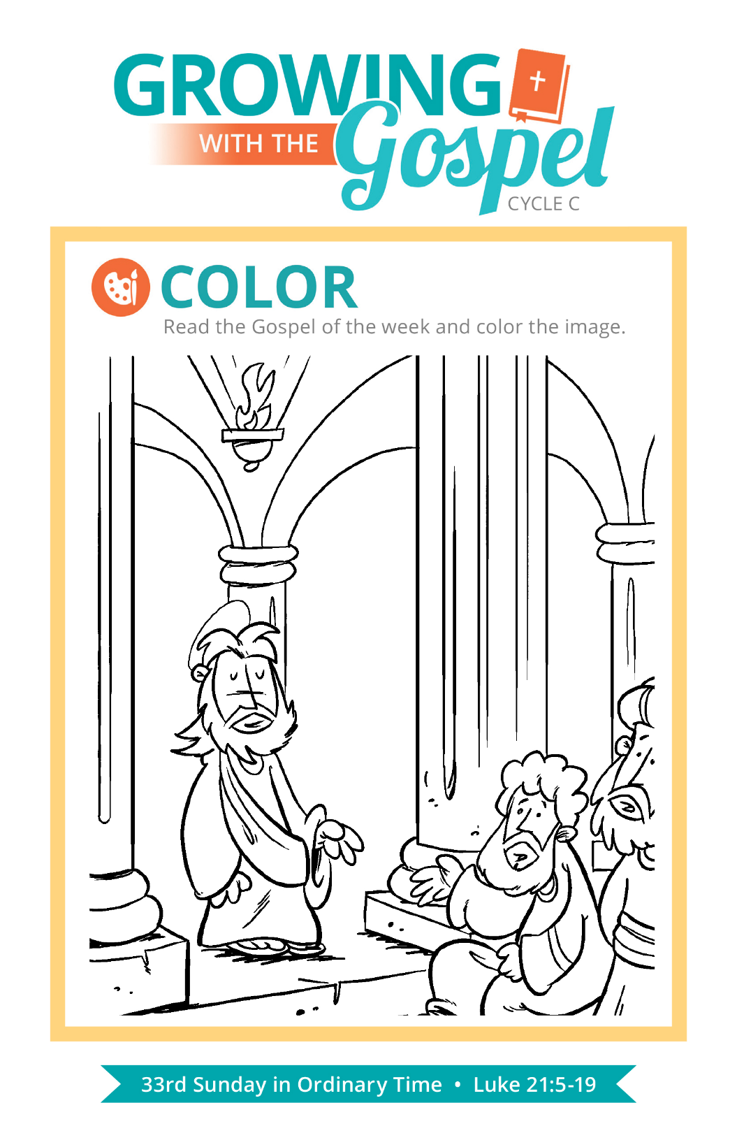
Calling Priests Father
Question:
Why do Catholics call priests Father?

Answer:
One of the common objections evangelical Christians have to Catholics is our practice of calling priests by the title Father. They will often cite a passage in Matthew’s Gospel in which Jesus tells his followers: “Call no one on earth your father; you have but one Father in heaven” (23:19). It seems pretty straightforward, but when we put this verse in context, we see that Jesus is speaking out against religious leaders who had forgotten what their proper role was and who were bad examples through their own hypocrisy and elitist attitudes.

In other Gospels, we find Jesus himself using the title father for different characters, such as in the Parable of Lazarus and the Rich Man (Luke 16:19-31]) and the Parable of the Prodigal Son (Luke 15:11-32). If we put the verse from Matthew into the full scope of Jesus’ teachings, he isn’t saying that we can’t use words like “father,” “rabbi,” or “master.” Rather, he is telling us that we should be mindful of the full meaning of those titles and not to misuse them.

To call a priest “Father” is more than a sign of respect for the office of the priesthood. It goes all the way back to the way St. Paul understood his own work as a missionary and evangelizer. Paul wrote, “I am writing you in this way not to shame you but to admonish you as my beloved children … It was I who begot you in Christ Jesus through my preaching of the Gospel. I beg you, then, be imitators of me. This is why I have sent you Timothy, my beloved and faithful son in the Lord” (1 Corinthians 4:14-17).

Yes, we have God alone as our heavenly Father, but there are also those here with us who nurture and nourish our faith through their teaching and care. This is why the title of Father has been applied to the church’s pastors in different ways since the earliest days of the Church, including monks and nuns using the title “abbot” and “abbess” (from abba) for their spiritual leaders and Christians around the world recognizing the “Holy Father” or “pope” (from papa) as the head of the family that is the Church. The title Father is a reminder that priests have a special responsibility to care for, protect, feed, listen to, and nourish those who have been entrusted to them, all after the example of our Father in heaven who never ceases to give us what we truly need.

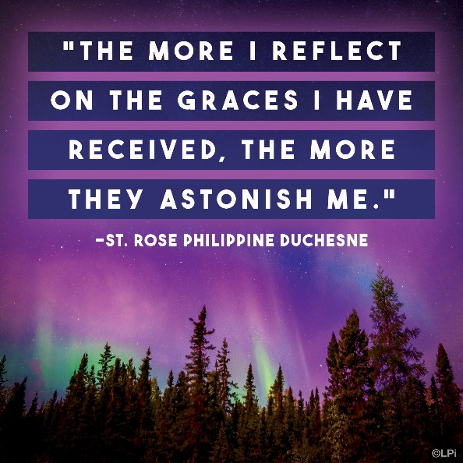
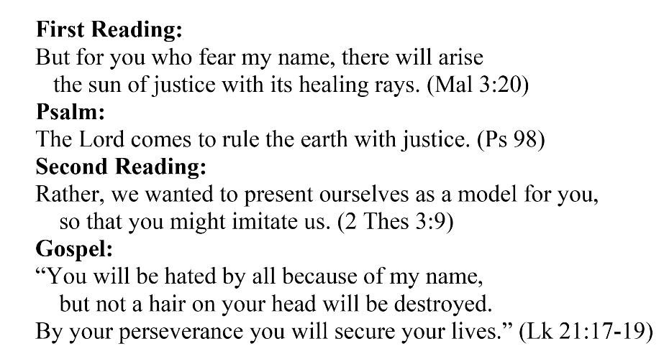
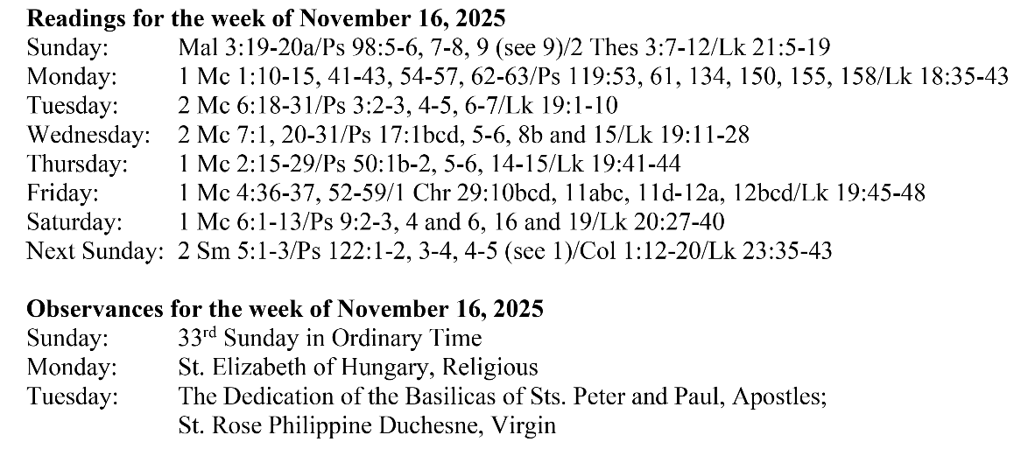
Are you in need of prayer? Do you have a prayer request? You can send your prayer requests to pcuadra@schottcommunities.org or call 954-434-3306 ext. 108

A copy of our prayer list can be found in the lobby of our chapel. To request a copy of our prayer list please email us at pcuadra@schottcommunities.org
To request a Mass please contact Pablo A. Cuadra at 954-434-3306 or e-mail at pcuadra@schottcommunities.org
Update: Celebrating a wedding anniversary soon? Let us know a week in advance and we can assist you with the renewal of your wedding vows.

Prayer to St. Michael the Archangel:
"St. Michael the Archangel, defend us in battle. Be our defense against the wickedness and snares of the Devil. May God rebuke him, we humbly pray, and do thou, O Prince of the heavenly hosts, by the power of God, thrust into hell Satan, and all the evil spirits, who prowl about the world seeking the ruin of souls. Amen"

