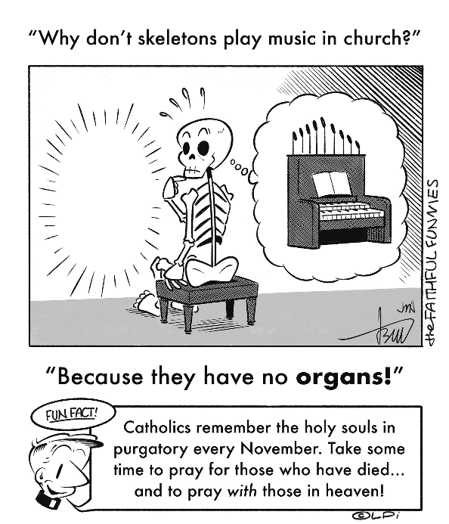
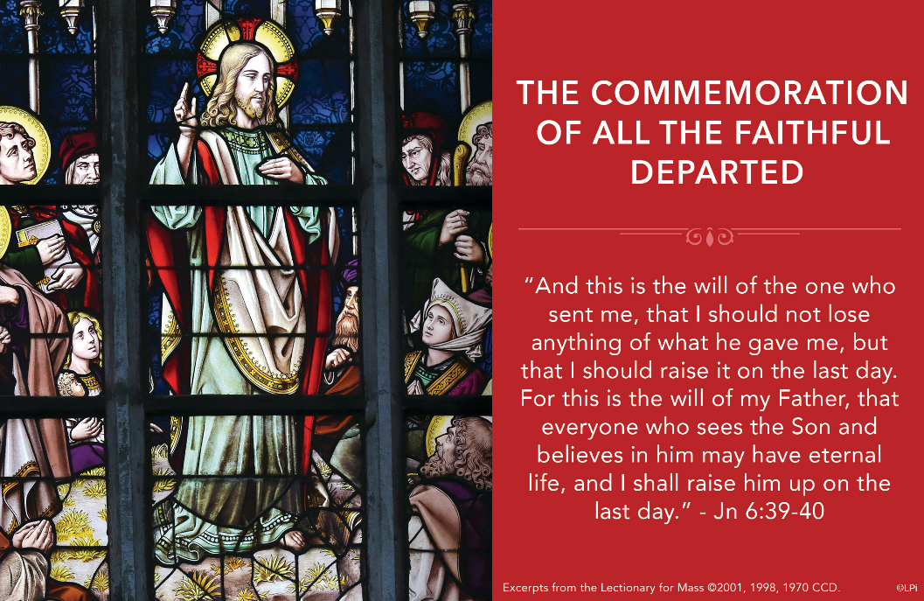
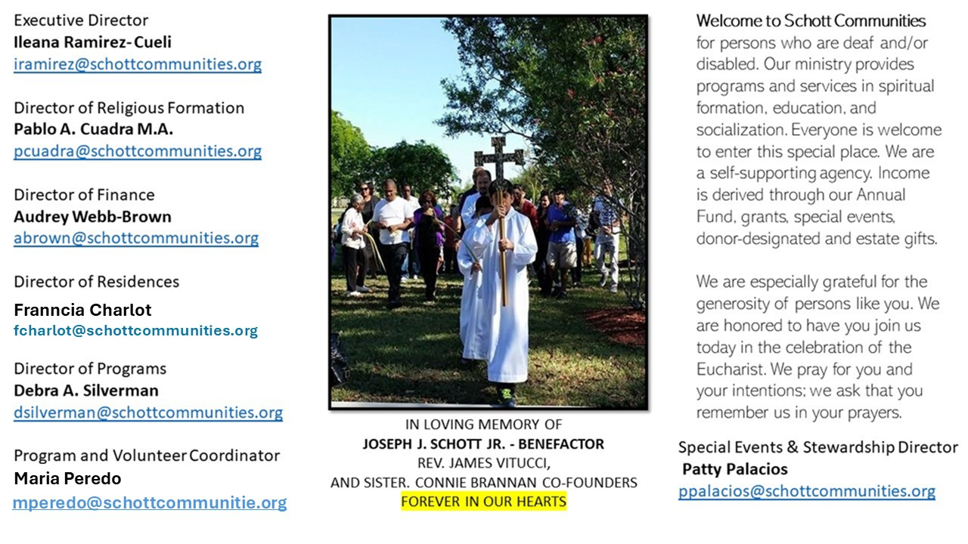

2 de noviembre de 2025
Conmemoración de todos los fieles difuntos
Juan 6:37-40
Hoy recordamos a nuestros familiares y amigos difuntos. Elevamos nuestras oraciones con las palabras del Salmo 130: “Desde el abismo clamo a ti, Señor: ¡Señor, escucha mi voz! Que tus oídos estén atentos al clamor de mis súplicas”. De esta forma, la Iglesia conmemora a todos los fieles difuntos.
El Papa Francisco nos dice: “La Conmemoración de los difuntos tiene un doble sentido. Un sentido de tristeza: un cementerio es triste, nos recuerda a nuestros seres queridos que se han marchado, nos recuerda también el futuro, la muerte; pero en esta tristeza, nosotros llevamos flores, como signo de esperanza. Puedo decir, también, de fiesta, pero más adelante, no ahora. Y la tristeza se mezcla con la esperanza. Y esto es lo que todos nosotros sentimos hoy, en esta celebración: la memoria de nuestros seres queridos, ante sus restos, y la esperanza. Pero sentimos también que esta esperanza nos ayuda, porque también nosotros tenemos que recorrer este camino. Todos nosotros recorreremos este camino. Antes o después, pero todos. Con dolor, más o menos dolor, pero todos. Pero con la flor de la esperanza, con ese hilo fuerte que está anclado en el más allá. Esta ancla no decepciona: la esperanza de la resurrección”. No debe existir ninguna duda, el Evangelio confirma esta ancla, que es Jesús y su promesa de vida eterna: “Toda persona que al contemplar al Hijo crea en Él, tendrá vida eterna, y yo la resucitaré en el último día” (Juan 6:40).

November 2, 2025
The Commemoration of All the Faithful Departed
John 6:37-40

I lost my wallet this year. It was such an annoyance to replace everything in it. A friend, moved by sympathy, gave me a beautiful new one. One month later I lost that one, too, with all my newly replaced cards. No matter what I did, I couldn’t find what I had lost. I resigned myself to never seeing either of my wallets again.
Fortunately, the Lord Jesus is not like me in this regard. In today’s Gospel (John 6:37–40), he says, “This is the will of the one who sent me, that I should not lose anything of what he gave me.” Jesus, unlike me, is ever vigilant with what the Father has given him. He searches for every lost soul — as the shepherd leaves the ninety-nine to pursue the one lost sheep, or the woman rejoices upon recovering a lost coin — and even descends to the depths of loss on the cross and into the realm of the dead to recover that which seems forever lost.
On All Souls’ Day, as we remember our faithful departed, these words kindle a hope beyond hope in our hearts. Even the dead are not lost to Jesus, though they may seem so to us. Nothing entrusted to him by the Father is ever truly lost. So, we may hope that every soul, no matter how wandering or forgotten in life, is secure in his loving care and destined to be raised on the last day. Of what the Father gives him, he loses nothing.

— Father John Muir

St. Jude Chapel, Sunday, November 2nd, 2025
Father Robert Bouffier
Celebrant

St. Martin de Porres | November 3
St. Martin de Porres (1579- 1639) is the first Black saint of the Americas. He had a great love of the Eucharist and was known for caring equally for all regardless of race or status. He founded an orphanage and school and even cared for the mice and rats at his monastery.


Christian Giving
October 26th, 2025
$782

We sincerely thank you and bless you for your generosity.
A bequest is a powerful tool to help the Deaf or Disabled.

Mass Intentions
“For the repose of the Souls in Purgatory
Requested by Schott Communities


Follow us on Facebook
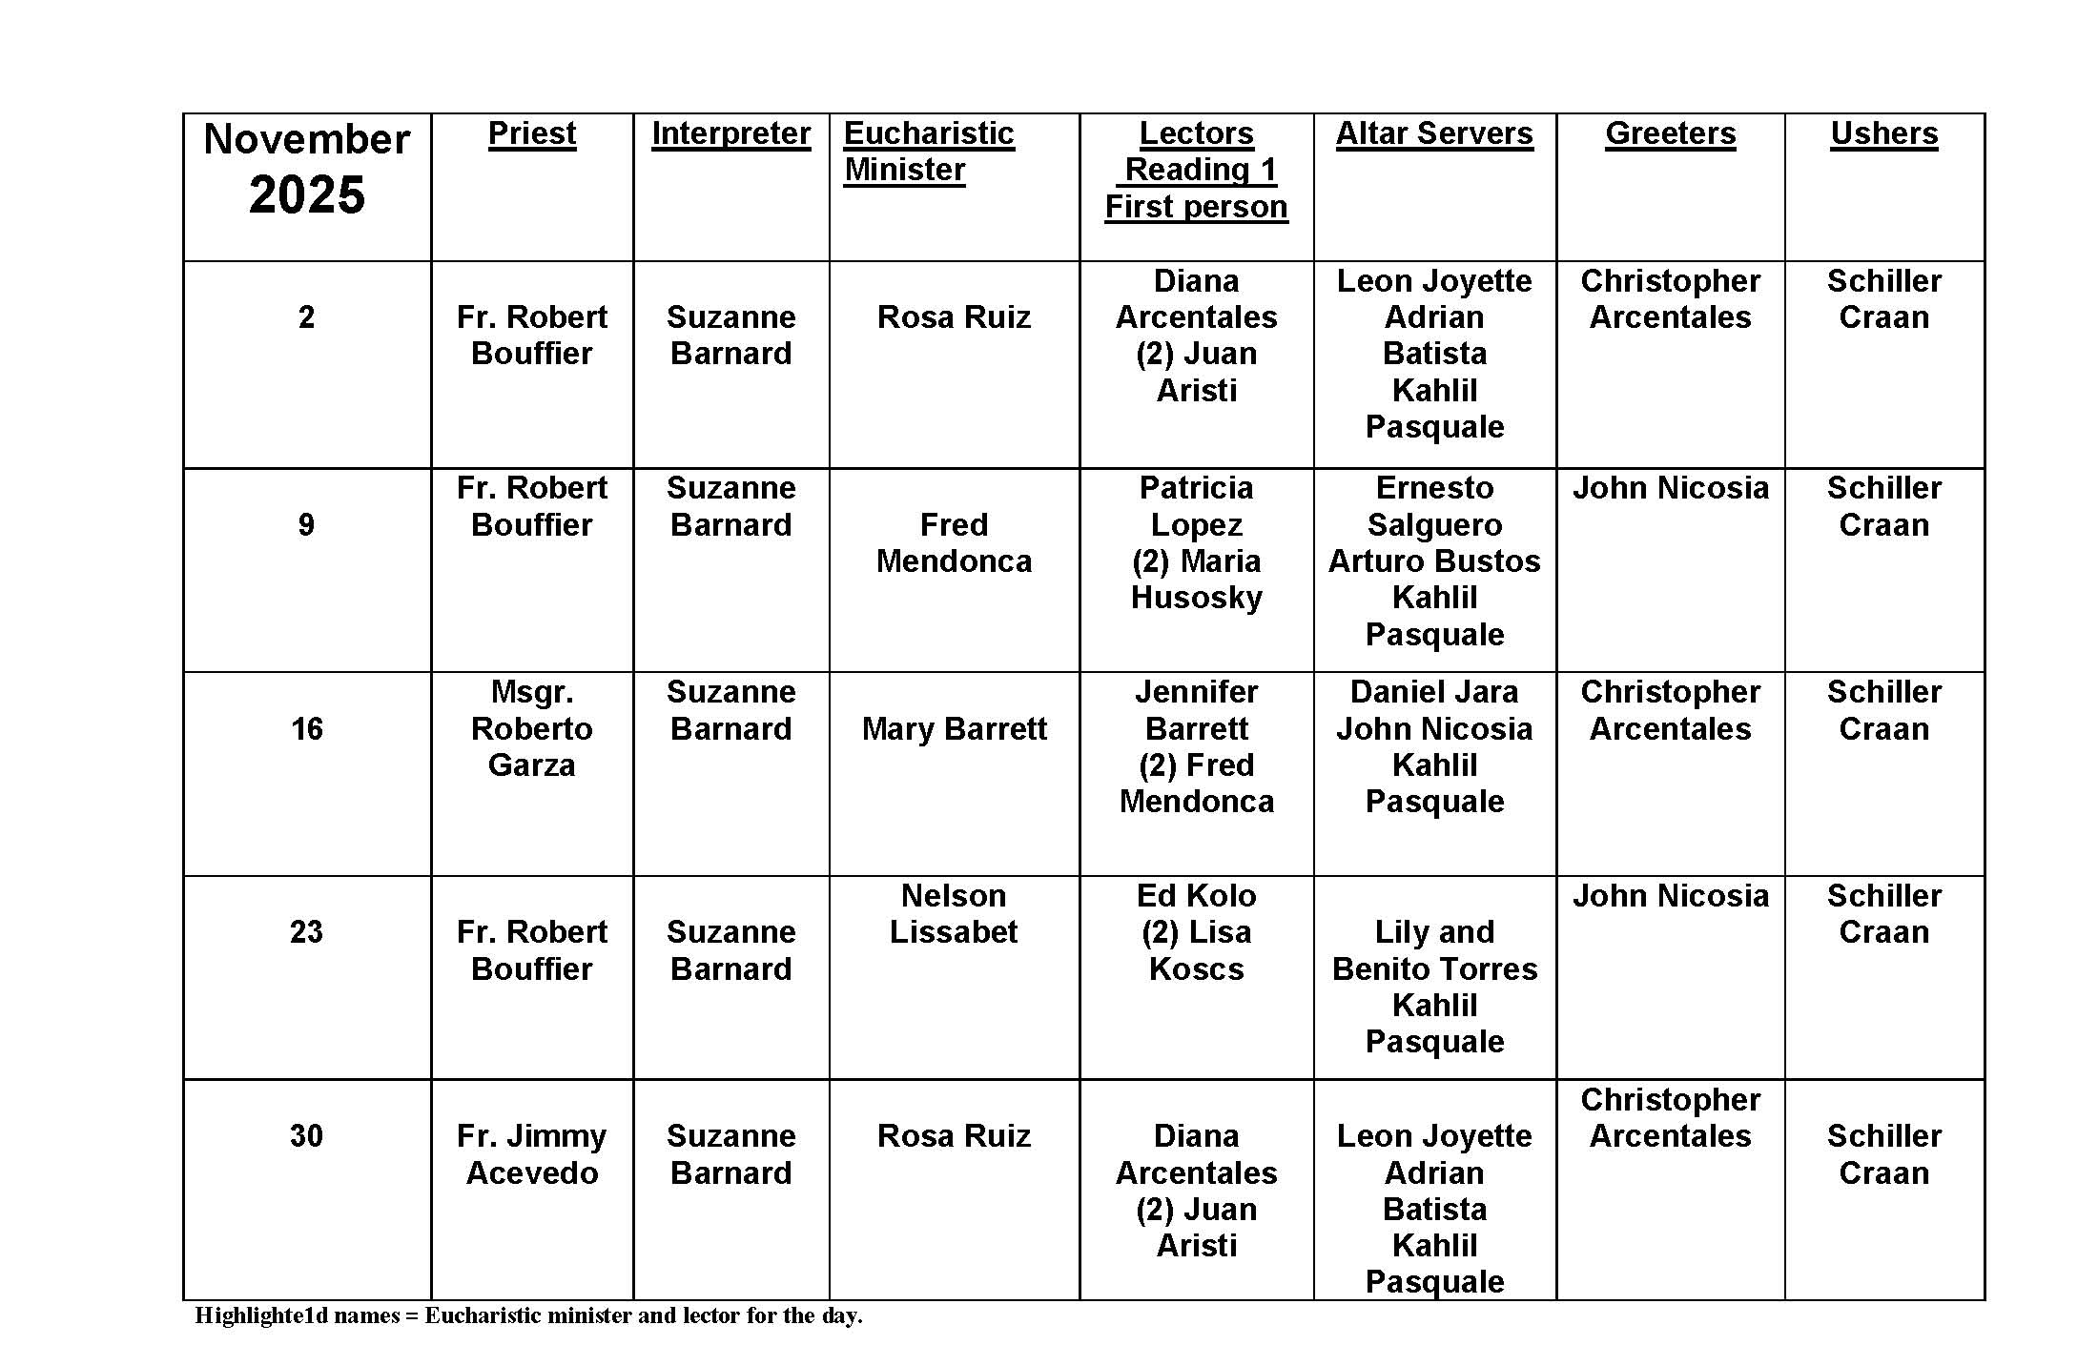
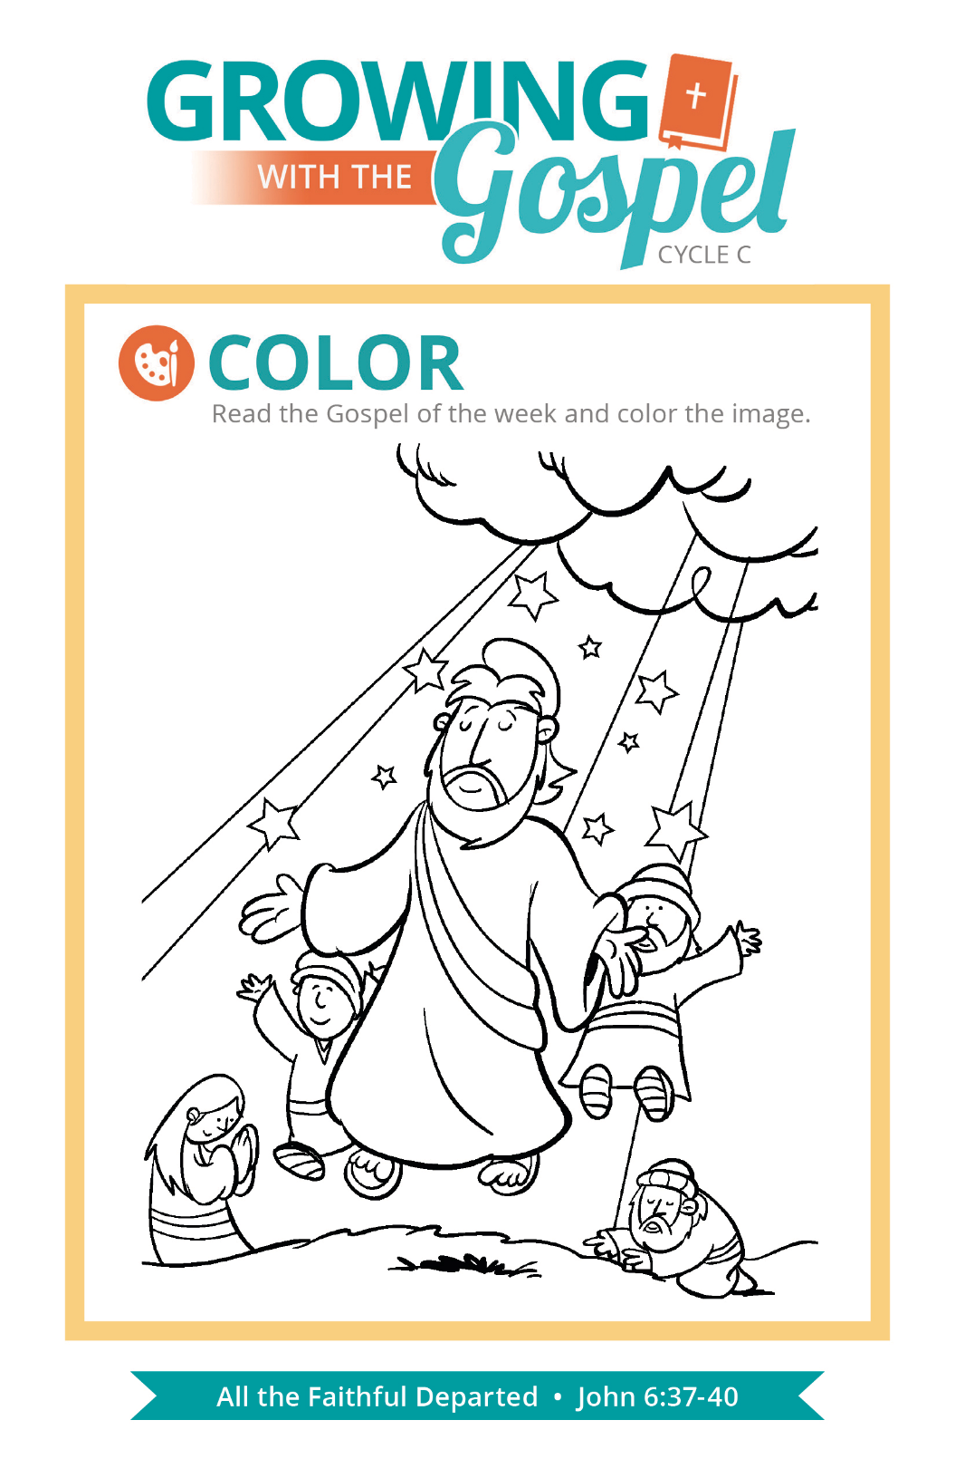
Resurrection of the Dead

Question:
What do Catholics believe about the resurrection of the dead?

Answer:
Every Sunday, we proclaim in the Creed that we believe “in the resurrection of the body.” Does that mean Christ’s resurrection or our own? Both! Jesus’ resurrection is part of the work of salvation, but it’s also a sign of what’s to come. While death separates our bodies and our souls, this was not the intention of God when He first created us. It’s an effect of original sin. At the end of time, our bodies and our souls will be reunited.

Scientifically, we may have questions about this, since bodies decompose over the course of centuries. Or what about the saints, whose relics are spread around the earth? How the resurrection will happen is a mystery. But we know that our resurrected body will be our body. If we are in heaven, our body will be in a glorified state. Some theologians speculate what this glorification will be like based on Jesus’ resurrected body. Will we be able to walk through walls? Will we eat, since Jesus broke bread with his disciples? We don’t really know the answers to these questions. We do know, however, that we will be free from the effects of the fall (such as sickness and pain) and physical defects that occurred in life. Christ redeems us as whole persons, body and soul!

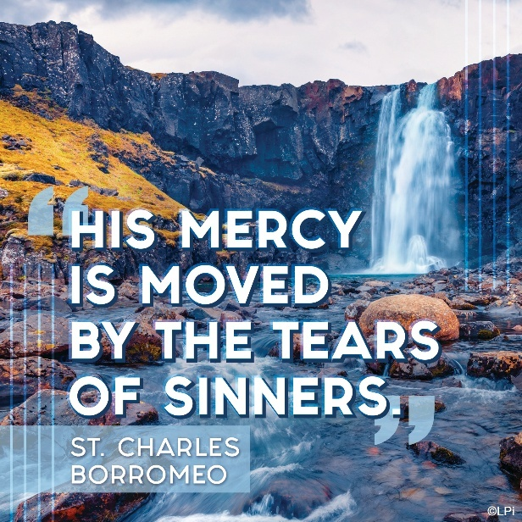
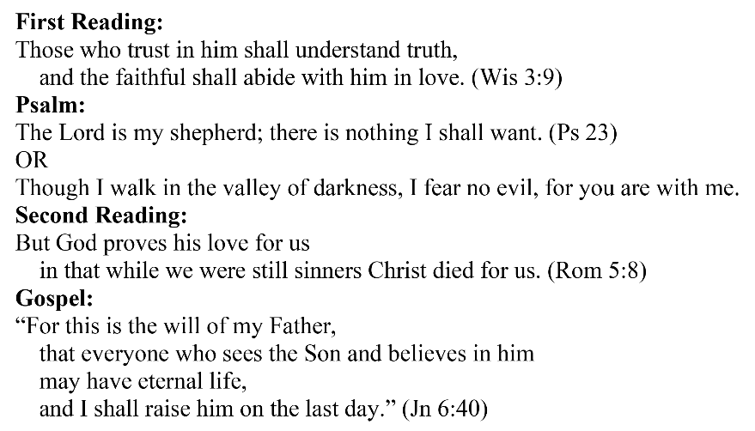
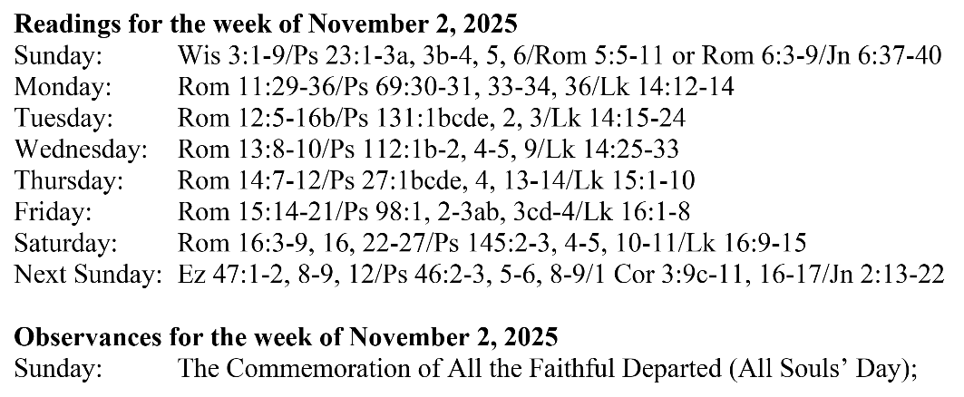
Are you in need of prayer? Do you have a prayer request? You can send your prayer requests to pcuadra@schottcommunities.org or call 954-434-3306 ext. 108

A copy of our prayer list can be found in the lobby of our chapel. To request a copy of our prayer list please email us at pcuadra@schottcommunities.org
To request a Mass please contact Pablo A. Cuadra at 954-434-3306 or e-mail at pcuadra@schottcommunities.org
Update: Celebrating a wedding anniversary soon? Let us know a week in advance and we can assist you with the renewal of your wedding vows.

Prayer to St. Michael the Archangel:
"St. Michael the Archangel, defend us in battle. Be our defense against the wickedness and snares of the Devil. May God rebuke him, we humbly pray, and do thou, O Prince of the heavenly hosts, by the power of God, thrust into hell Satan, and all the evil spirits, who prowl about the world seeking the ruin of souls. Amen"

