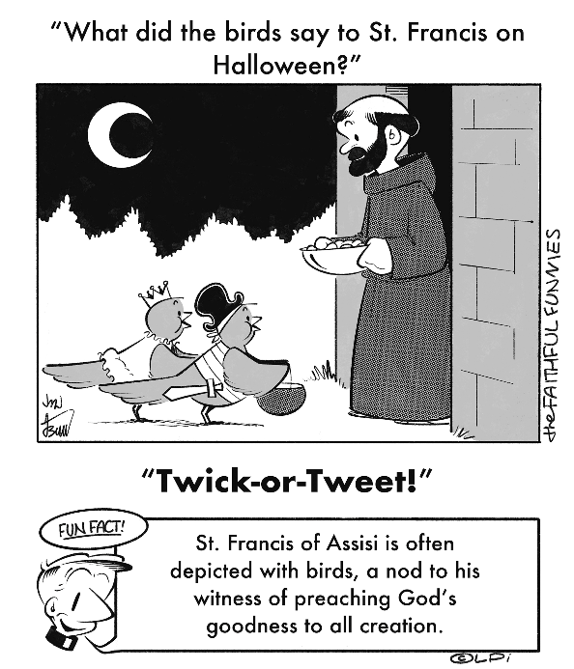
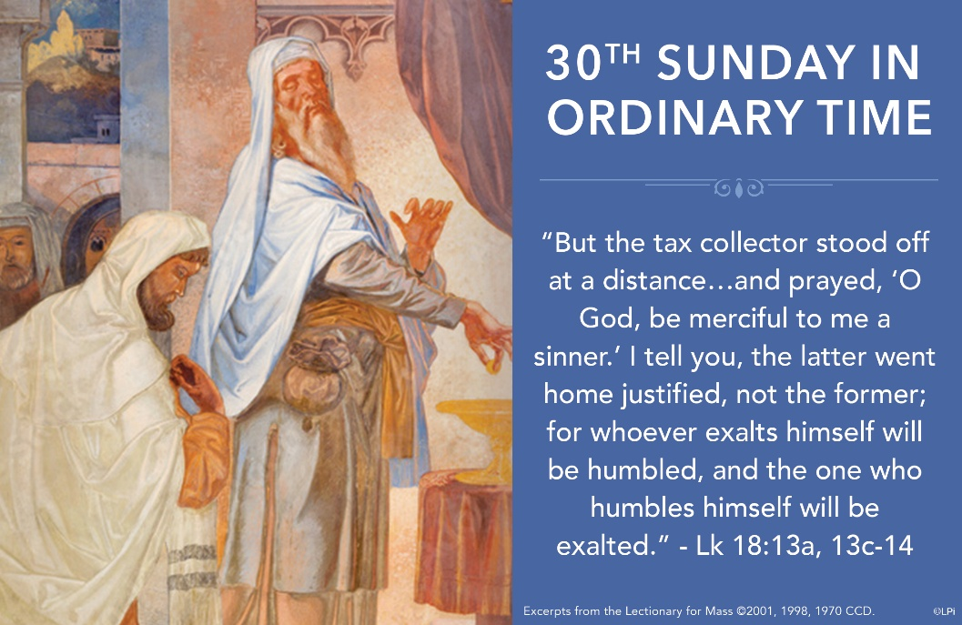
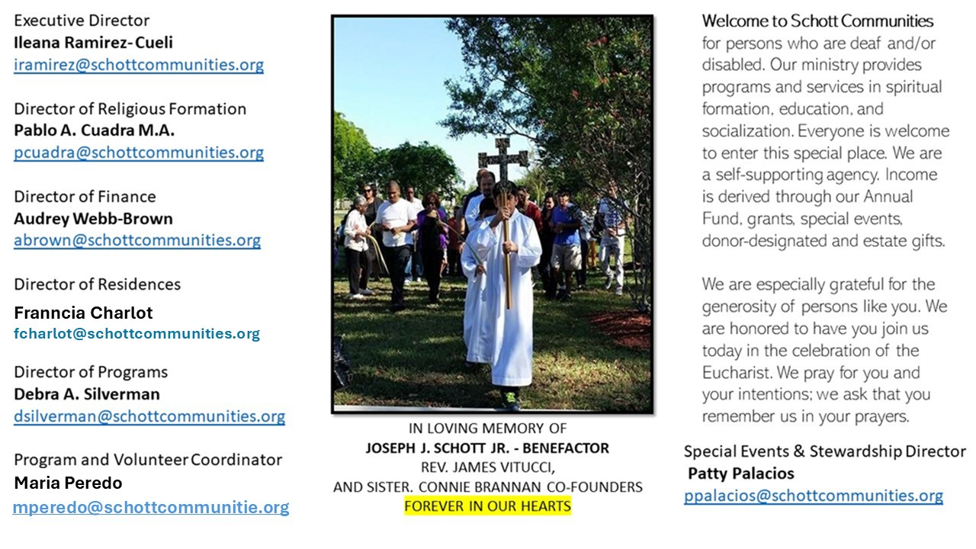

26 de octubre de 2025
XXX Domingo del Tiempo Ordinario
Lucas 18:9-14

Ante Dios no podemos fingir ni aparentar: Él nos conoce profundamente. Por más cara de buenos que pongamos, Él ve más allá: ve nuestro corazón. Tampoco podemos decirle cuán buenos somos, porque nos conoce y sabe perfectamente nuestras acciones. Hoy, Jesús nos cuenta otra parábola: la de dos hombres que fueron al templo a orar. Cada uno lo hace a su manera, y al escuchar el relato, nos damos cuenta de que uno lo hace mejor que el otro. Pero lo más importante es que los dos hablan con Dios. Con este ejemplo podemos aprender a orar y a presentarnos ante Dios tal como somos. “Efectivamente, el fariseo, a pesar de las obras, perdió la justicia; el publicano, en cambio, se granjeó la justicia por la humildad de sus palabras. Aunque, a decir verdad, la del publicano no era propiamente humildad: de hecho, la humildad se da cuando uno que es grande se humilla a sí mismo. La actitud del publicano no fue humildad, sino verdad: sus palabras eran verdaderas, pues él era un pecador”- San Juan Crisóstomo (350–407), Homilía 2 sobre la Penitencia.

“Pero, aunque somos pecadores, no debemos desalentarnos, porque el Señor está con nosotros, quien nos ha dado todo y nos hará vencer también este pequeño paso de hoy, con la gracia de la fuerza, de la valentía, de la oración, de la vigilancia y de la alegría” (Papa Francisco). En conclusión: puede ser que en cada uno de nosotros vivan un fariseo y un publicano. Ambos necesitan de Dios para ser liberados y perdonados. Ante Dios, oremos con verdad y con sinceridad de corazón.

October 26, 2025
Thirtieth Sunday in Ordinary Time
Luke 18:9-14

Every now and then readers of these reflections write letters in which they object to something. Years ago, this Gospel of Luke 18 prompted such an email. A man wrote to me: “I find it deeply offensive that you suggest we are still sinners once we are God’s sons and daughters.” His objection stirred in me a profound awareness of the paradox at the heart of our faith. Are we sinners or beloved children of God?
In this Gospel (Luke 18:9-14), a tax collector appears as one who has missed the mark. His sins have isolated him. His breast-beating is not an act of self-flagellation for pride’s sake but a heartfelt admission of his failure and unworthiness. Remarkably, Jesus honors the candid humility of the parable’s penitent. Why? Because we are always in need of mercy, always. But even more, perhaps because on the cross, Jesus will fully embrace a similar place of humiliation and rejection. He will enter into the most shameful, offensive place of the sinner so that we might “go home justified.”
There is a sacred tension in admitting that we are sinners and yet have profound hope. We are beloved sons and daughters of God, growing precisely through our honest acceptance of failure. When we cry, “Have mercy on us,” during Mass or when we repeat the “Jesus Prayer” in quiet moments, or in the confessional, we embrace our imperfections as fertile ground for divine grace. In doing so, we follow Christ’s example — finding true exaltation in the humble acknowledgment of our human frailty.

— Father John Muir

St. Jude Chapel, Sunday, October 26th, 2025
Father Robert Bouffier
Celebrant

PRAYER – FOR EVERYDAY AND EVERYBODY
Prayer of Praise
Dear God,
As we look to the week ahead, help us to remember that You will accompany us at every moment — You who greet us with mercy anew every morning, and grace in abundance each night.
Amen.


Christian Giving
October 19th, 2025
$

We sincerely thank you and bless you for your generosity.
A bequest is a powerful tool to help the Deaf or Disabled.

Mass Intentions
“For the repose of the Souls in Purgatory
Requested by Schott Communities


Follow us on Facebook
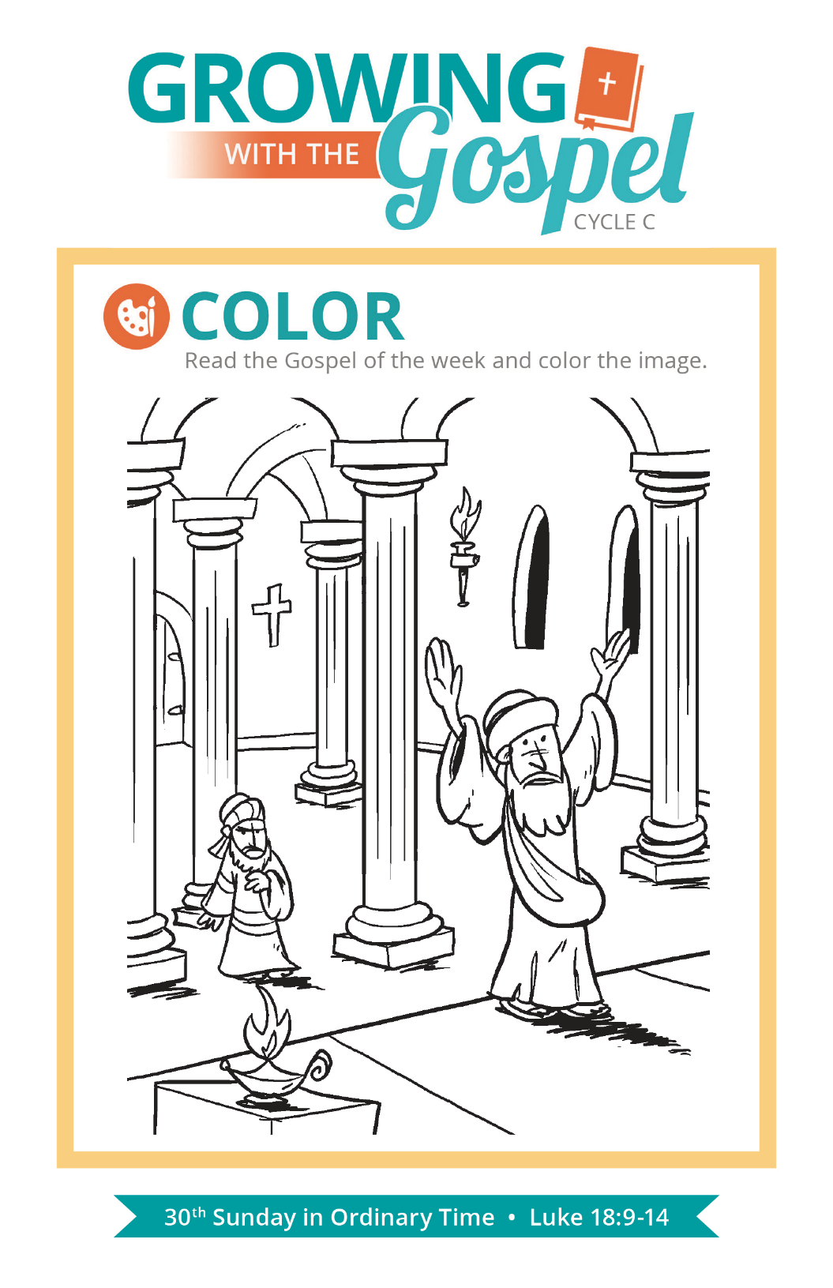
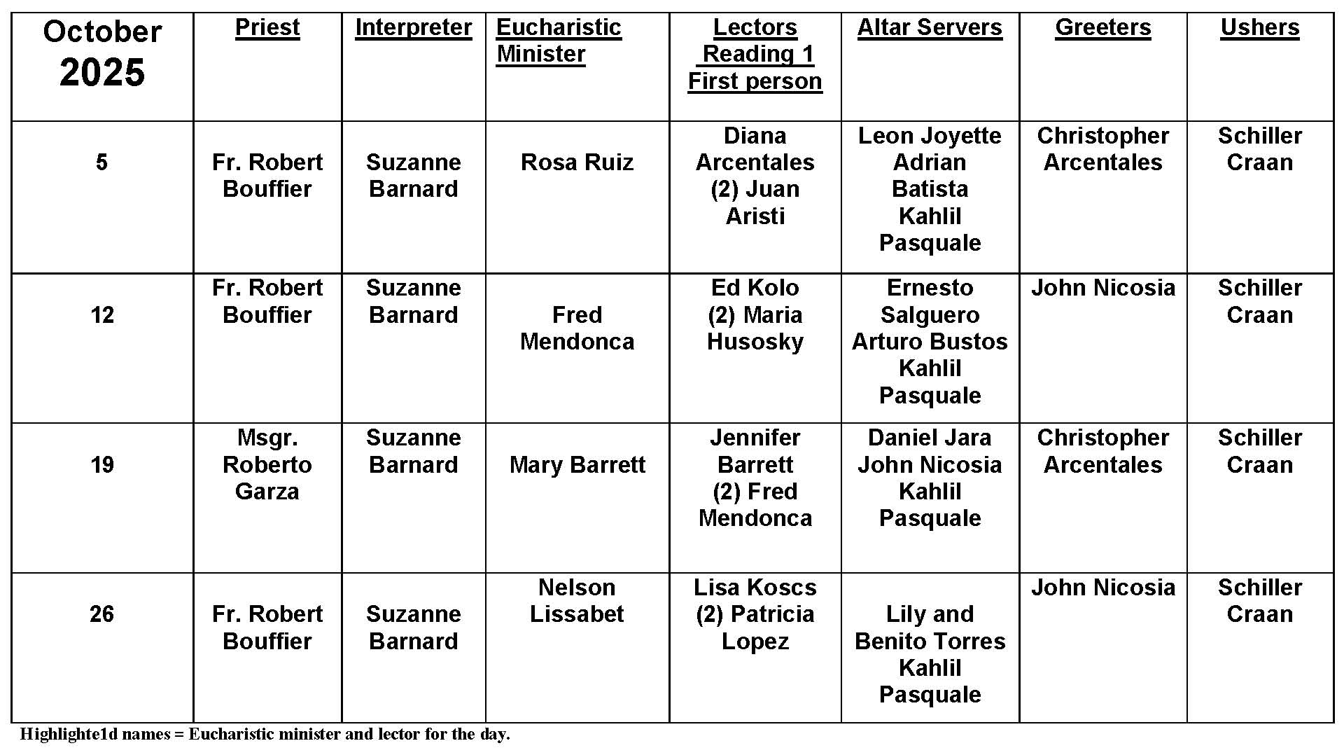
Why Kneel?

Question:
Why do we kneel at Mass?

Answer:
Since the beginnings of the Church, kneeling has been a key posture of prayer. We see Sts. Peter and Paul in the Acts of the Apostles kneeling in prayer. Early in the 4th century, the Council of Nicea prohibited kneeling on Sundays and special feasts. Kneeling began more as a posture of penance for our sins, but in the history of the Church, it has become more a posture or reverence and solemn prayer.

You will notice that the times we kneel at Mass are tied to the consecration of the holy Eucharist. We kneel in both anticipation of what will occur and then in awe of what has taken place: Jesus Christ becomes truly present to us under the guise of bread and wine. The profoundness of this event has over time led the Church to mandate in the current General Instruction of the Roman Missal that kneeling is the only posture allowed during this time. The sheer awesomeness of the holy Eucharist leads us to fall to our knees in wonder and thanksgiving.

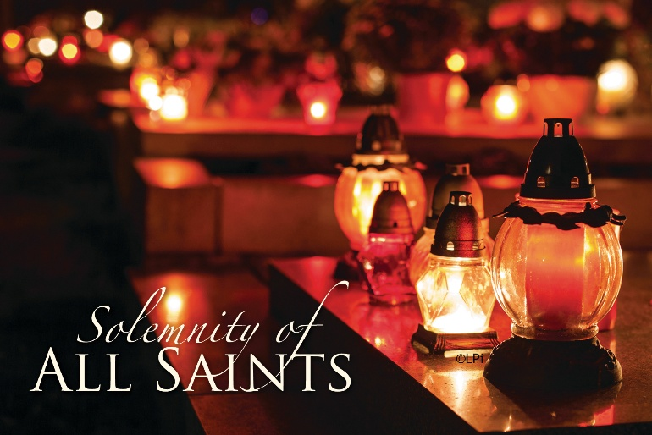
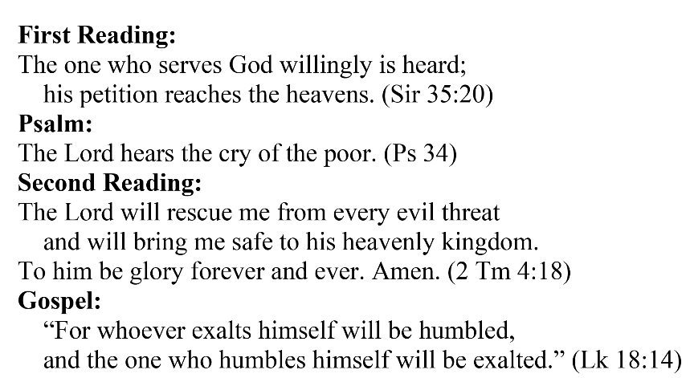
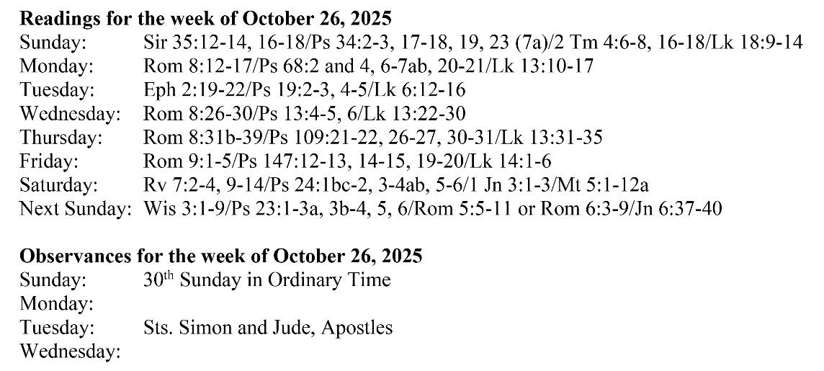
Are you in need of prayer? Do you have a prayer request? You can send your prayer requests to pcuadra@schottcommunities.org or call 954-434-3306 ext. 108

A copy of our prayer list can be found in the lobby of our chapel. To request a copy of our prayer list please email us at pcuadra@schottcommunities.org
To request a Mass please contact Pablo A. Cuadra at 954-434-3306 or e-mail at pcuadra@schottcommunities.org
Update: Celebrating a wedding anniversary soon? Let us know a week in advance and we can assist you with the renewal of your wedding vows.

Prayer to St. Michael the Archangel:
"St. Michael the Archangel, defend us in battle. Be our defense against the wickedness and snares of the Devil. May God rebuke him, we humbly pray, and do thou, O Prince of the heavenly hosts, by the power of God, thrust into hell Satan, and all the evil spirits, who prowl about the world seeking the ruin of souls. Amen"

