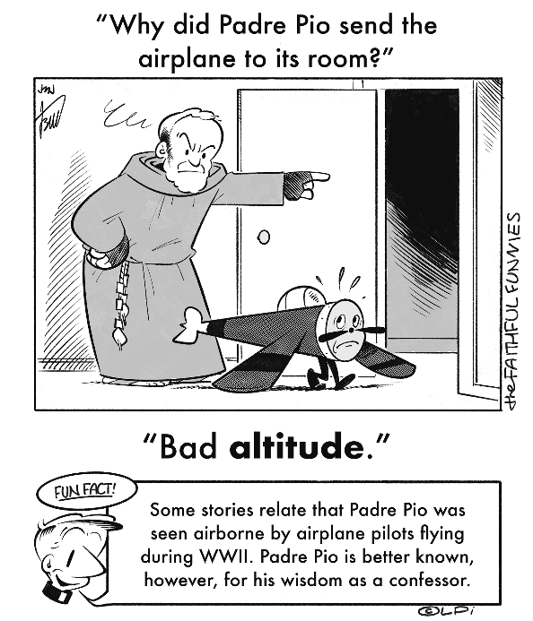
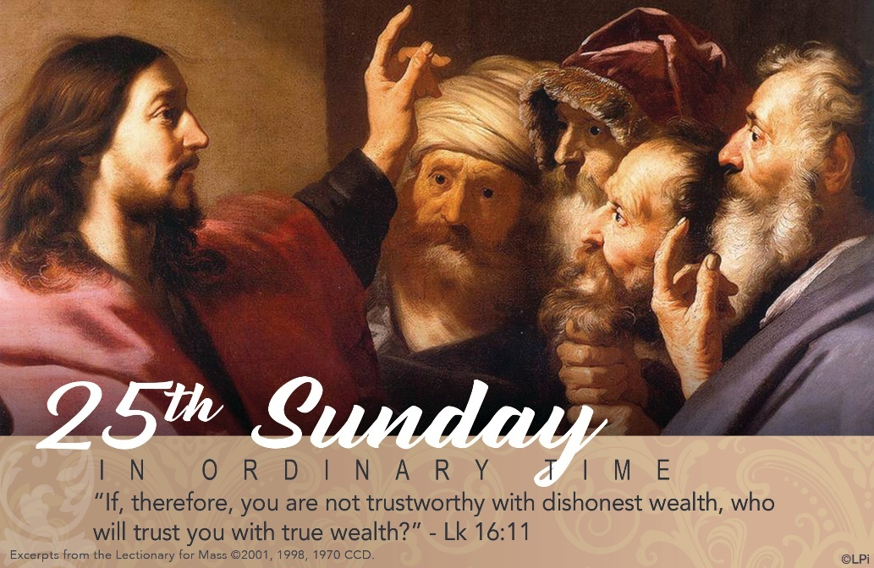
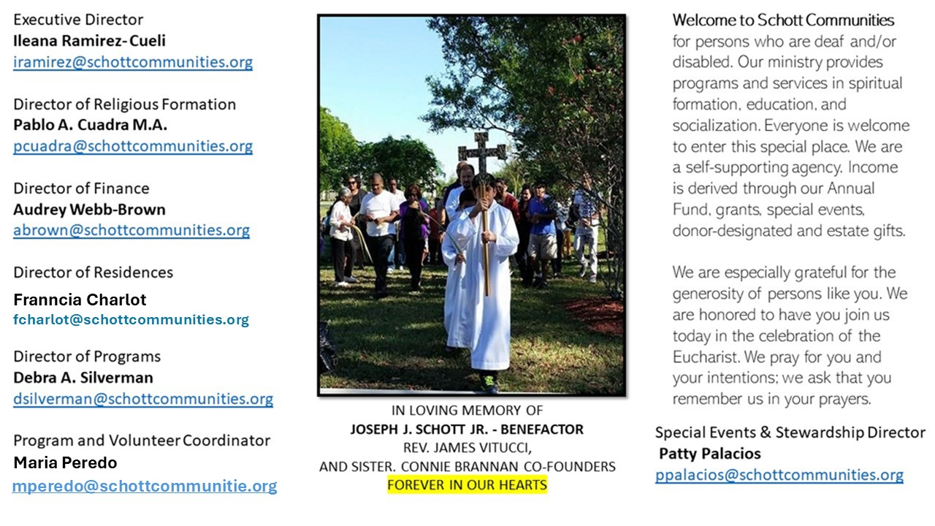

21 de septiembre de 2025
XXV Domingo del Tiempo Ordinario
Astuto el administrador de la parábola que Jesús nos cuenta hoy. Nos dice que consiguió hacer amigos entre los deudores de su amo, porque les perdonó parte de su deuda. Es elogiado por ser tan ágil en bienes ajenos. "El patrón admiró la manera tan inteligente de actuar de ese administrador que lo estafaba" (Lucas 16:8). No se puede explotar a las personas por dinero y decir que se ama a Dios, especialmente en estos tiempos modernos, donde aparentemente todo funciona bien. Sin embargo, se explota mucho a los inmigrantes de cualquier país del mundo. Abunda la trata de personas, los salarios injustos y las deudas de países pobres imposibles de pagar. Por mencionar algunos ejemplos.
"Existe una astucia cristiana de hacer las cosas con picardía, pero no con el espíritu del mundo: hacer las cosas honestamente. Y esto es bueno. Es lo que dice Jesús cuando invita a ser astutos como serpientes y simples como palomas. Poner juntas estas dos dimensiones es una gracia del Espíritu Santo, una gracia que debemos pedir. También hoy hay muchos de estos estafadores, corruptos… A mí me impresiona ver cómo la corrupción está extendida por todas partes" (Papa Francisco). Tiene razón el Papa Francisco al estar impresionado y a la vez preocupado por tanta deshonestidad en nuestra sociedad. Tenemos que poner acción y darnos cuenta de que no se puede servir a Dios y al dinero. Así lo dijo Jesús, y su mensaje vale tanto entonces como ahora.

September 21, 2025
25th Sunday in Ordinary Time
Luke 16:10-13

Before I was a priest, I was a lazy worker for a retail Apple store. Hearing a rumor that my boss was going to fire me, I secretly sold iPhones for half-price, gave away dozens of free iPads, and donated several brand-new laptops to managers in other stores in the mall. After a week, my boss called me into his office. He knew what I was up to. He said I had cost the store thousands of dollars. “Really great work, John,” he said. “I am going to recommend you to be my assistant manager and double your pay.” I was amazed.

And so are you. Which is understandable because it never happened. How could it? My tall tale is a retelling of Jesus' brow-furrowing parable we hear this week. A lazy, dishonest steward defrauds his boss and then the “master commended the dishonest servant for acting prudently” (Luke 16:8). What is the Lord saying to us?

Most of us treat our spiritual lives like a lazy teenager at an Apple store. We really don’t care. We go through the motions. Then, if we are lucky, something happens that shakes us to spiritual action; to employ whatever time, money, and resources we have to build around us a strong network of love. Every saint did that. Our Lord is so good he wants us to use his stuff to forgive debts and to bless others. He wants us to ensure our future. So do it!

— Father John Muir

St. Jude Chapel, Sunday, September 21st, 2025
Monsignor Roberto Garza
Celebrant

St. Pius of Pietrelcina | September 23
Best known as Padre Pio, St. Pius was born Francesco Forgione in 1887 in Pietrelcina, Italy. As a young boy he suffered many illnesses including typhoid. He joined Capuchin Franciscans at 15 and took the name of Pius or "Pio" in honor of Pope Pius I. He was ordained in 1910, and at this time he received the marks of stigmata, the wounds of Christ, but they eventually healed. Frequent illnesses continued to plague him as a young man.
Amen.


Christian Giving
September 14th, 2025
$474

We sincerely thank you and bless you for your generosity.
A bequest is a powerful tool to help the Deaf or Disabled.

Mass Intentions
“For the repose of the Souls in Purgatory
Requested by Schott Communities


Follow us on Facebook

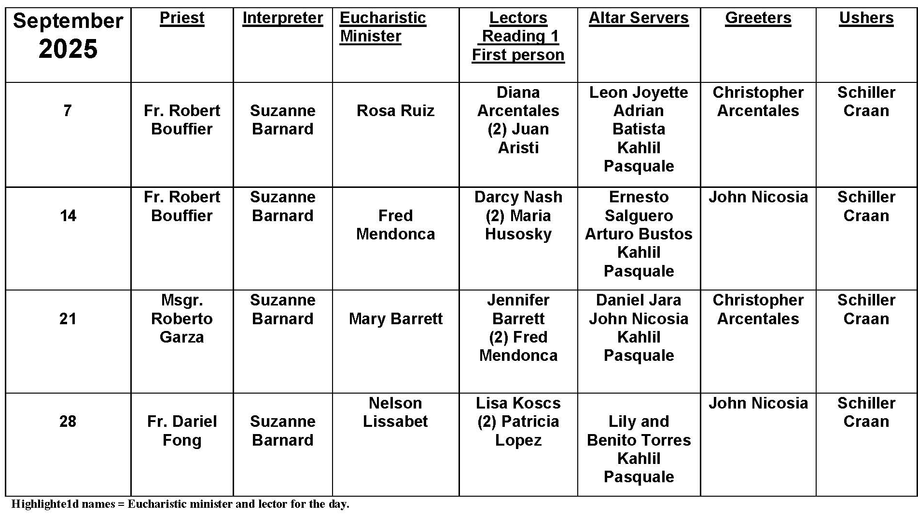
Fish on Friday
Question:
Why do Catholics eat fish on Friday?

Answer:
For centuries, meatless Fridays were the norm for Catholics throughout the world. Friday was chosen because that was the day on which Jesus died, and Christians wanted to find a way to honor that day with special prayers and acts of penance and self-denial. The practice of abstaining from meat on Fridays — under pain of sin — grew out of that desire, and it became an official part of Church teaching until the time of the Second Vatican Council.

In the 1960s, there was a shift in the Church’s thinking, in large part because there was a recognition that differences in cultures and economic realities meant that eating or not eating meat had different meanings for different peoples. For example, in cultures that were largely dependent on seafood or a vegetarian diet, abstaining from meat was no sacrifice at all. While in other places, eating fish and other kinds of seafood was actually something rare and special and not a sacrifice. This was all part of a basic reflection on “why we do what we do” among the Church’s pastors.

Today, Catholics throughout the world are still instructed to abstain from meat on the Fridays of Lent. The bishops of some countries, such as in England and Wales, ask Catholics to abstain from meat every Friday, continuing the older tradition. The Bishops of the United States have taken a slightly different approach, encouraging Catholics to honor Friday as a special day by abstaining from meat every Friday or by taking on some other work of penance or charity for the sake of others.

Regardless of what we choose to do, the real value in all of this is to see a reflection of Good Friday in each Friday, to remember the self-giving love of Jesus, and to honor that love through some sort of sacrifice or act of mercy.

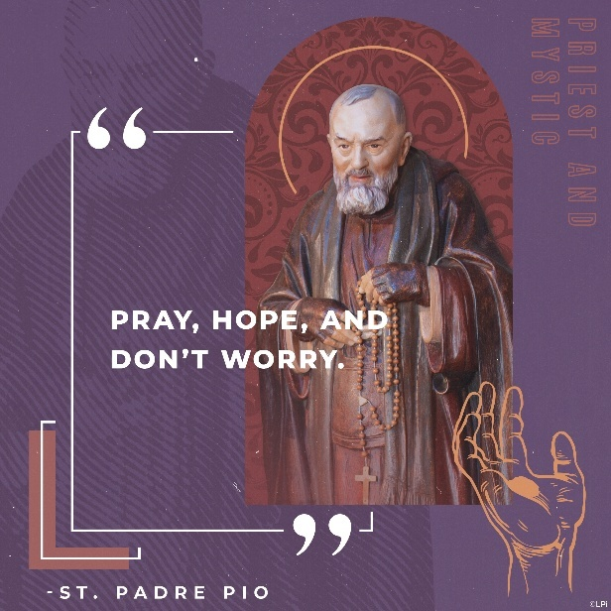
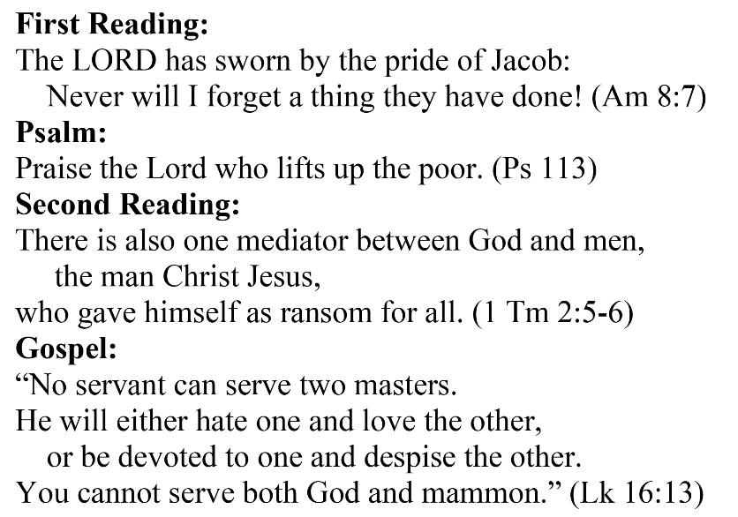
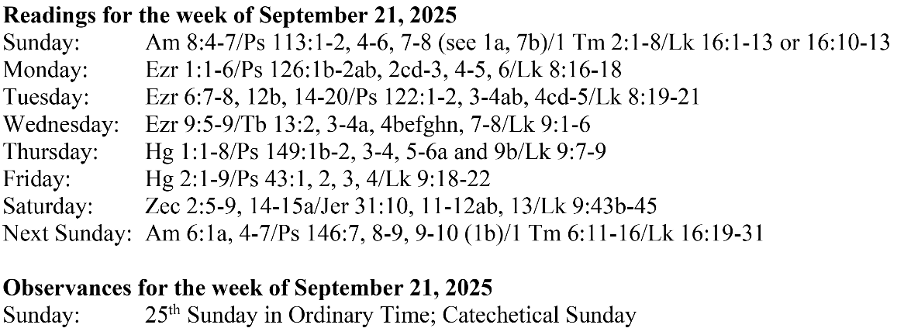
Are you in need of prayer? Do you have a prayer request? You can send your prayer requests to pcuadra@schottcommunities.org or call 954-434-3306 ext. 108

A copy of our prayer list can be found in the lobby of our chapel. To request a copy of our prayer list please email us at pcuadra@schottcommunities.org
To request a Mass please contact Pablo A. Cuadra at 954-434-3306 or e-mail at pcuadra@schottcommunities.org
Update: Celebrating a wedding anniversary soon? Let us know a week in advance and we can assist you with the renewal of your wedding vows.

Prayer to St. Michael the Archangel:
"St. Michael the Archangel, defend us in battle. Be our defense against the wickedness and snares of the Devil. May God rebuke him, we humbly pray, and do thou, O Prince of the heavenly hosts, by the power of God, thrust into hell Satan, and all the evil spirits, who prowl about the world seeking the ruin of souls. Amen"

