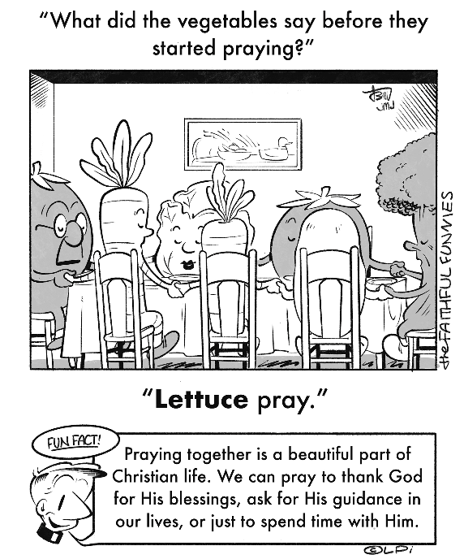
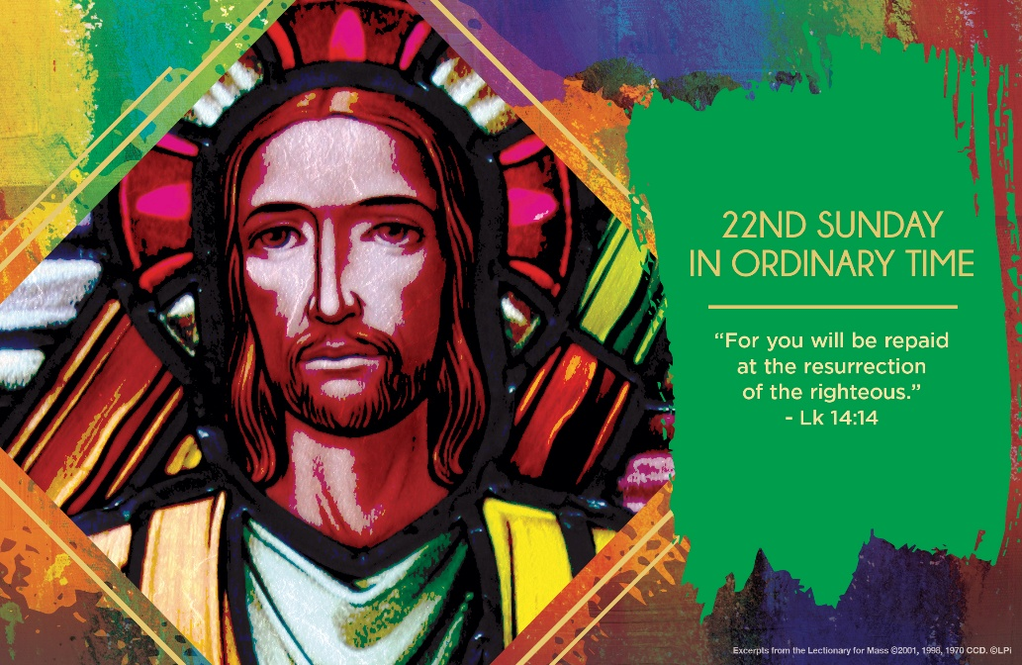
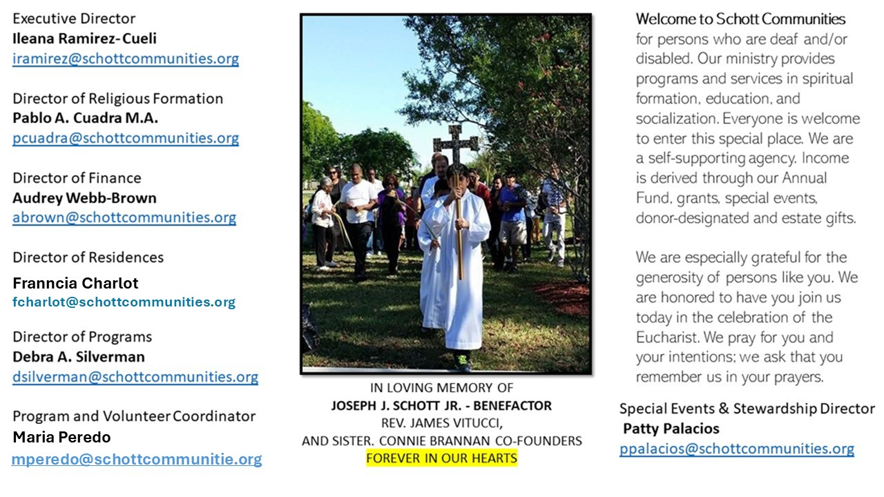

31 de agosto de 2025
XXII Domingo del Tiempo Ordinario

El Reino de Dios se construye en la vida de cada día, donde cada uno de nosotros somos los protagonistas. Se debe trabajar duro y se exige perfección; sin embargo, al mismo tiempo se nos pide no aparentar, no presumir, sino, por el contrario, ser humildes y servir al que lo necesite. Porque tu Reino, Señor, se construye con dedicación, esfuerzo y amor. No se trata de prestigio ni de comodidad. “No debemos buscar por nuestra propia iniciativa la atención y consideración de los demás, sino más bien dejar que otros nos la presten. Jesús siempre nos muestra el camino de la humildad. ¡Debemos aprender el camino de la humildad! Porque es el más auténtico, lo que también nos permite tener relaciones auténticas” (Papa Francisco).
Los primeros asientos en las fiestas deben tomarse con humildad, no con protagonismo. Jesús, este domingo, nos da una lección de lo que es la humildad en los banquetes o fiestas a las que somos invitados. “Cuando alguien te invite a un banquete de bodas, no escojas el mejor lugar. Puede ocurrir que haya sido invitado otro más importante que tú, y el que los invitó a los dos venga y te diga: ‘Deja tu lugar a esta persona’ Y, con gran vergüenza, tendrás que ir a ocupar el último lugar” (Lucas 14:8-9). Todos los servidores del Señor debemos ocupar su lugar en el servicio que realizamos, ya sea en la familia, en el trabajo o en la comunidad. Servir implica siempre ocupar el último lugar.

August 31, 2025
22nd Sunday in Ordinary Time
Luke 14:1, 7-14

Once I was invited to a group meeting with Pope Francis. Entering the room, I paused, eyeing the seats next to the Pope’s fancy chair. Someone saw my paralysis and invited me to sit in the seat farthest from what I wanted. Hiding my disappointment, I sat. We waited. To our surprise, an aid pointed out that those seats were still empty and invited me and another to have them. We calmly but gleefully strode across the room and sat. Pope Francis entered, and we enjoyed two hours of amazingly uplifting conversation.

Jesus says this week to us: “When you are invited, go and take the lowest place so that when the host comes to you he may say, ‘My friend, move up to a higher position.’ Then you will enjoy the esteem of your companions at the table” (Luke 14:10). This is not about how to score free seat upgrades. Rather, it is a wise pattern for the whole of life. It is how to live free from the anxiety of constantly grasping for status and recognition.

Jesus perfectly embodies his seat-taking advice. He eschews his glorious throne for the lowest: death on a cross, that lonely chair we all deserve. In his resurrection, he calls us up higher to his marvelous banquet seats. This week, perhaps we should look for opportunities to choose the lowest seat. We’ll be pleasantly surprised when we do.

— Father John Muir

St. Jude Chapel, Sunday, August 31th, 2025
Father Jimmy Acevedo
Celebrant

Imago Divina
Imago divina (Latin for “divine image”) is an extension of the ancient practice of lectio divina (literally, “divine lesson”). Imago divina is, in a sense, praying with one’s eyes, using the medium of artwork to assist in lifting the mind to God.


Christian Giving
August 24th, 2025
$

We sincerely thank you and bless you for your generosity.
A bequest is a powerful tool to help the Deaf or Disabled.

Mass Intentions
“For the repose of the Souls in Purgatory
Requested by Schott Communities


Follow us on Facebook
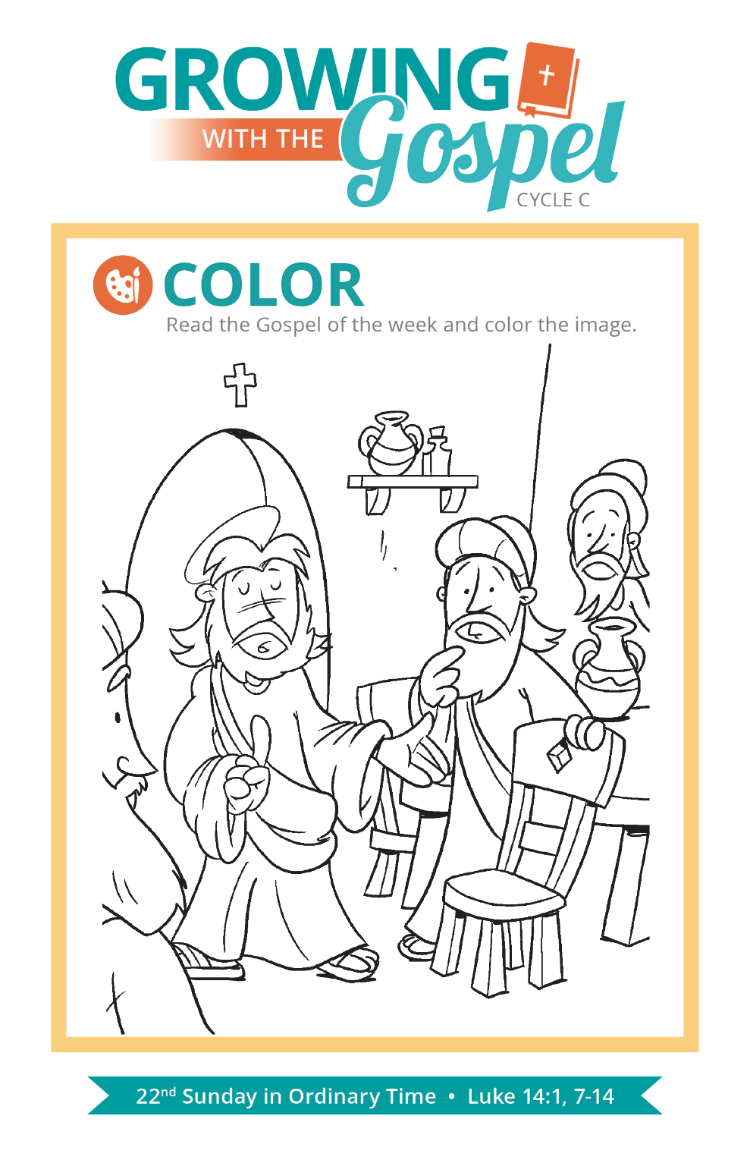
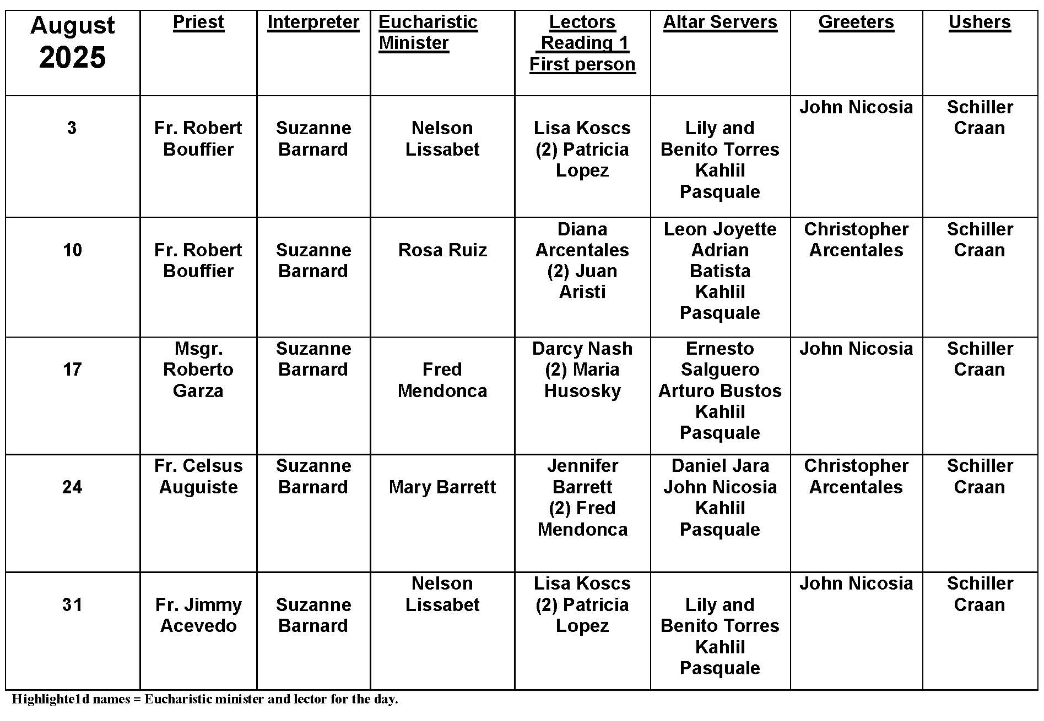
Can We Chew Gum at Mass?

Question: Does chewing gum break the fast before Communion?
Answer:
If you look in Canon Law or in the Catechism, there is no mention of chewing gum. I guess it does not rate the attention of the universal church! The Church requires us to fast for one hour before we receive the Eucharist. Basically, we are to refrain from food and drink, not including water or medicine. There are also exceptions for people who are ill. Overall, the fast is intended for us to prepare ourselves to receive the Eucharist and in some small way to literally as well as spiritually hunger for what we are about to receive. Chewing gum, while not really food, does at least break the spirit of the fast. Besides that, it is a distraction and rude. What do you do with the gum when it is time to receive Communion? People have actually come to the altar chewing away, oblivious to what they were doing or Who they were receiving. At best, it is distracting and irreverent. At worst, it adds a barrier to giving our best to receiving God's best.

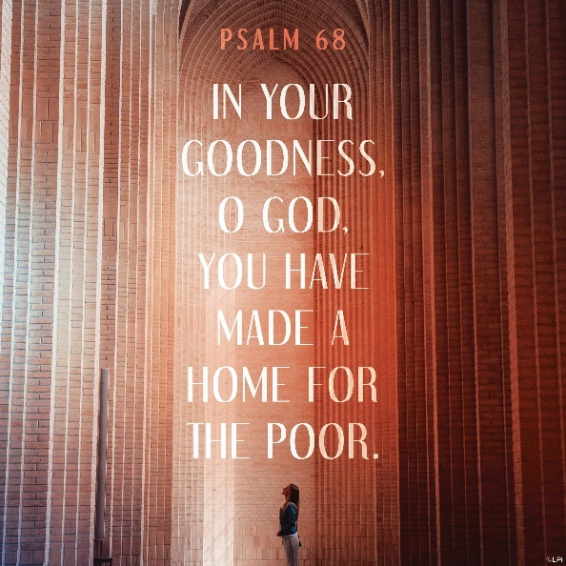
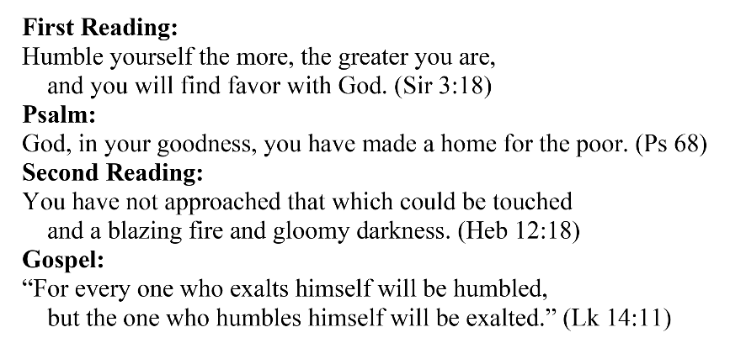
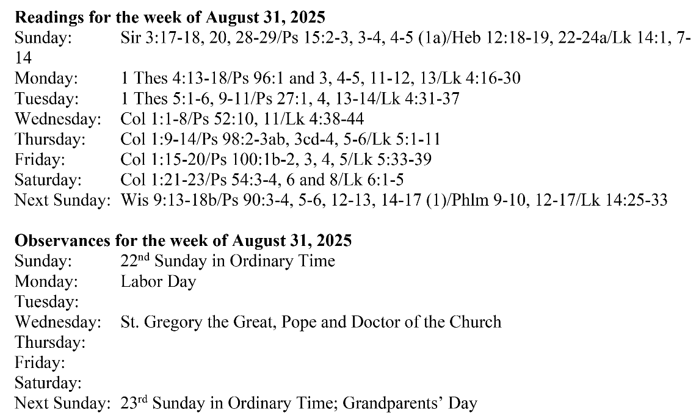
Are you in need of prayer? Do you have a prayer request? You can send your prayer requests to pcuadra@schottcommunities.org or call 954-434-3306 ext. 108

A copy of our prayer list can be found in the lobby of our chapel. To request a copy of our prayer list please email us at pcuadra@schottcommunities.org
To request a Mass please contact Pablo A. Cuadra at 954-434-3306 or e-mail at pcuadra@schottcommunities.org
Update: Celebrating a wedding anniversary soon? Let us know a week in advance and we can assist you with the renewal of your wedding vows.

Prayer to St. Michael the Archangel:
"St. Michael the Archangel, defend us in battle. Be our defense against the wickedness and snares of the Devil. May God rebuke him, we humbly pray, and do thou, O Prince of the heavenly hosts, by the power of God, thrust into hell Satan, and all the evil spirits, who prowl about the world seeking the ruin of souls. Amen"

