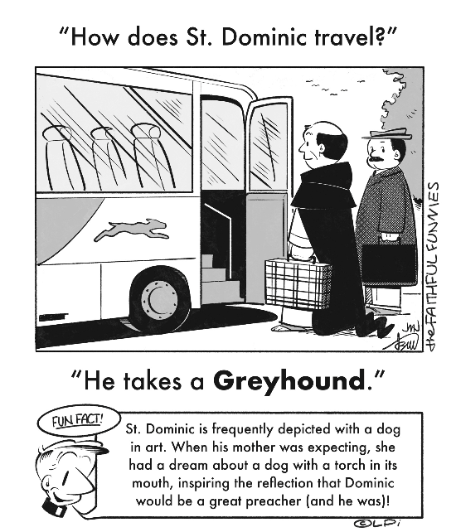
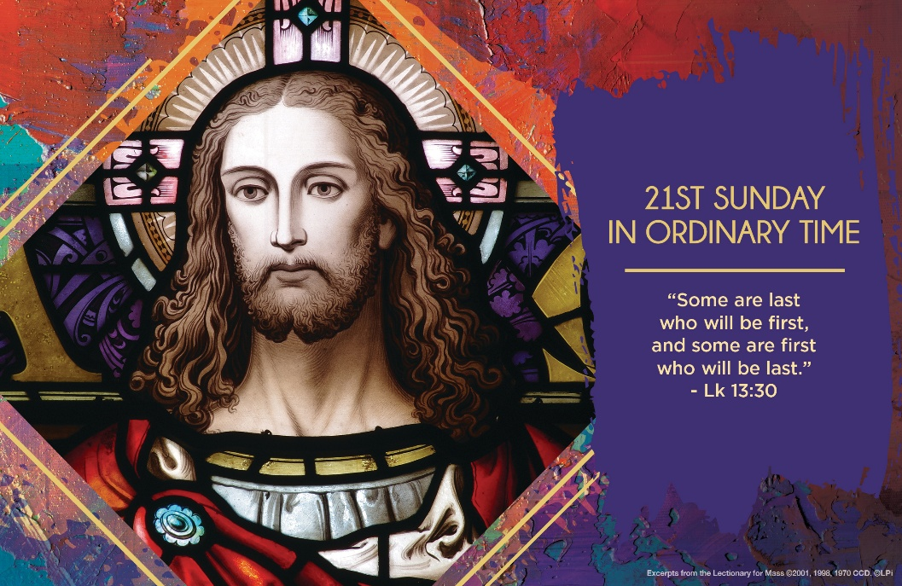
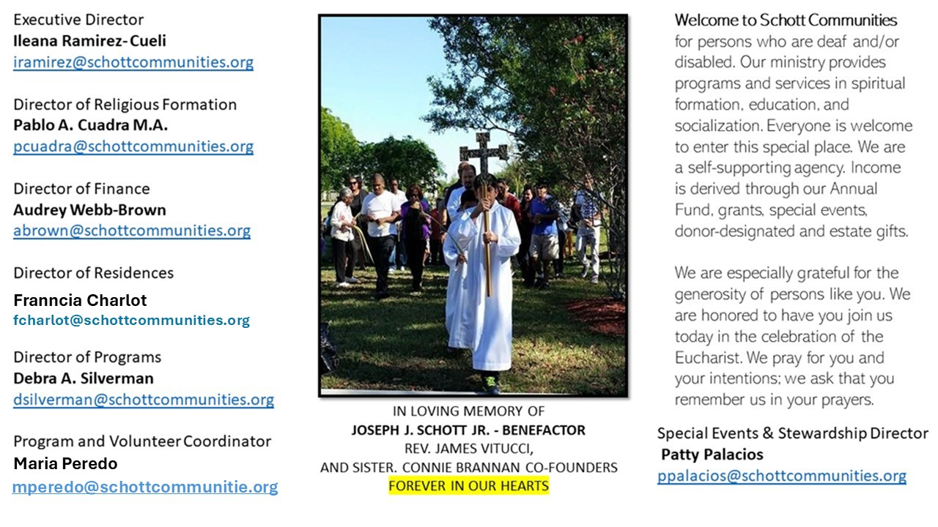

24 de agosto de 2025
XXI Domingo del Tiempo Ordinario

¿Has intentado alguna vez o has tenido la experiencia de entrar por alguna puerta angosta? Es incómodo y te sientes apretado si intentan entrar más de dos personas al mismo tiempo. Nos gustan las puertas anchas, altas y bonitas. La puerta angosta es para entrar de uno en uno, no más. "Esfuércense por entrar por la puerta angosta, porque yo les digo que muchos tratarán de entrar y no lo lograrán" (Lucas 13:24). La manera de hablar de Jesús es diferente a otras ocasiones. Habla claro y directo: dice "esfuércense". Nada es fácil; moldear la arcilla de lo que estamos hechos requiere de esfuerzo.
El Evangelio de hoy también nos advierte: "Unos que estaban entre los últimos son ahora los primeros, mientras que los primeros han pasado a ser los últimos" (Lucas 13:30). ¡Qué sorpresa tan grande! Dios no nos reconocerá por nuestros títulos ni por los puestos de importancia en la sociedad, mucho menos por la riqueza y las propiedades. Así que, ahora sí, se comprende el mensaje de esforzarse para entrar por la puerta angosta. "Ahora considero un deber mío explicarles por qué la puerta es angosta. Cualesquiera que desee entrar, primero, y antes que nada, tiene que poseer una fe honrada e incontaminada; en segundo lugar, una vida sin mancha, sin pecado, en la que no existan posibilidades de culpa, conforme a la medida de la justicia humana" (San Cirilo de Alejandría, 375-444, Comentario al Evangelio de San Lucas).

August 24, 2025
21st Sunday in Ordinary Time
Luke 13:22-30

I’ve been hiking Camelback Mountain in Phoenix, Arizona most of my life. It is a vigorous forty-five minutes to the top. Near the peak, the end suddenly appears much further away, and steeper. At that moment, a descending hiker often offers encouragement: “Keep going! The peak is right there. It’s not as far as it looks. You can do it!” It usually works. After another five minute push, you summit and enjoy a glorious panorama of the Sonoran Desert in the Valley of the Sun.

When Jesus is asked about how many people are saved, he says: “Strive to enter through the narrow gate” (Luke 13:24). How many? Strive! Focus on your journey. What does heavenly census taking have to do with you or me? How would it help a hiker on a mountain to ask the others coming down, “How many people are going to make it to the top?” A normal response would be something like: “How is that a relevant question? Carry on!”

Jesus links one virtue directly to salvation: perseverance (cf. Matt 24:13; hypomone in Greek). Strive! Endure! Keep going! The one absolutely necessary virtue is perseverance, to not give up on our journey. The mountain we struggle to climb is often our own weakness, failures, and sins. Persevere in prayer. Keep celebrating the sacraments. Embrace daily duties. With God’s grace, you are strong enough to keep going. Perhaps the peak is not as far away as you might fear. Keep going!

— Father John Muir

St. Jude Chapel, Sunday, August 24th, 2025
Father Celsus Auguiste
Celebrant

Ignatian Spiritual Exercises
The Ignatian Spiritual Exercises are prayers and meditations which are meant to accompany souls on a journey toward deeper contemplation of God’s love and a more meaningful understanding of his call to discipleship.


Christian Giving
August 17th, 2025
$

We sincerely thank you and bless you for your generosity.
A bequest is a powerful tool to help the Deaf or Disabled.

Mass Intentions
“For the repose of the Souls in Purgatory
Requested by Schott Communities


Follow us on Facebook
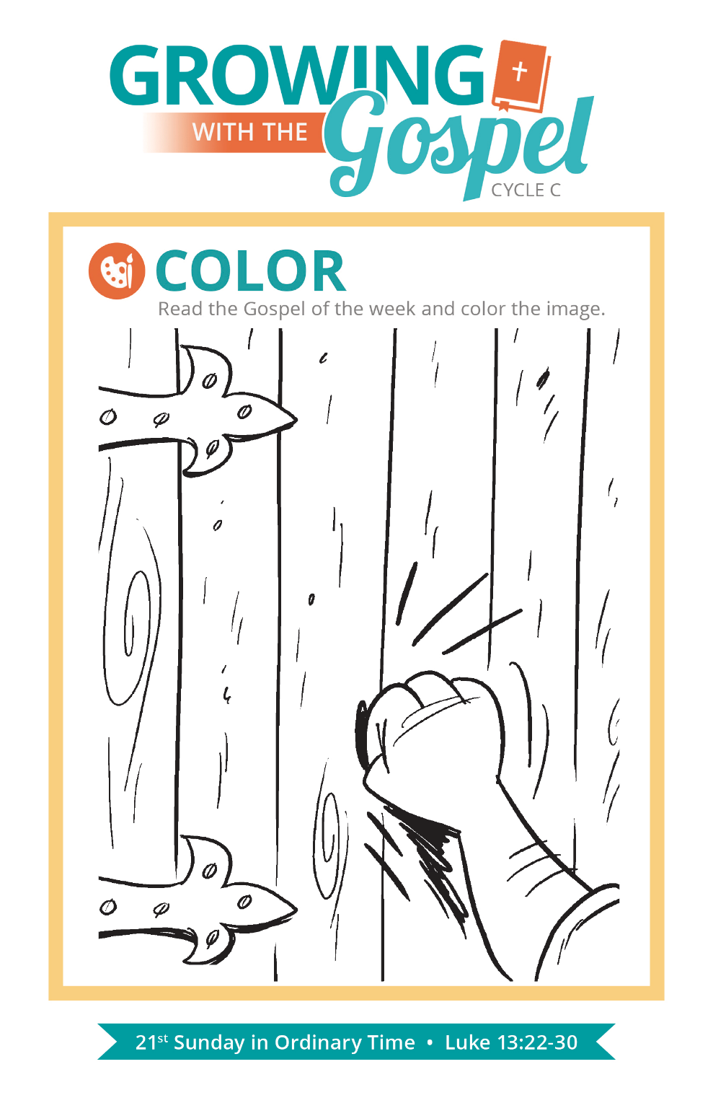
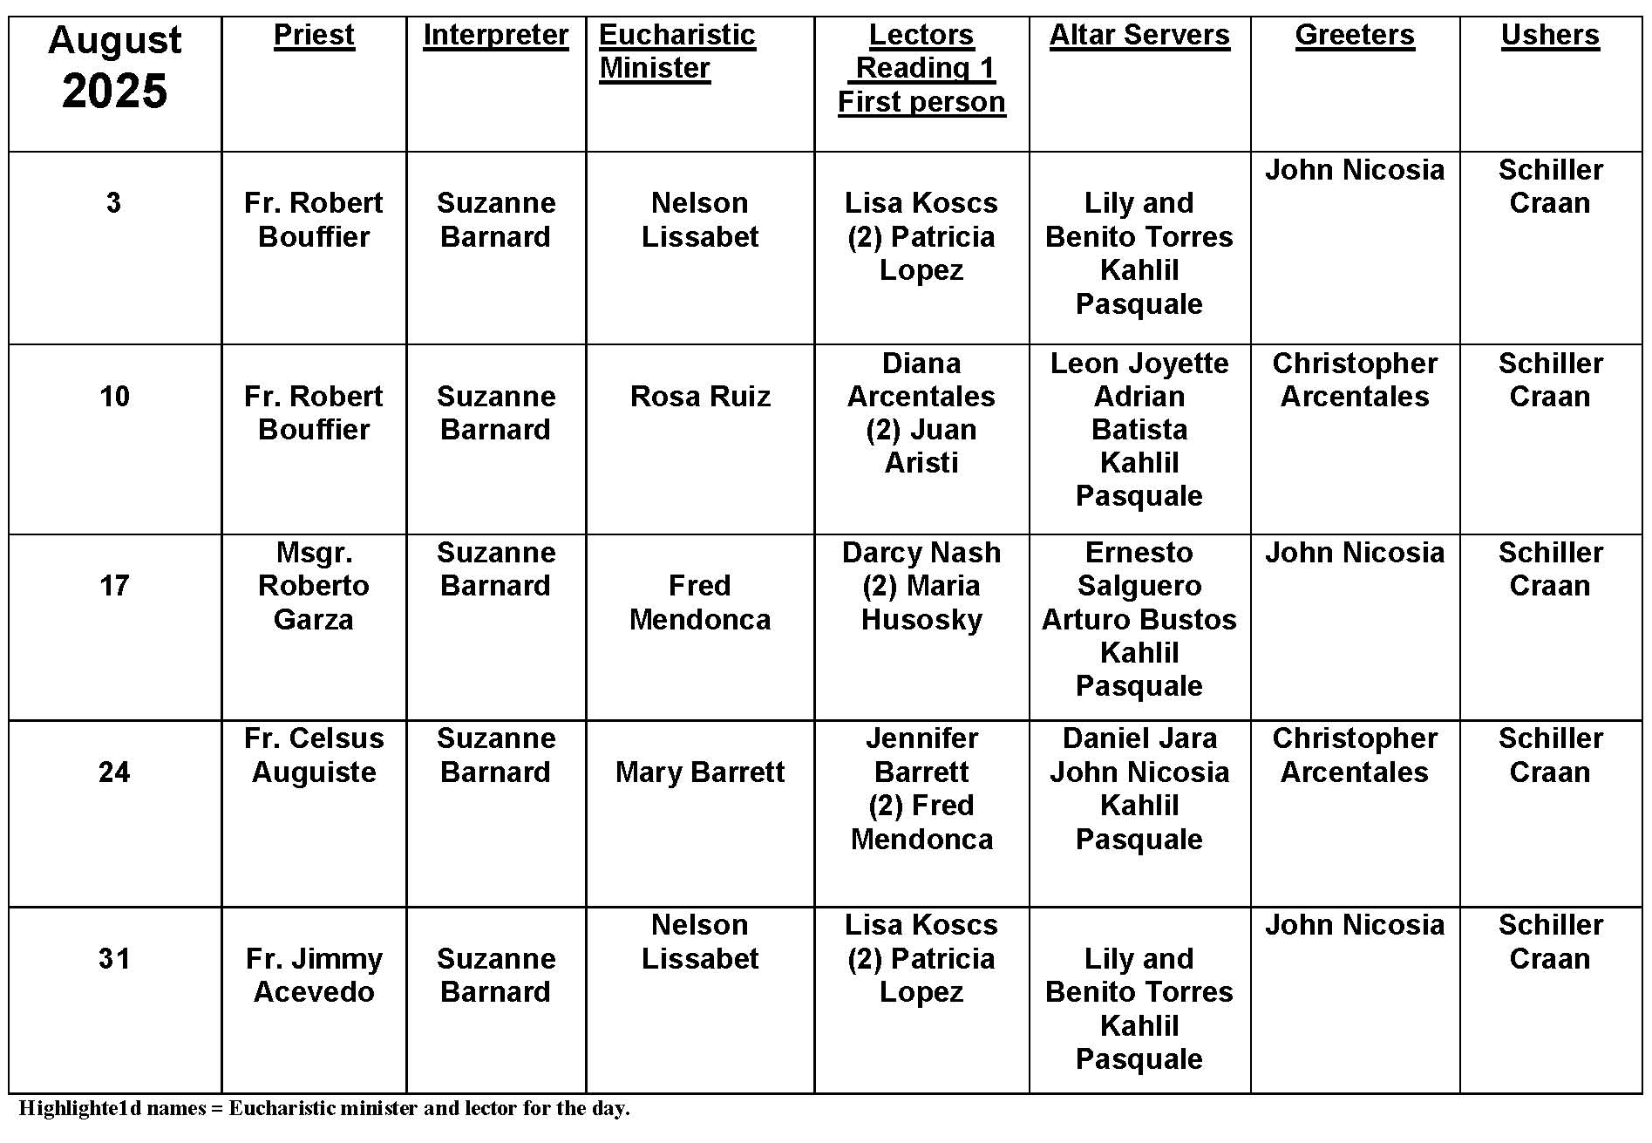
Basilica Versus Cathedral

Question:
What is the difference between a basilica and a cathedral?
Answer:
Basilicas are churches that are so titled because of their antiquity, dignity, historical importance, or significance as centers of worship. A cathedral is the principal church of a diocese, which contains the chair of the bishop, or “cathedra” in Latin. The chair is the symbol of the bishop’s teaching authority.

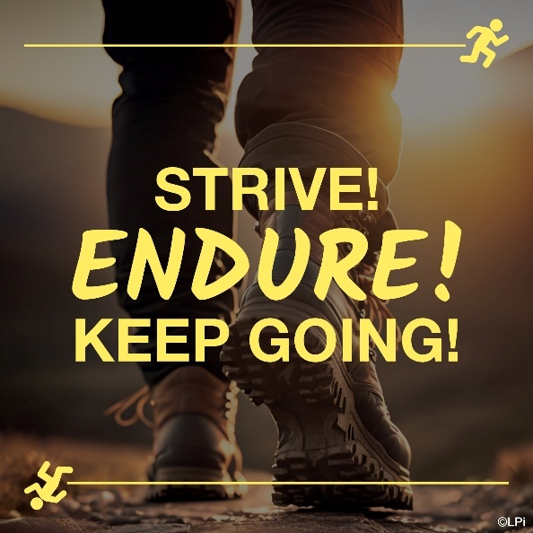
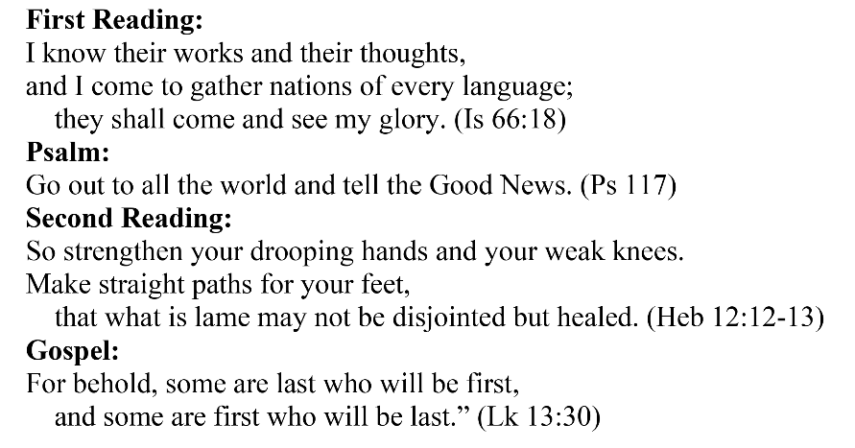
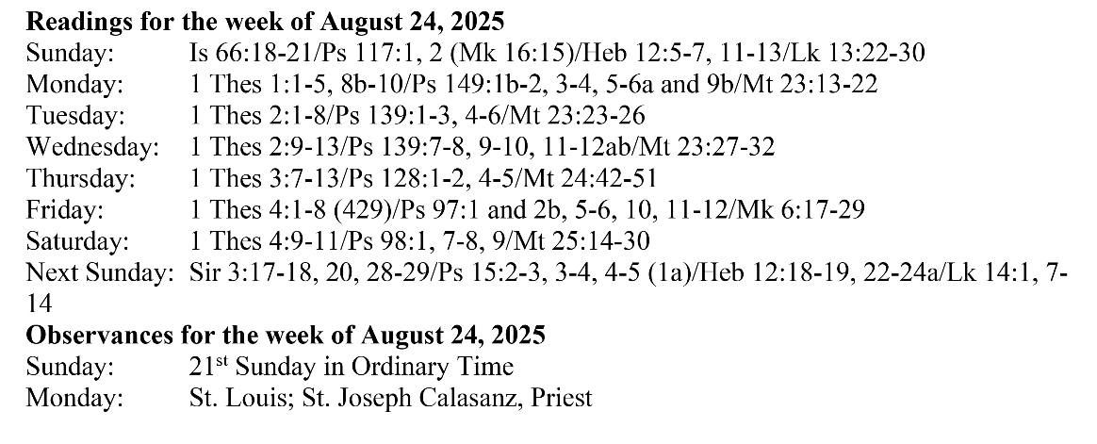
Are you in need of prayer? Do you have a prayer request? You can send your prayer requests to pcuadra@schottcommunities.org or call 954-434-3306 ext. 108

A copy of our prayer list can be found in the lobby of our chapel. To request a copy of our prayer list please email us at pcuadra@schottcommunities.org
To request a Mass please contact Pablo A. Cuadra at 954-434-3306 or e-mail at pcuadra@schottcommunities.org
Update: Celebrating a wedding anniversary soon? Let us know a week in advance and we can assist you with the renewal of your wedding vows.

Prayer to St. Michael the Archangel:
"St. Michael the Archangel, defend us in battle. Be our defense against the wickedness and snares of the Devil. May God rebuke him, we humbly pray, and do thou, O Prince of the heavenly hosts, by the power of God, thrust into hell Satan, and all the evil spirits, who prowl about the world seeking the ruin of souls. Amen"

