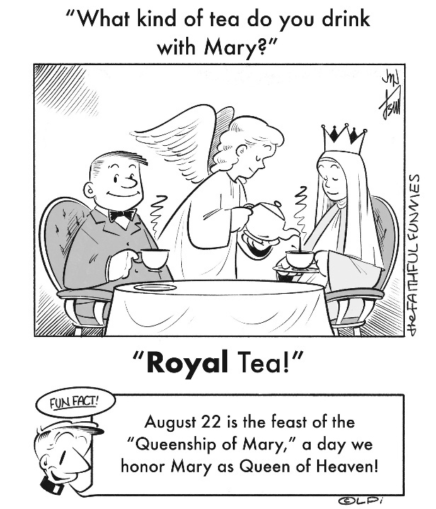
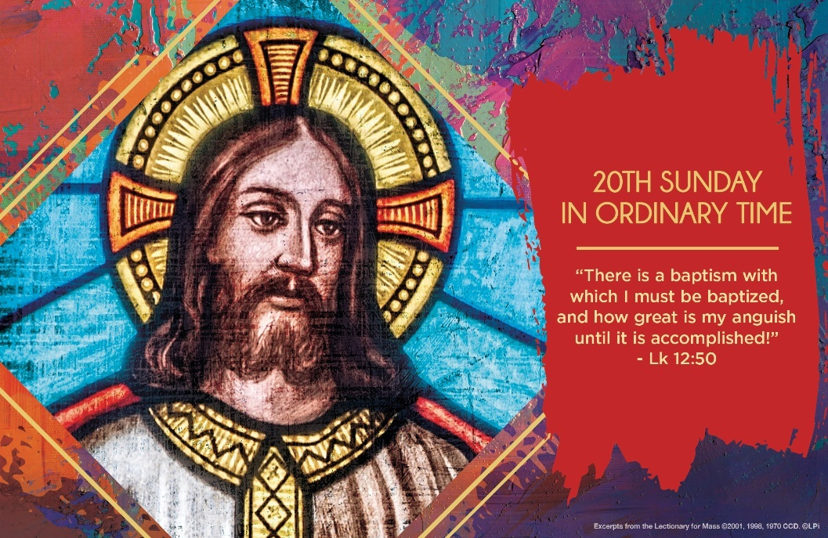
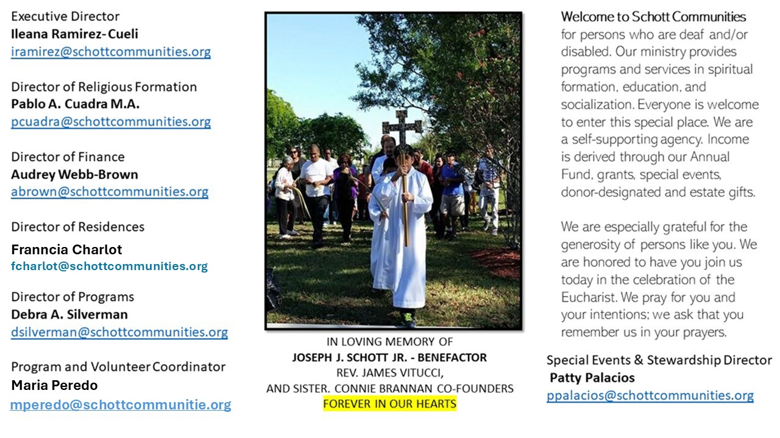

17 de agosto de 2025
XX Domingo del Tiempo Ordinario

La forma como nos llevamos a veces en la familia y con los amigos es dolorosa: pleitos, venganzas, argumentos sin sentido, tan solo para herirnos. Alegamos por política, por deporte, por religión y más. Nos encendemos de la nada; pareciera que traemos fuego para discutir. Perdemos el control de la nada y por nada. Pero el fuego del que Jesús nos habla hoy es diferente. Es el fuego de la justicia, del perdón y de la inclusión: “He venido a traer fuego a la tierra, y ¡cuánto desearía que ya estuviera ardiendo!” (Lucas 12:49). Compartir esa pasión por Jesús es algo que muy pocos entienden. Se trata del fuego del Espíritu Santo en nosotros.
De nuevo se nos repite la misión de Jesús al mundo: “Traer a la tierra el fuego que enciende la vida y mediante el cual el hombre es salvado. Jesús nos llama a difundir en el mundo este fuego, gracias al cual seremos reconocidos como sus verdaderos discípulos” (Papa Francisco). San Juan Crisóstomo (c. 350-407) decía que: “Esto es el fuego del Espíritu Santo: él no tolera que se tenga algún deseo mundano; en cuanto, nos conduce a otro tipo de amor… De hecho, cuando la fuerza de este fuego ha entrado en el alma del hombre, éste expulsa la indiferencia y la pereza”. Dejarnos conducir por el Espíritu Santo es el secreto que nos dispone a dar la cara por la justicia y la paz. De esas divisiones habla Jesús, referente a estar en contra unos de otros en la familia y los amigos. Es que vivir el Evangelio y ser testigos de él dando testimonio divide.

August 17, 2025
20th Sunday in Ordinary Time
Luke 12:49-53

During my baseball career, my best coach often said, “You shouldn’t be worried if I yell at you. Be worried if I don’t. If I stop pushing you, it means I don’t think you have any more potential.” He demanded a lot, and I knew it meant he saw that I could be something special on the baseball field.

Jesus says some demanding words to us this week. “Do you think I have come to establish peace on the earth?” he asks, “No, tell you, but rather division” (Luke 12:51). He wants you and me–in fact, all the earth–to participate in the luminous glory of God. That’s why he speaks of himself as a divine arsonist. Divine fire is like a good coach: it demands the removal of all that obstructs the achievement of the lofty goal.

How is your life demanding right now? That inconvenient family situation, the unfair boss at work, the kids who reject their parents’ wishes, the nagging health issue? Maybe things would be more peaceful devoid of these seemingly arbitrary difficulties. But for us who believe in the one who comes to set the earth of fire, we should be much more worried if he stops demanding so much from us. In fact, let’s thank him for it. He sees how glorious we can become.

— Father John Muir

St. Jude Chapel, Sunday, August 17th, 2025
Monsignor Roberto Garza
Celebrant

Gregorian Chant
Defined by a monophonic (meaning a single melody without harmony or chords), unaccompanied song, Gregorian chant is a form of sacred music used in liturgical settings and prayer. It has been synonymous with Catholic musical worship since the first millennium.


Christian Giving
August 10th 2025
$

We sincerely thank you and bless you for your generosity.
A bequest is a powerful tool to help the Deaf or Disabled.

Mass Intentions
“For the repose of the Souls in Purgatory
Requested by Schott Communities


Follow us on Facebook
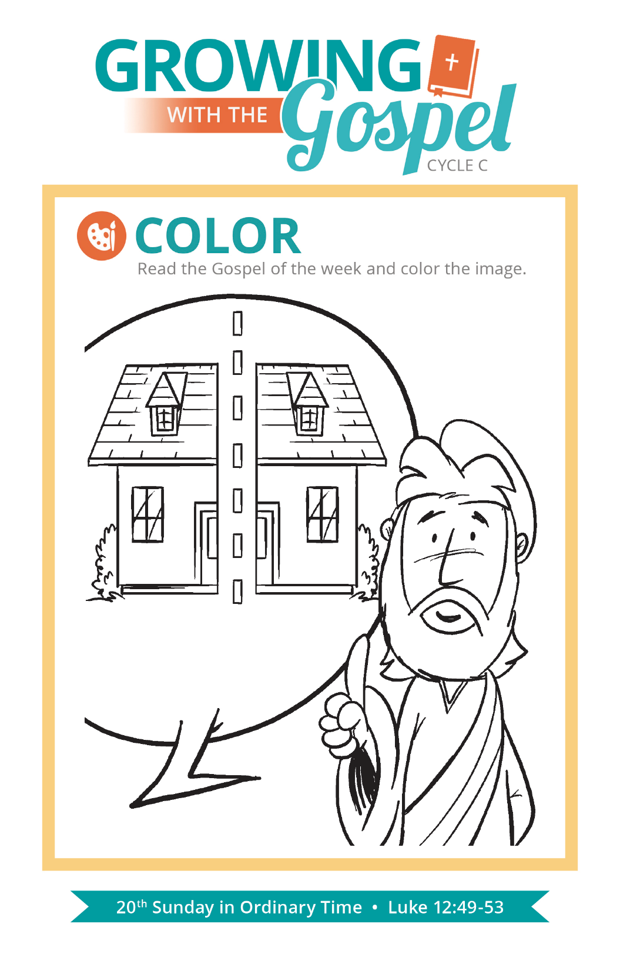
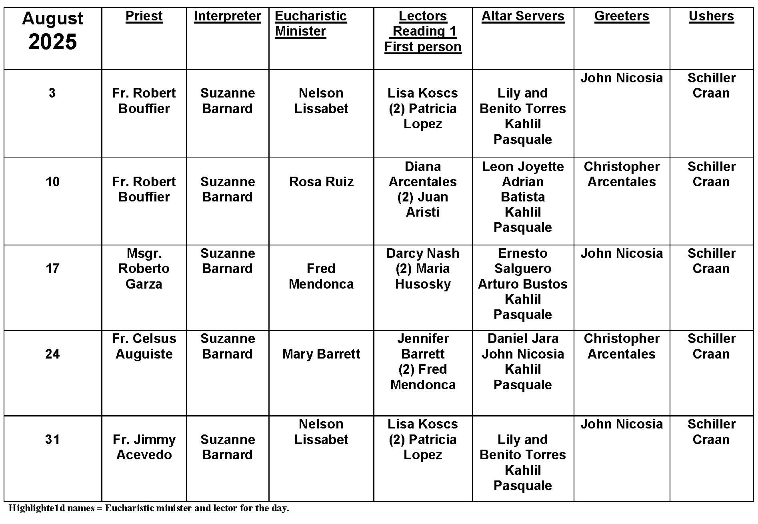
Queenship of Mary

Question:
Why do we have a feast for the Queenship of Mary?

Answer:
For many of us, the language of kings and queens may seem like they belong to history or a medieval movie. Royalty have absolute authority over a kingdom and their subjects, a concept that is foreign to many of us today. While Jesus doesn’t rule a political kingdom, we honor and recognize him as the King of Kings, Lord of Heaven and Earth. To God alone belongs absolute authority over all of existence.

We may think of queens as the spouse of the king, but there is another key relationship: the king’s mother. In Biblical history, we see instances where the mother of the king is given due as a queen herself, complete with a throne! Mary’s guiding influence over her Son is seen most notably in the Wedding Feast at Cana. Mary is not Queen on her own merit. She is “full of grace” and “blessed” in “all ages” because of the reign of her Son.


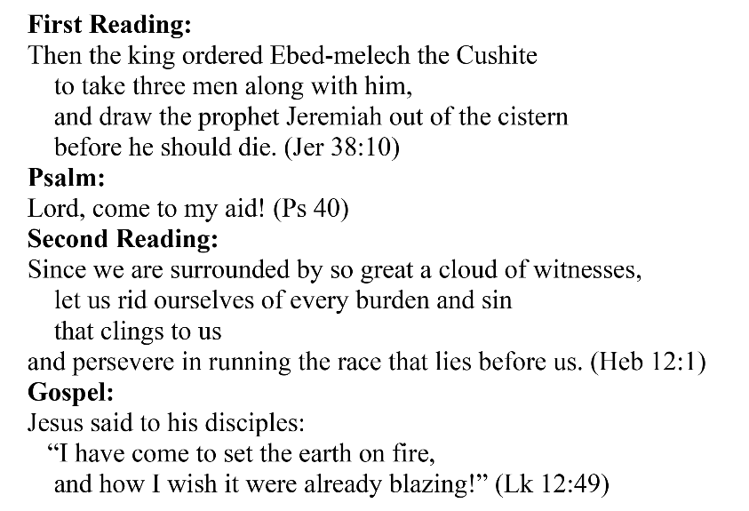
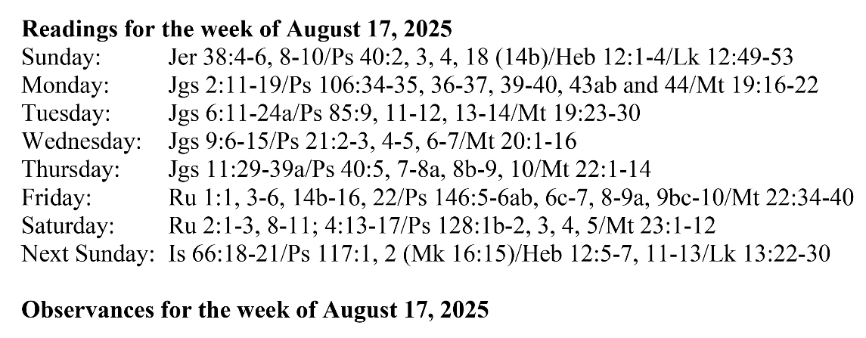
Are you in need of prayer? Do you have a prayer request? You can send your prayer requests to pcuadra@schottcommunities.org or call 954-434-3306 ext. 108

A copy of our prayer list can be found in the lobby of our chapel. To request a copy of our prayer list please email us at pcuadra@schottcommunities.org
To request a Mass please contact Pablo A. Cuadra at 954-434-3306 or e-mail at pcuadra@schottcommunities.org
Update: Celebrating a wedding anniversary soon? Let us know a week in advance and we can assist you with the renewal of your wedding vows.

Prayer to St. Michael the Archangel:
"St. Michael the Archangel, defend us in battle. Be our defense against the wickedness and snares of the Devil. May God rebuke him, we humbly pray, and do thou, O Prince of the heavenly hosts, by the power of God, thrust into hell Satan, and all the evil spirits, who prowl about the world seeking the ruin of souls. Amen"

