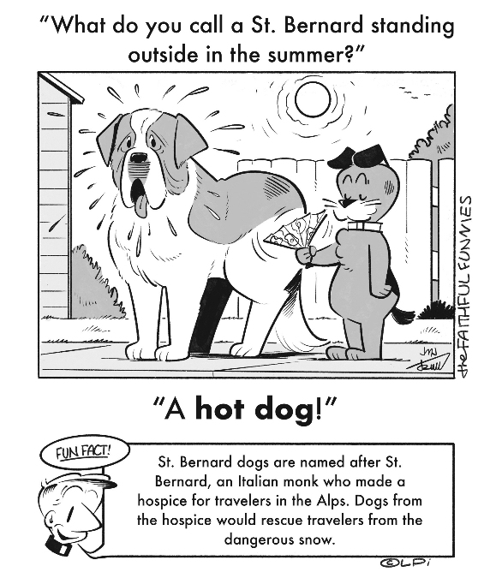
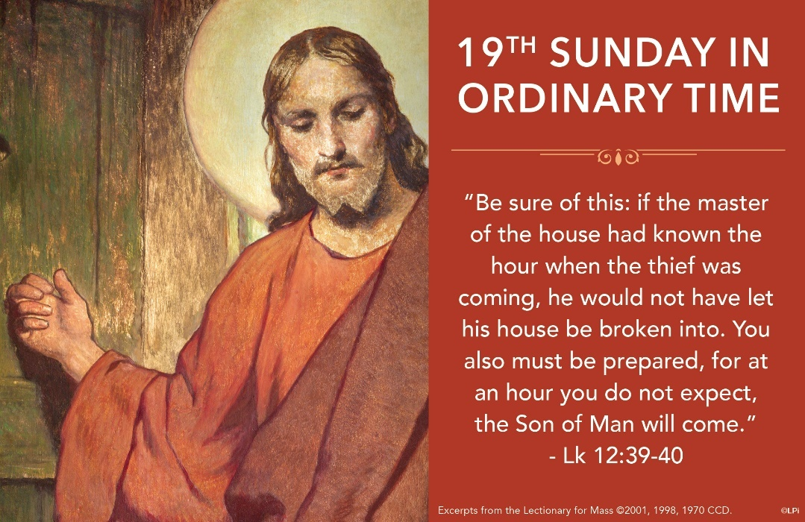
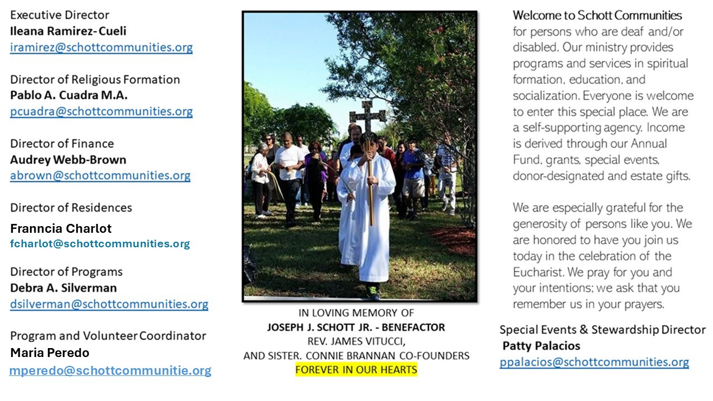

10 de agosto de 2025
XIX Domingo del Tiempo Ordinario

Todos tenemos algo bajo nuestro cuidado: la familia, un enfermo, los padres, los niños. Incluso el lugar en que vivimos, nuestra casa común, nuestro planeta. Dios cuenta con nosotros para dar respuesta al Evangelio de hoy. "Estén preparados", nos dice. "Tengan puesta la ropa de trabajo y sus lámparas encendidas" (Lucas 12:33). Nos pide estar siempre en vela, alertas, preparados para su llegada. Por lo tanto, debemos estar atentos, trabajando en todo lo que nos acerca a Él. Ser fieles a su Palabra implica responsabilidad, implica avivar el fuego de Dios en el corazón de cada persona.
Pedro, como siempre, se anima a preguntar: "Señor, esta parábola que has contado, ¿es sólo para nosotros o es para todos?". Gracias, Pedro, por preguntar. Así, el Señor Jesús afirma que el trabajo y la fidelidad son para todos sin excepción: "Afortunado ese servidor si, al llegar su señor, lo encuentra cumpliendo su deber" (Lucas 12:43). Esta respuesta es una invitación a cooperar en el crecimiento del Reino de Dios, a entusiasmarnos en los proyectos comunitarios que llevan al bien común. "El amor a la sociedad y el compromiso por el bien común son una forma excelente de la caridad, que no solo afecta a las relaciones entre los individuos, sino a las macro relaciones, como las relaciones sociales, económicas y políticas" (Papa Francisco, Laudato Si', 231, septiembre 21, 2023).

August 10, 2025
19th Sunday in Ordinary Time
Luke 12:32-48

There was a young mother in my parish community who was depressed due to financial strain. She prayed for help. One morning before Mass, she placed on the counter a zip-lock bag filled with jewelry and old coins. Smiling, she explained she had been fixing an old cabinet and found the items hidden deep within the walls of her home. One particular coin could be worth as much as $900,000. The contents of the bag–previously unknown to them–were now their prized possession. Their plans changed that week. They had to learn how much it was worth.

This week, the Lord tells us, “For where your treasure is, there also will your heart be” (Luke 12:34). Our lives revolve around what we treasure. When we discover the treasure the Father gives us–the kingdom of God–everything changes. We might not know its precise value, but we rearrange our lives around it. The joy of this discovery should never be far from our minds.

Sometimes we go through times when we can’t find this treasure. It seems hidden. Or it appears like dirty old coins and worthless jewelry in a Ziploc bag. But how crazy would my parishioners be if they tossed it away without knowing the cash value? How much crazier are we if we center our hearts on any treasure except that of Jesus and his kingdom? Remember, the Father is pleased to give it to us. That’s why we put our hearts there, even when it is hidden.

— Father John Muir

St. Jude Chapel, Sunday, August 10th, 2025
Father Robert Bouffier
Celebrant

House Blessing
Catholics who move to a new place of residence often wish to have their dwelling blessed, to call the favor and help of God upon all those who live in the house and all those who will enter it. The Roman Ritual provides two formats for such blessings.

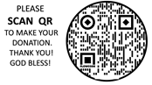
Christian Giving
August 3rd 2025
$

We sincerely thank you and bless you for your generosity.
A bequest is a powerful tool to help the Deaf or Disabled.

Mass Intentions
“For the repose of the Souls in Purgatory
Requested by Schott Communities


Follow us on Facebook
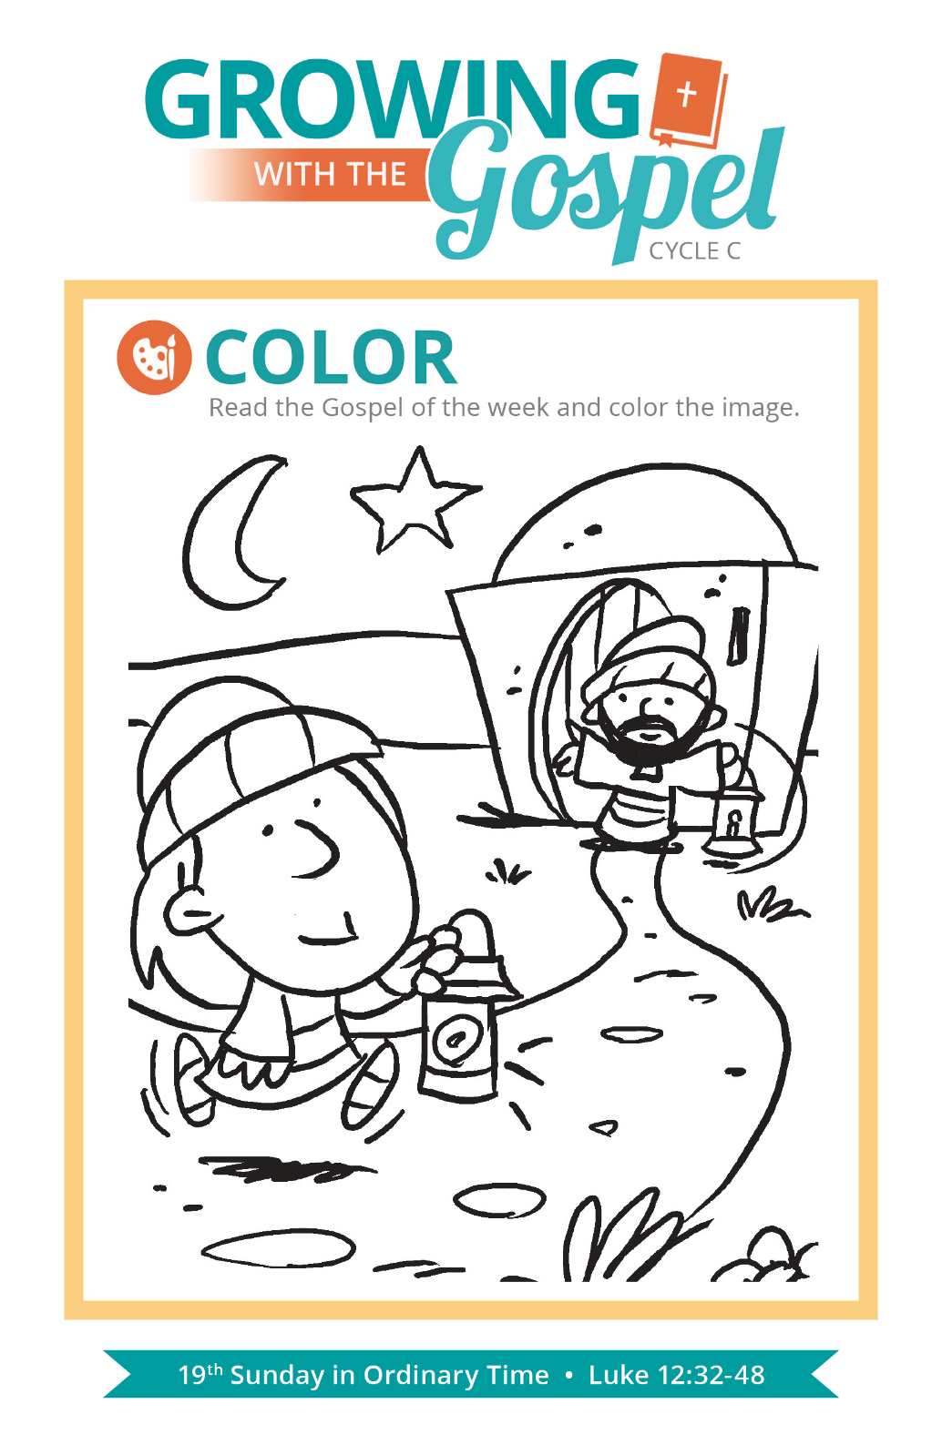
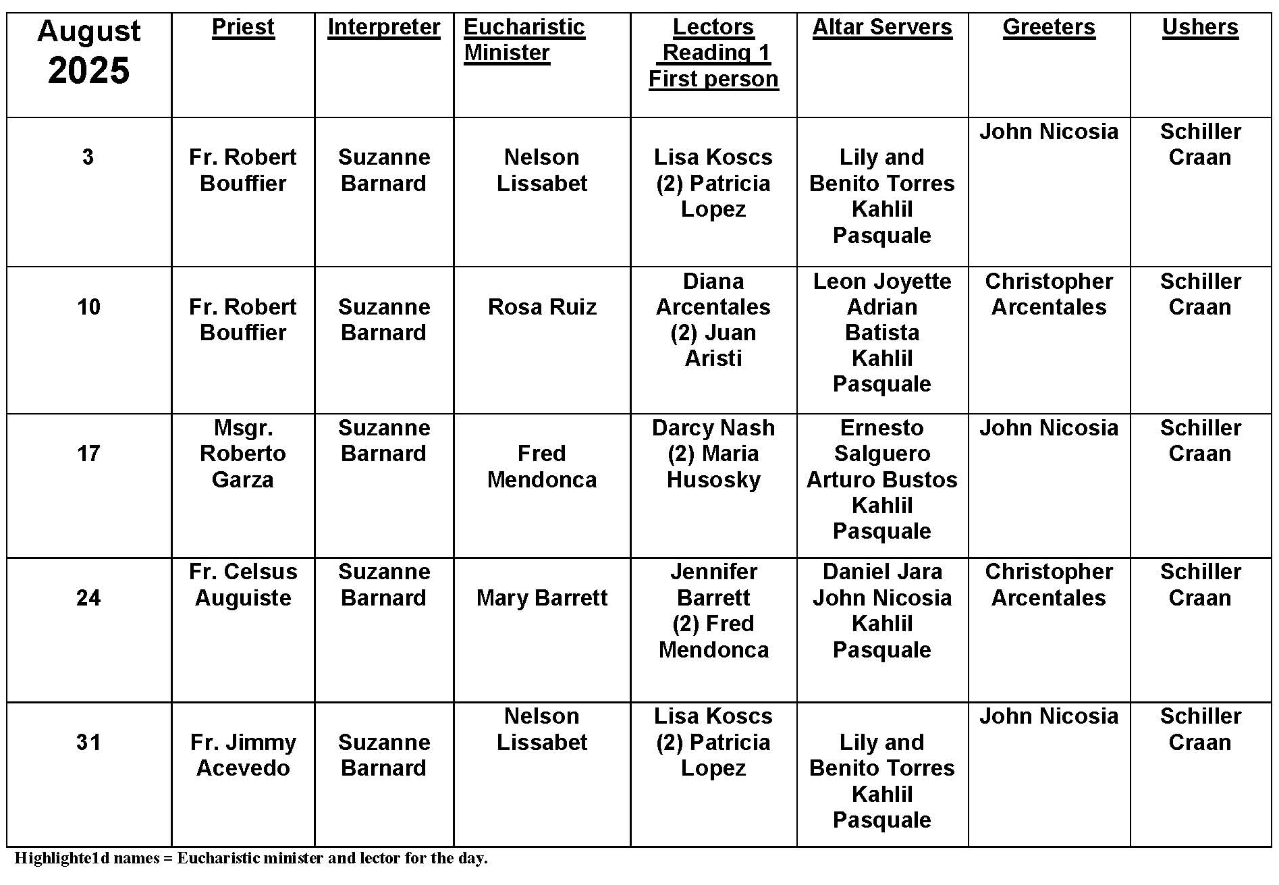
Parish Registration

Question:
Why is it so important that we register in a parish? Isn't it good enough that we go to Mass?
Answer:
Registration is the official way we join a parish community. Many people think that because they attend a particular parish they automatically belong. At times, young adults who have moved away for years think they are still signed up under their parents. But membership requires signing up, formally enrolling yourself in a parish. Registration is a commitment to a community, a way to be included in the religious, social, and ministerial activities of your parish. Your registration affects the parish in many ways. Census numbers can determine how many priests are assigned to a church, what benefits and obligations the community has to the diocese, and how Masses, Confessions, and devotions are planned and scheduled.
Registration shows you belong. It is also necessary for certain benefits, like scheduling sacraments, obtaining sponsor certificates, and getting donation statements for taxes. Most importantly, it lets the parish count on you, to call on you to assist in its mission. Registering in your parish is a statement of faith and confidence in the life and work of your parish.

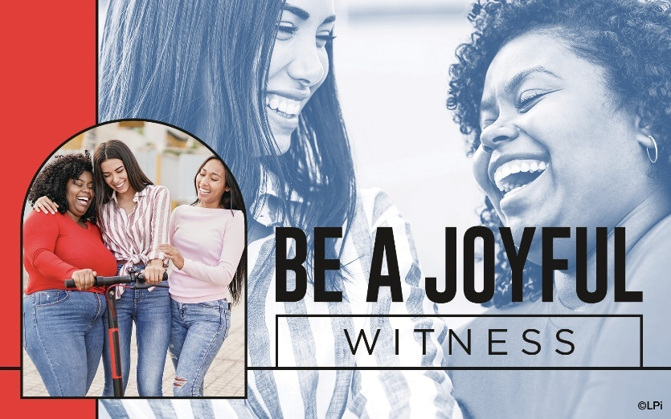
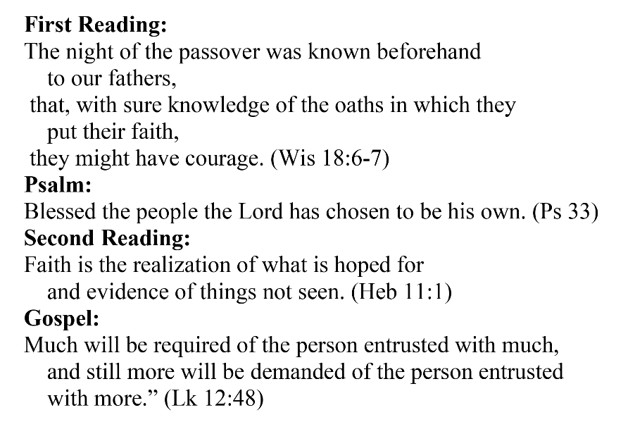
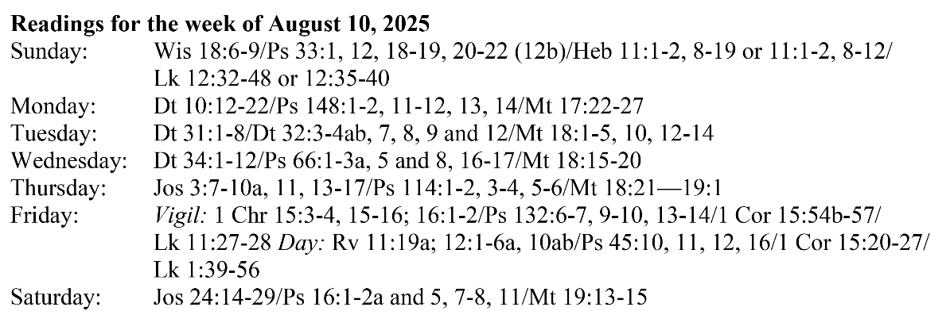
Are you in need of prayer? Do you have a prayer request? You can send your prayer requests to pcuadra@schottcommunities.org or call 954-434-3306 ext. 108

A copy of our prayer list can be found in the lobby of our chapel. To request a copy of our prayer list please email us at pcuadra@schottcommunities.org
To request a Mass please contact Pablo A. Cuadra at 954-434-3306 or e-mail at pcuadra@schottcommunities.org
Update: Celebrating a wedding anniversary soon? Let us know a week in advance and we can assist you with the renewal of your wedding vows.

Prayer to St. Michael the Archangel:
"St. Michael the Archangel, defend us in battle. Be our defense against the wickedness and snares of the Devil. May God rebuke him, we humbly pray, and do thou, O Prince of the heavenly hosts, by the power of God, thrust into hell Satan, and all the evil spirits, who prowl about the world seeking the ruin of souls. Amen"

