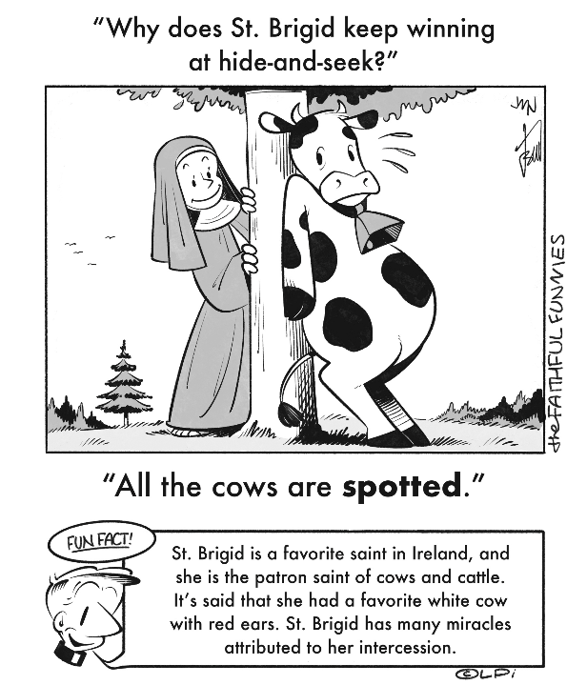
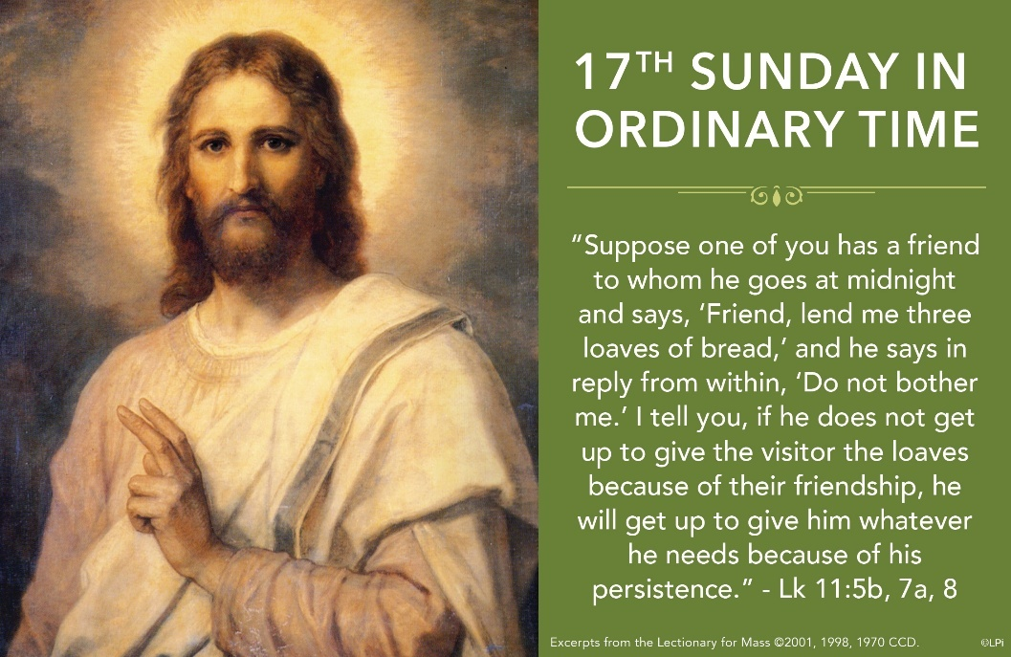
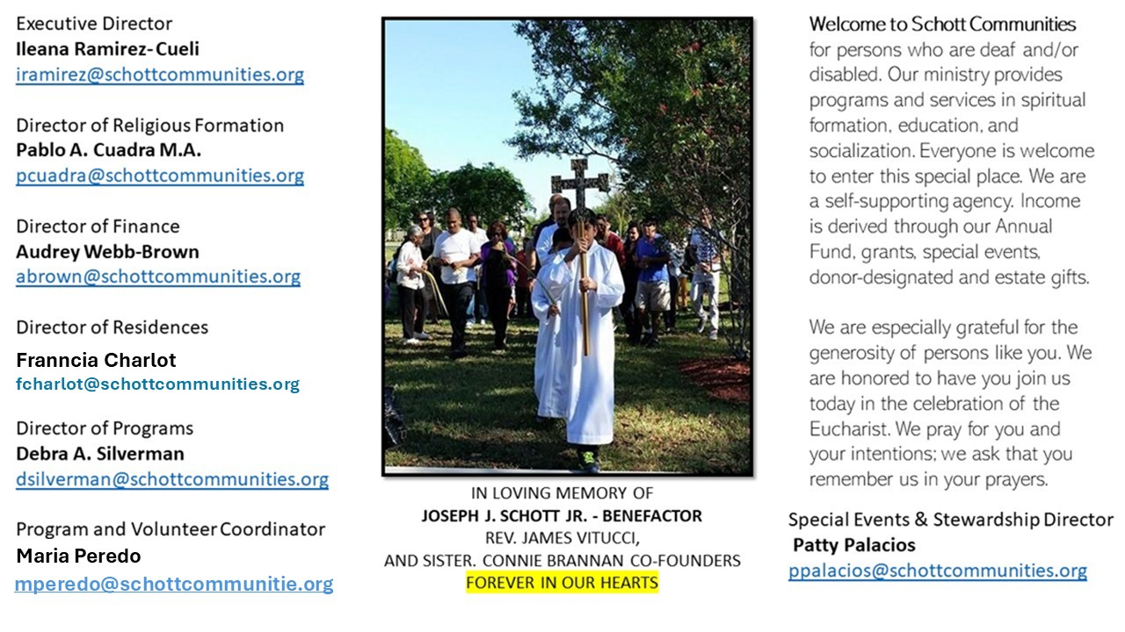

27 de julio de 2025
XVII Domingo del Tiempo Ordinario
¿Te has preguntado alguna vez cuál es la mejor manera de hacer oración? Quizá la respuesta sea "de muchas maneras". A lo mejor explicarás las diferentes formas de hacer oración. Cada persona tiene su experiencia de oración. El Catecismo de la Iglesia Católica, en su número 2564, nos ayuda a comprender mejor lo que es orar: “La oración cristiana es una relación de Alianza entre Dios y el hombre en Cristo. Es la acción de Dios y del hombre; brota del Espíritu Santo y de nosotros, dirigidas por completo al Padre, en unión con la voluntad humana del Hijo de Dios hecho hombre”. Santa Teresa del Niño Jesús, en sus manuscritos autobiográficos, decía sobre su experiencia de oración (C25 r.): “Para mí, la oración es un impulso del corazón, una sencilla mirada hacia el cielo, un grito de agradecimiento y de amor tanto desde dentro de la prueba como desde dentro de la alegría”.
El Catecismo de la Iglesia Católica, en su número 2759, nos enseña: “Estando él [Jesús] en cierto lugar, cuando terminó, le dijo uno de sus discípulos: ‘Maestro, enséñanos a orar, como enseñó Juan a sus discípulos’” (Lucas 11:1). En respuesta a esta petición, el Señor confía a sus discípulos y a su Iglesia la oración cristiana fundamental. San Lucas da de ella un texto breve (con cinco peticiones [Lucas 11:2-4]). San Mateo nos transmite una versión más desarrollada (con siete peticiones [Mateo 6:9-13]). La tradición de la Iglesia ha conservado el texto de San Mateo. El Padrenuestro es fundamental para todo cristiano. Recémoslo siempre con fe.

July 27, 2025
17th Sunday in Ordinary Time
Luke 11:1-13

Once I went to a hospice facility to celebrate Last Rites for an elderly dying man. His family had told me that he had been uncommunicative for days. At the conclusion of the ritual, we began to recite the Our Father prayer. To everyone’s surprise, his lips moved, clearly mouthing the words to the Lord’s prayer. Stripped of most of his faculties, the man could still pray those precious God-given petitions. A lifetime of prayer had planted the words even deeper than his failing consciousness.

Do we want the Lord’s prayer to be as deeply embedded in us? If we want to be people of hope, we should. Recall that our Lord immediately follows the prayer by saying: “Ask, and it will be given to you; search, and you will find; knock, and the door will be opened to you” (Luke 11:9). We only ask, search and knock because we hope that the request is not in vain. Everything we could possibly hope for is contained in the prayer. Praying the Our Father deepens our hope.

We should consciously pour all our hopes into the Lord’s prayer; we should allow it to be an expression of hope, not simply rote words. Then, over time, it builds up our hope in God. It sinks deep into our souls and bodies. How blessed we are when these words of hope are on our lips, even when everything else seems to fail.

— Father John Muir

St. Jude Chapel, Sunday, July 27th, 2025
Father Robert Bouffier
Celebrant

St. Peter Julian Eymard
St. Peter Julian Eymard, known as "Apostle of the Eucharist,” founded the Society of the Blessed Sacrament and the Servants of the Blessed Sacrament. He promoted perpetual adoration, inspired those estranged from the Church to return, and worked to educate all about Christ.


Christian Giving
July 20th 2025
$

We sincerely thank you and bless you for your generosity.
A bequest is a powerful tool to help the Deaf or Disabled.

Mass Intentions
“For the repose of the Souls in Purgatory
Requested by Schott Communities


Follow us on Facebook
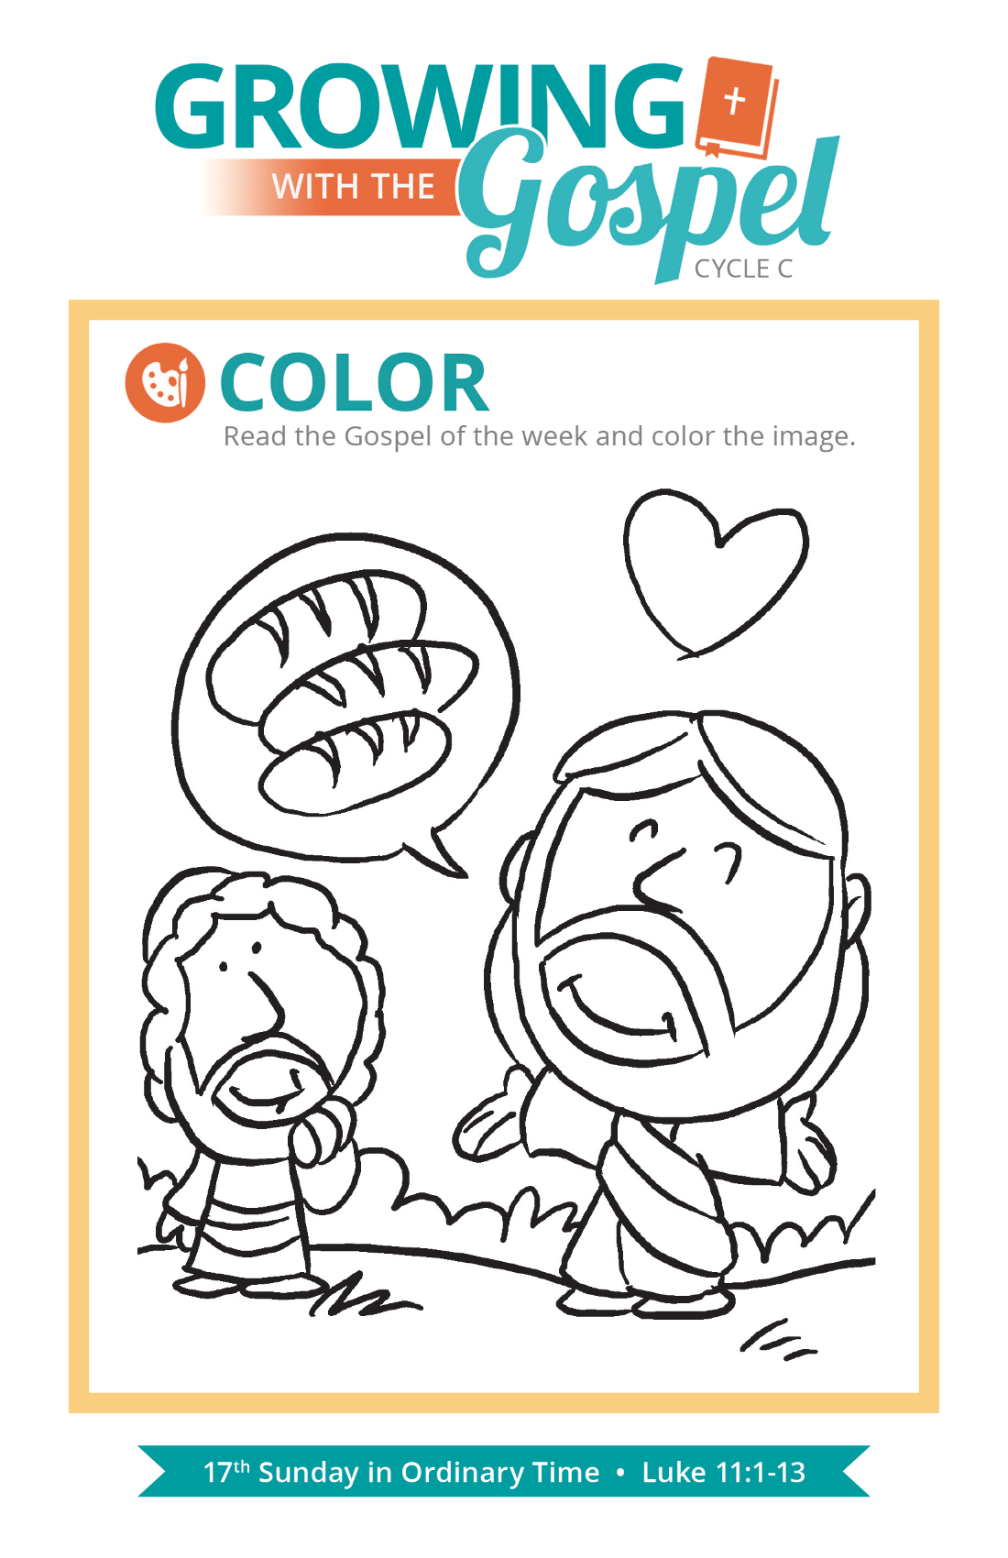
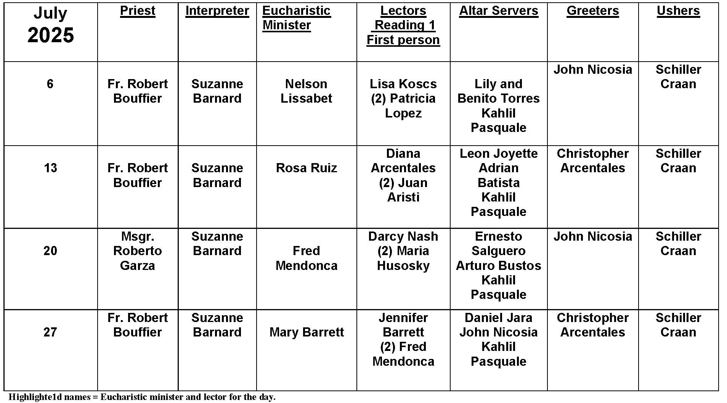
Weddings

Question:
This time of year, I attend a lot of weddings. Why do Catholic weddings need to take place in a church?

Answer:
Technically, there is a clause in Church law that could allow for weddings to take place outside of a church, in a suitable space under special circumstances, but it requires the rare permission of the bishop. But the meaning of marriage goes very, very deep, and the Church has a vested interest in protecting that meaning. As Catholics, we don’t see a wedding as an event that needs a pleasing backdrop.

Marriage is a sacrament, both an occasion of joyful promise and symbolic solemnity. It is a spiritual event. The loving bond of marriage symbolizes the mystical union between Christ and his Church. The man and woman profess lifelong vows of fidelity, and they receive supernatural grace from God to keep their promises. Receiving the sacrament of Marriage in a church has broader symbolic meaning for the couple as well. Marriage isn’t simply two people in isolation from the world around them. Marriage is the joining of families and the beginning of a new, holy mission in the life of the couple. Weddings are sacred occasions, and it’s fitting that they occur in sacred spaces.

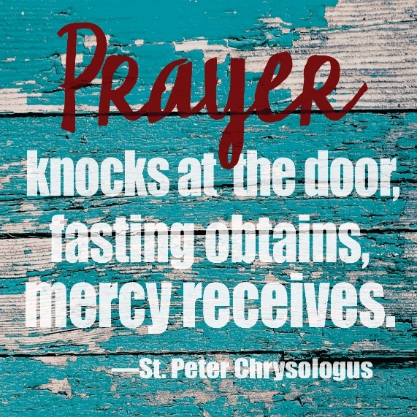
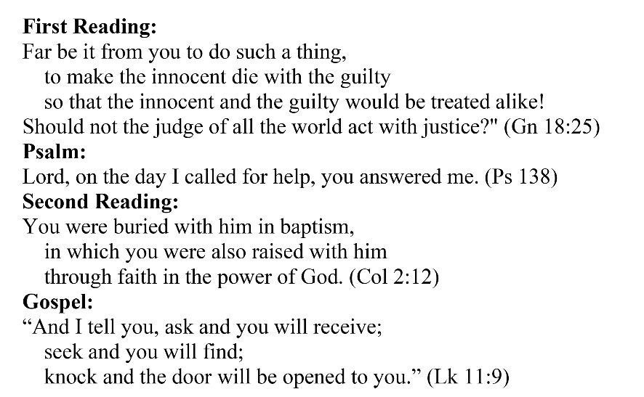
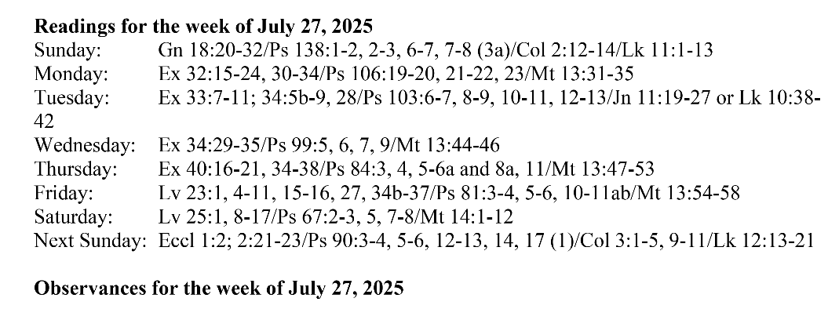
Are you in need of prayer? Do you have a prayer request? You can send your prayer requests to pcuadra@schottcommunities.org or call 954-434-3306 ext. 108

A copy of our prayer list can be found in the lobby of our chapel. To request a copy of our prayer list please email us at pcuadra@schottcommunities.org
To request a Mass please contact Pablo A. Cuadra at 954-434-3306 or e-mail at pcuadra@schottcommunities.org
Update: Celebrating a wedding anniversary soon? Let us know a week in advance and we can assist you with the renewal of your wedding vows.

Prayer to St. Michael the Archangel:
"St. Michael the Archangel, defend us in battle. Be our defense against the wickedness and snares of the Devil. May God rebuke him, we humbly pray, and do thou, O Prince of the heavenly hosts, by the power of God, thrust into hell Satan, and all the evil spirits, who prowl about the world seeking the ruin of souls. Amen"

