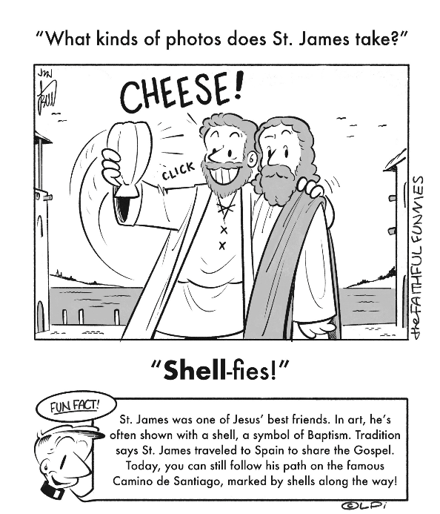
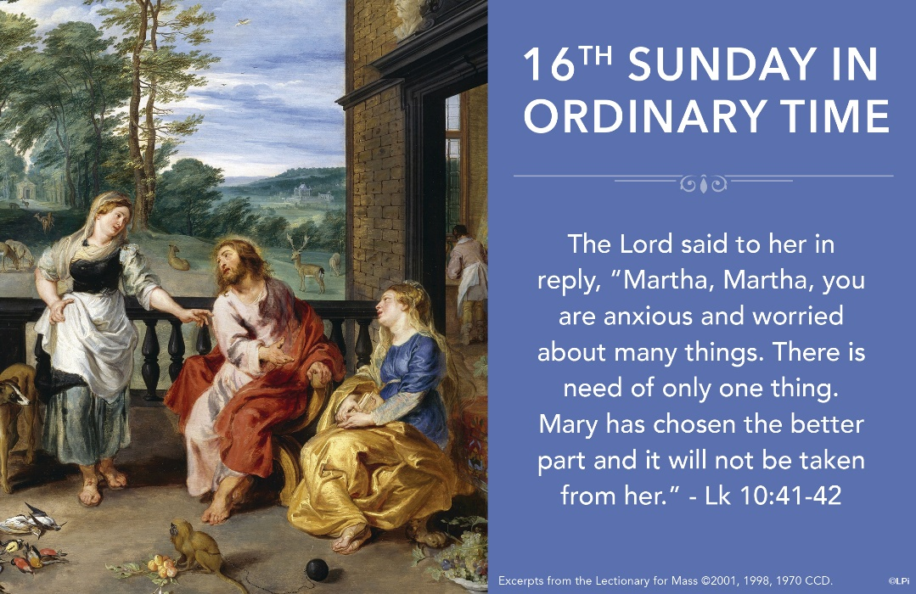
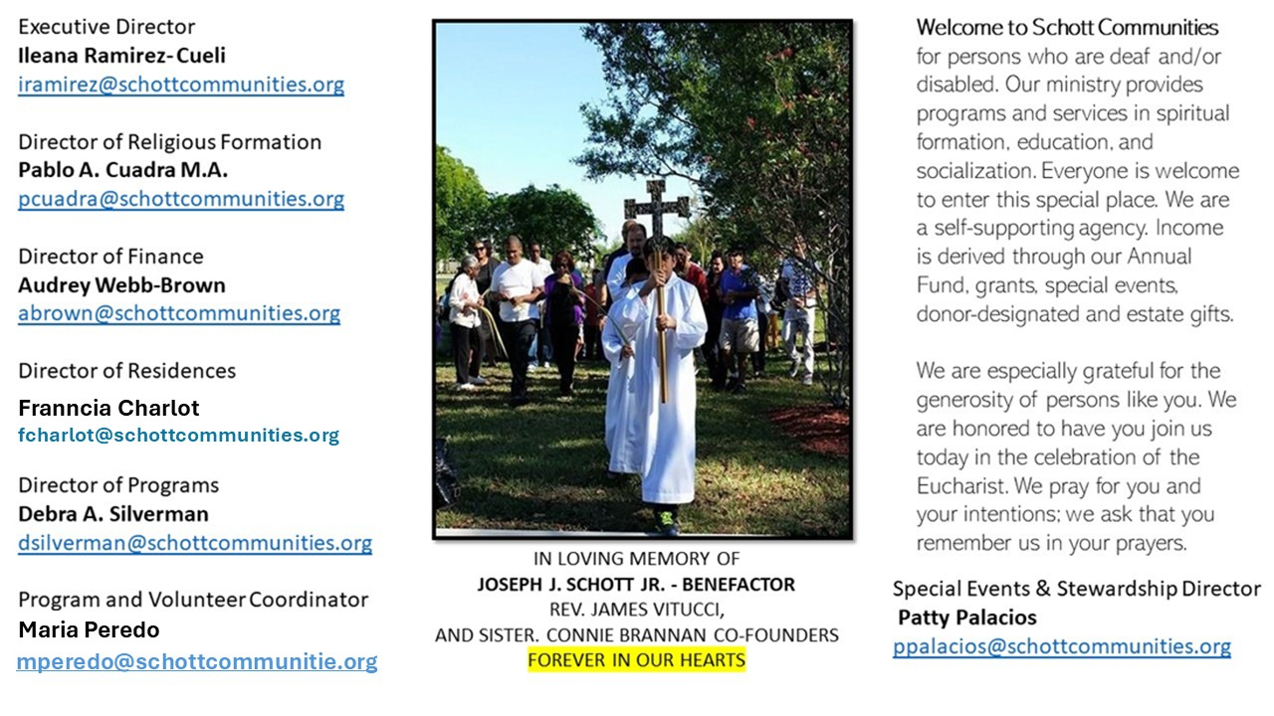

20 de julio de 2025
XVI Domingo del Tiempo Ordinario
En este domingo, la liturgia de la Palabra nos invita a escuchar cuidadosamente la forma de recibir a los huéspedes. En la primera lectura, Abraham recibe al Señor con gran entusiasmo y le prepara un gran banquete. Dios se detiene, conversa con él y le hace la promesa de que, a su vuelta, Sara, su mujer, tendrá un hijo. “Dentro de un año volveré por aquí, y entonces Sara, tu mujer, tendrá un hijo” (Génesis 18:10). “El Señor siempre nos sorprende: cuando empezamos a escucharlo realmente, las nubes se desvanecen, las dudas dan paso a la verdad, los miedos a la serenidad y las diferentes situaciones de la vida encuentran su lugar que les corresponde. El Señor siempre, cuando viene, arregla las cosas, incluso para nosotros” (Papa Francisco).
San Agustín lo expresa de la siguiente manera en su Sermón 255: “Esta dulcísima tarea había escogido para sí María, que se mantenía inactiva; a la vez aprendía y alababa. En cambio, Marta estaba ocupada en muchas cosas. Lo que hacía era ciertamente necesario, pero pasajero: cosas para el camino, aún no las propias de la vida futura; se ocupaba del viaje, aún no de lo que iba a poseer. Había recibido, en efecto, al Señor y a cuantos iban con él”. Y continúa, diciendo, explicando el texto de este domingo: “Se dignó ser recibido como huésped no por necesidad, sino por benevolencia. ¿Qué dará Dios a los que lo sirven, lo adoran, creen en él, en él ponen su esperanza y a él aman?”

July 20, 2025
16th Sunday in Ordinary Time
Luke 10:38-42

One of my close friends is a hermit priest who lives on a desert mountain. Recently I found myself in a group conversation about him. One vehemently objected, “What does he do up there all day? Nothing! Priests are down here working, running parishes, making a difference, and he…he is doing nothing! What a waste.” The words dripped with indignation and resentment. Most of the group quietly nodded in silent agreement. Were they correct?

No! To see why, consider a similar scenario in this week’s gospel. Jesus visits his friends Martha and Mary. A hardworking and exasperated Martha complains to Jesus that her sister is attending to him rather than to urgent household tasks. Our Lord, rather than praising hospitality, explicitly celebrates the less-productive sister for doing the “one necessary thing.” He praises her for she “has chosen the better part” (Luke 10:42). Mary is busy doing what matters.

Before we freak out like Martha, consider that all work–domestic, manual, professional, ministerial, contemplative–is done to help us (sooner or later) to experience the love that makes us happy. We should be thankful for those who focus on the “better part” of radical, ceaseless prayer. They invite us to remember the purpose of all work is the enjoyment of love. Contemplatives, hermits, anyone fervently committed to prayer–they invite us to cast aside our forgetful, resentful, and self-aggrandizing attitudes in exchange for hearts ready to do what is finally necessary.

— Father John Muir

St. Jude Chapel, Sunday, July 20th, 2025
Monsignor Roberto Garza
Celebrant

St. Bridget Prayers
The St. Bridget Prayers evoke the imagery of Christ’s suffering and death, plead for the forgiveness of the supplicant’s sins, for a happy death, for fear and love of the Lord, and for a renunciation of worldly desires.


Christian Giving
July 13th 2025
$495

We sincerely thank you and bless you for your generosity.
A bequest is a powerful tool to help the Deaf or Disabled.

Mass Intentions
“For the repose of the Souls in Purgatory
Requested by Schott Communities


Follow us on Facebook
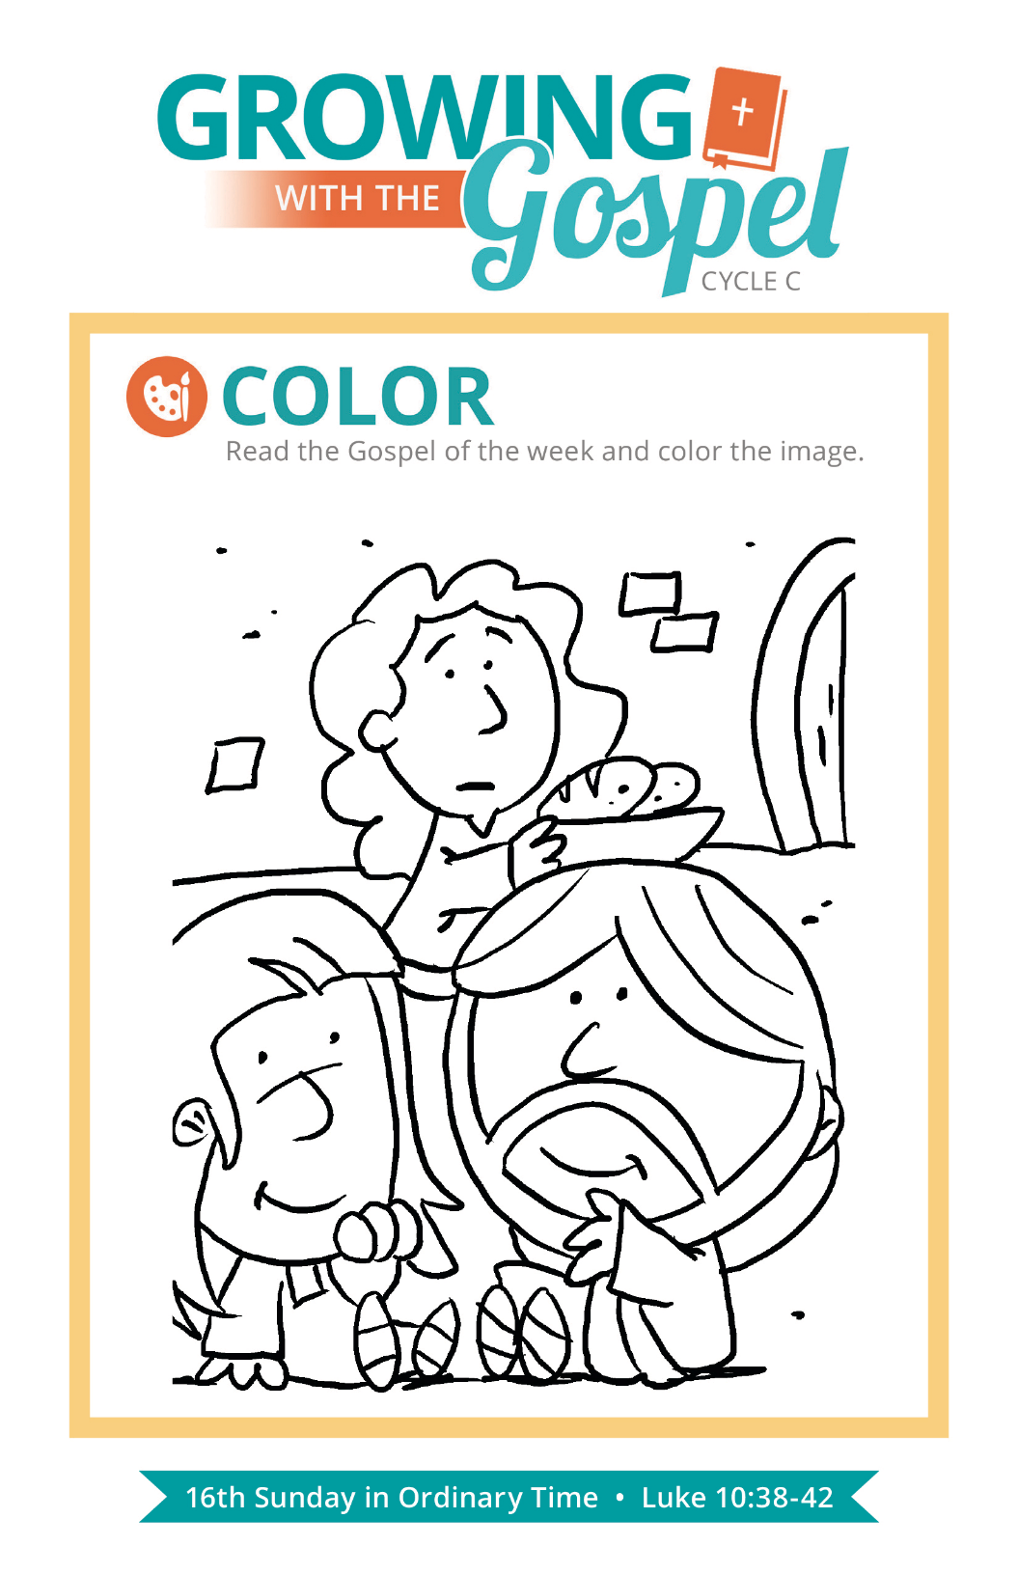
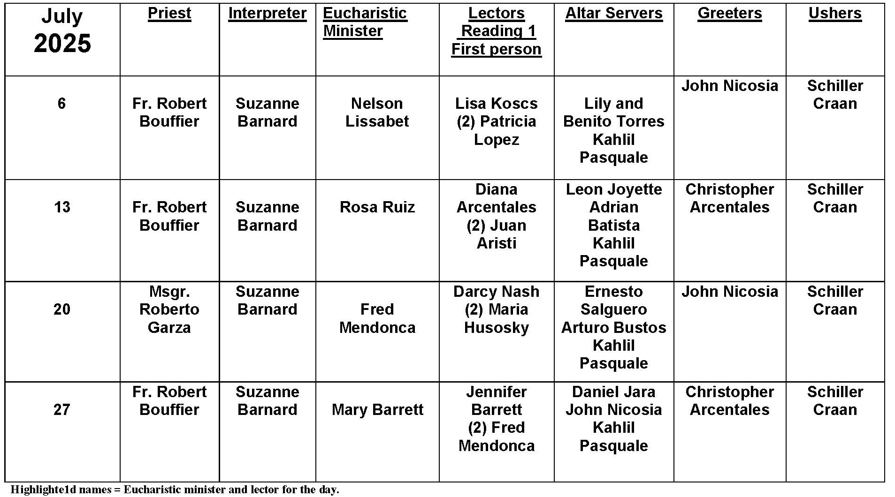
Mary Magdalene

Question:
July 22 is the feast of Mary Magdalene. I’ve heard a lot of stories about her, but who was she really?

Answer:
Mary Magdalene has been the subject of speculation and scholarship over the last 2,000 years. Mary Magdalene makes her first named appearance in Luke 8:2. She is one of several women following Jesus. Luke specifically mentions that Mary had previously been delivered from demonic possession. Whatever her life looked like before she met Jesus, it wasn’t good! Because of this association with being a repentant sinner, Mary Magdalene has been associated with other similar stories in the Gospel, such as the woman caught in adultery or the woman who bathes Jesus’ feet with her tears.

Mary Magdalene shows up again by name at the end of the Gospels, when she stands with the Blessed Virgin Mary at the foot of the Cross. Mary is also present in the garden of the resurrection. She is one of the woman who goes to bring spices to Jesus’ tomb, where they find the stone rolled away. Mary stays in the garden weeping, believing his body has been stolen. Jesus approaches her and calls her by name, and she becomes the first witness to the resurrection! While many of the details of Mary Magdalene’s life have been lost to time, she is an example of powerful conversion, deep faith, and intimate love for Christ.

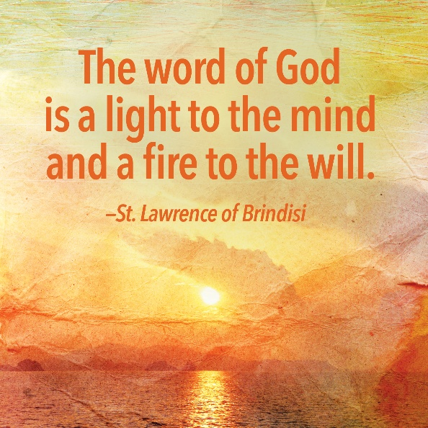
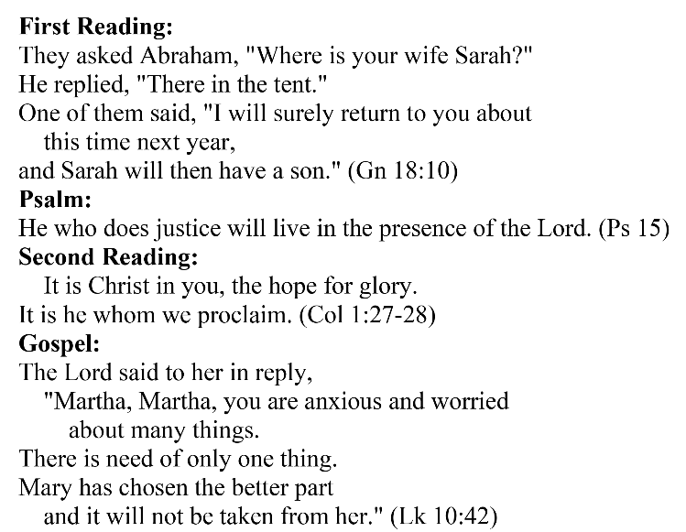
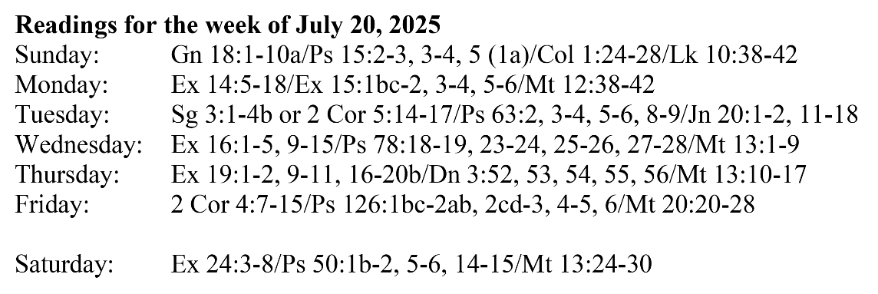
Are you in need of prayer? Do you have a prayer request? You can send your prayer requests to pcuadra@schottcommunities.org or call 954-434-3306 ext. 108

A copy of our prayer list can be found in the lobby of our chapel. To request a copy of our prayer list please email us at pcuadra@schottcommunities.org
To request a Mass please contact Pablo A. Cuadra at 954-434-3306 or e-mail at pcuadra@schottcommunities.org
Update: Celebrating a wedding anniversary soon? Let us know a week in advance and we can assist you with the renewal of your wedding vows.

Prayer to St. Michael the Archangel:
"St. Michael the Archangel, defend us in battle. Be our defense against the wickedness and snares of the Devil. May God rebuke him, we humbly pray, and do thou, O Prince of the heavenly hosts, by the power of God, thrust into hell Satan, and all the evil spirits, who prowl about the world seeking the ruin of souls. Amen"

