
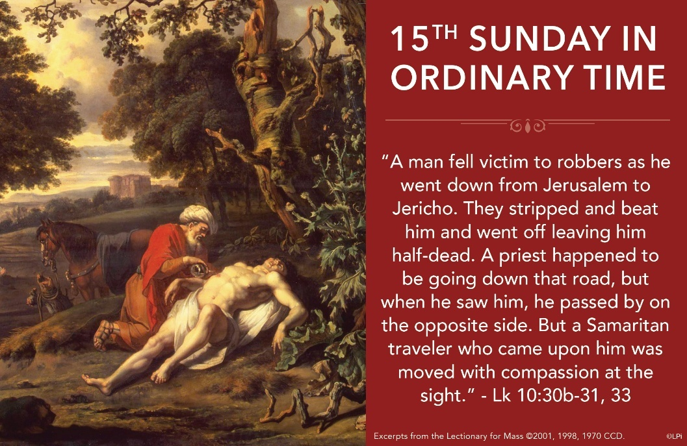
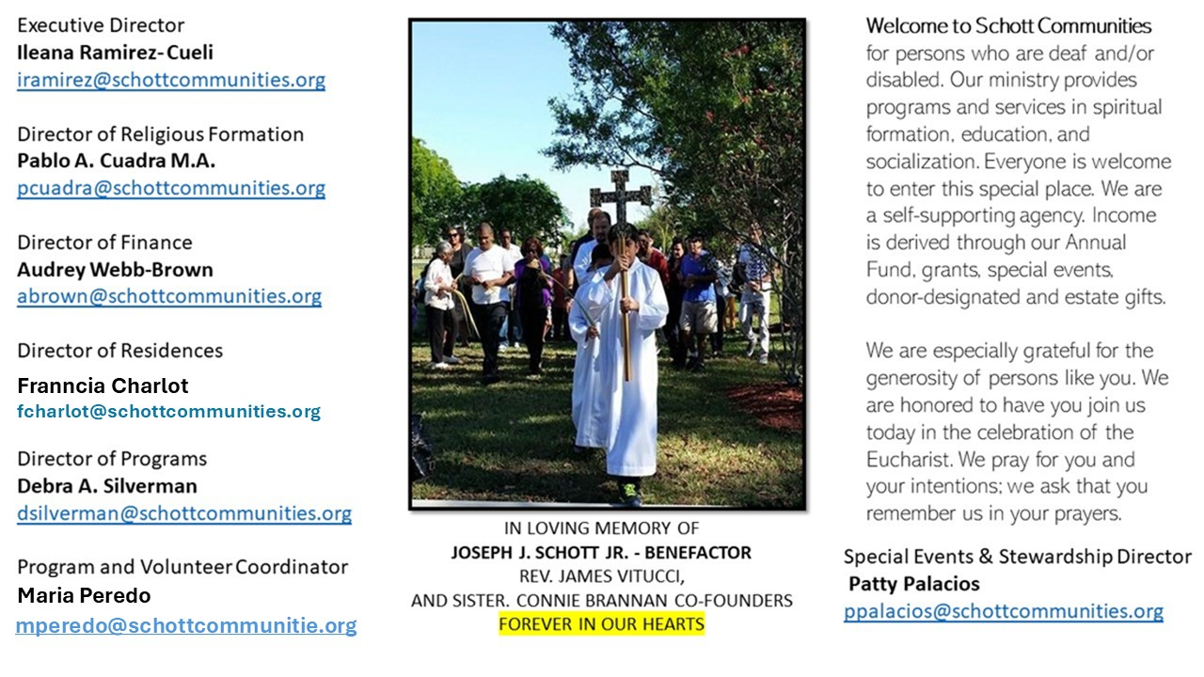

13 de julio de 2025
XV Domingo del Tiempo Ordinario
“Vete y haz tú lo mismo” (Lucas 10:37). Esta parábola es muy rica en enseñanza. Si revisamos nuestra propia vida, descubriremos que en diferentes circunstancias actuamos como los personajes representados en ella. ¿Cuántas veces hemos sido como el que pasó de largo y se hizo el que no vio lo que pasaba? Y lo hacemos con frecuencia en la propia familia: vemos el sufrimiento y pensamos: "Solo les pasa a ellos por no poner cuidado o por tontos." Hoy pongamos atención en el posadero que, al pedido del buen samaritano, cumplió con su trabajo al pie de la letra. En lenguaje actual se llama responsabilidad y cuidado. Pidamos al Señor que nos dé la apertura e iniciativa del samaritano, pero también la responsabilidad del posadero, para que sanara el hombre que fue asaltado.
¿Cuántas veces nosotros damos rodeos para ayudar a alguien en necesidad? ¿Qué podemos aprender hoy de esta enseñanza de Jesús? El hombre no tiene nombre, precisamente, porque nos representa a cualquiera de nosotros que necesita cuidado. Hombre o mujer de cualquier raza o nación está implícito en esta parábola. ¡Es la historia de la humanidad a través de los años! Sin embargo, existe otro pequeño detalle para dar ayuda al que está en apuros: acercarte y escuchar su historia para poder curar sus heridas. A veces nos toca pagar a alguien para que haga el trabajo; otras veces, hacerlo nosotros. Y es ahí donde está el secreto: hacerlo juntos en Cristo.

July 13, 2025
15th Sunday in Ordinary Time
Luke 10:25-37

I used to be a bad neighbor. I’d get wrapped up in my life and ignore those around me. Then I found sage advice from Benjamin Franklin to this effect: to be a better neighbor, ask someone to do a favor for you. It’s counterintuitive, isn’t it? Tell strangers that I need their help? Yuck. I’ll risk looking needy. Worse, I’ll be indebted to them. But I tried it, and it works like a charm. Recently I asked my neighbor Alan for a hacksaw, and Inga for an egg. They kindly obliged, and our friendship is growing.

This week we hear a scribe of the law cynically ask Jesus, “And who is my neighbor?” (Luke 10:29). Like him, we prefer to keep the list of our “neighbors” as short as possible. It requires less interruption and inconvenience. But when Jesus tells the parable of the Good Samaritan, he exposes the lonely, cold-heartedness tendency of the scribe’s (and our) heart. My “neighbor” is anyone I encounter who manifests a concrete need. There isn’t time to require any other credential because human need opens us to the happy reciprocity which is love.

Jesus’ words challenge us this week to ask a neighbor for help in some small way. How marvelous that God himself shows us how. He moves into our world and asks us to love Him with small deeds of love. Maybe that’s where Ben Franklin got the idea.

— Father John Muir

St. Jude Chapel, Sunday, July 13th, 2025
Father Robert Bouffier
Celebrant

Spiritual Direction
Spiritual direction is the practice of seeking counsel from someone who is learned in the faith for the purpose of discerning the will of God in one’s life.


Christian Giving
July 6th 2025
$

We sincerely thank you and bless you for your generosity.
A bequest is a powerful tool to help the Deaf or Disabled.

Mass Intentions
“For the repose of the Souls in Purgatory
Requested by Schott Communities


Follow us on Facebook
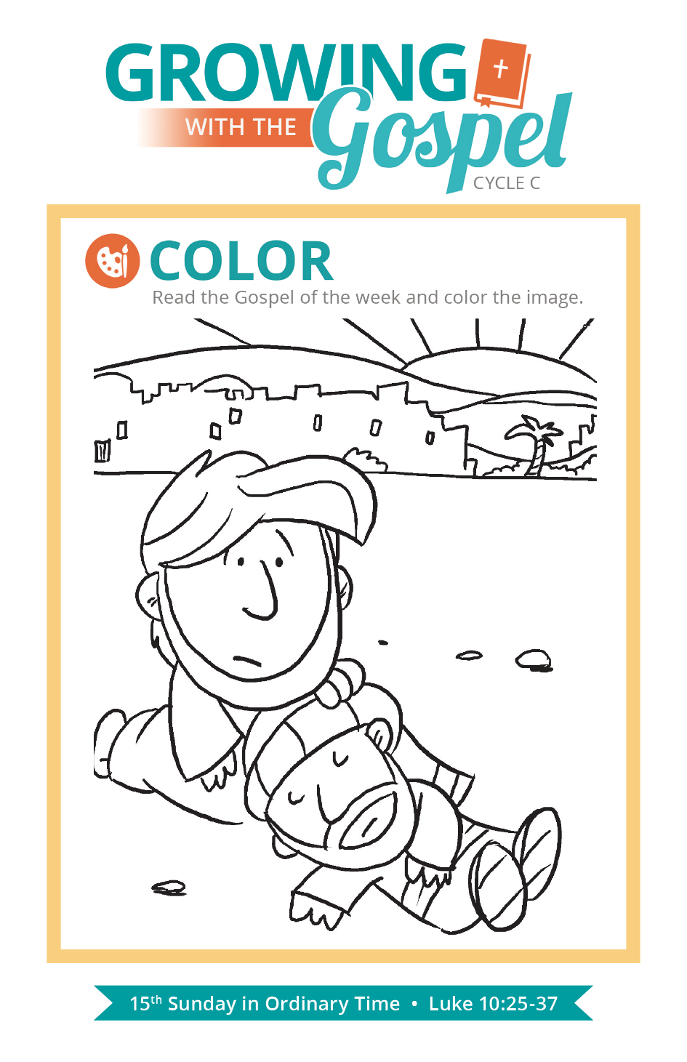
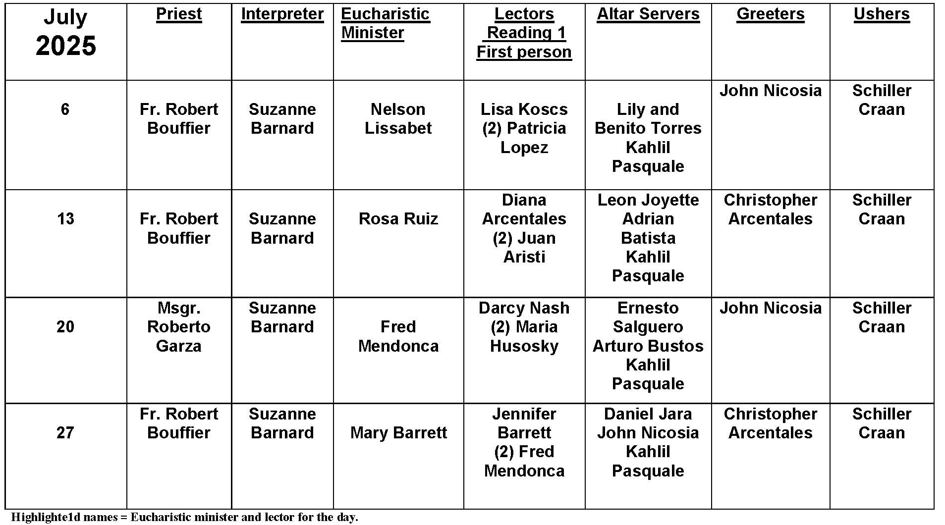
What Is Mammon?

Question:
When Jesus says, “You cannot serve both God and mammon,” what does he mean? What is mammon?

Answer:
When you hear Scripture proclaimed each Sunday, remember it wasn’t originally written in English. Hebrew, Aramaic, Greek — these ancient tongues were the original language of our Old and New Testaments. Most of the time, all of the words are translated into our native language. Sometimes, a word or two is left in the original language. Such is the case in this Scripture passage.

Mammon is an ancient Aramaic word referring to money, wealth, or profit. Earthly wealth isn’t bad in itself, nor does it automatically exclude us from being a disciple of Jesus. But what dominates our life? To serve money — that is, to seek accumulation of wealth for its own sake and to structure our lives around it — is morally problematic. What good is our wealth if it isn’t at the service of others? What good is our wealth if its pursuit leads us to selfishness, obsession, greed, envy, and comparison? There are many things that can be opposed to our service of God — power, prestige, popularity. Ultimately, something in our lives will be our master. But there is only one God worth serving.


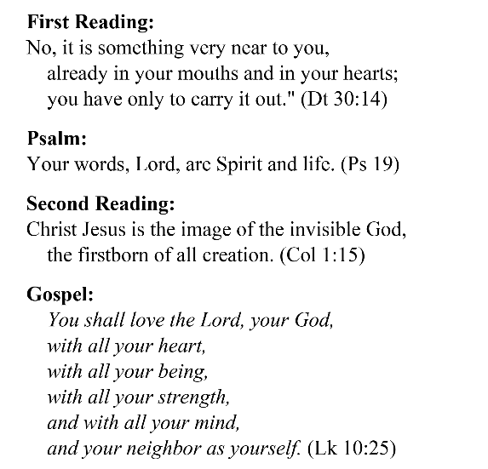
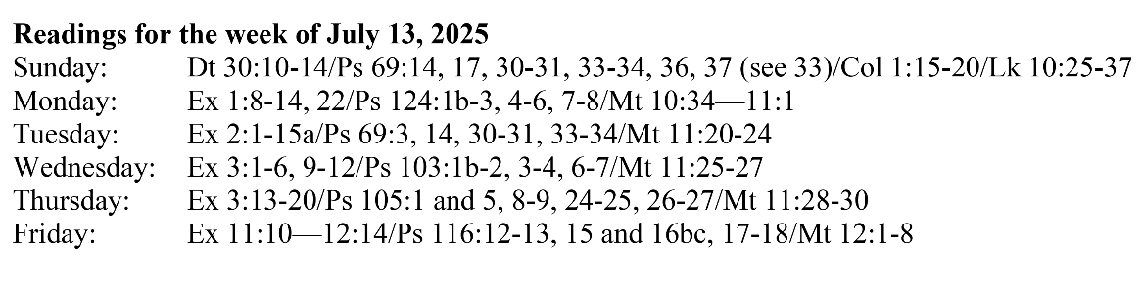
Are you in need of prayer? Do you have a prayer request? You can send your prayer requests to pcuadra@schottcommunities.org or call 954-434-3306 ext. 108

A copy of our prayer list can be found in the lobby of our chapel. To request a copy of our prayer list please email us at pcuadra@schottcommunities.org
To request a Mass please contact Pablo A. Cuadra at 954-434-3306 or e-mail at pcuadra@schottcommunities.org
Update: Celebrating a wedding anniversary soon? Let us know a week in advance and we can assist you with the renewal of your wedding vows.

Prayer to St. Michael the Archangel:
"St. Michael the Archangel, defend us in battle. Be our defense against the wickedness and snares of the Devil. May God rebuke him, we humbly pray, and do thou, O Prince of the heavenly hosts, by the power of God, thrust into hell Satan, and all the evil spirits, who prowl about the world seeking the ruin of souls. Amen"

