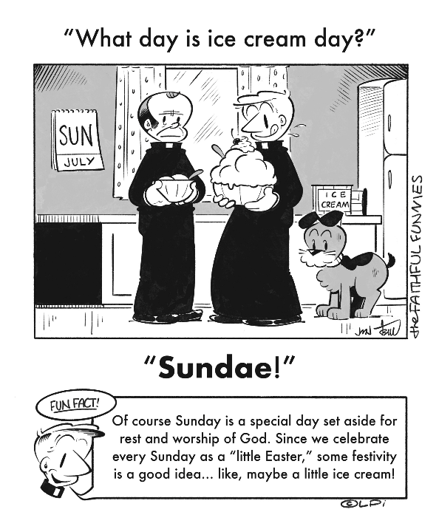
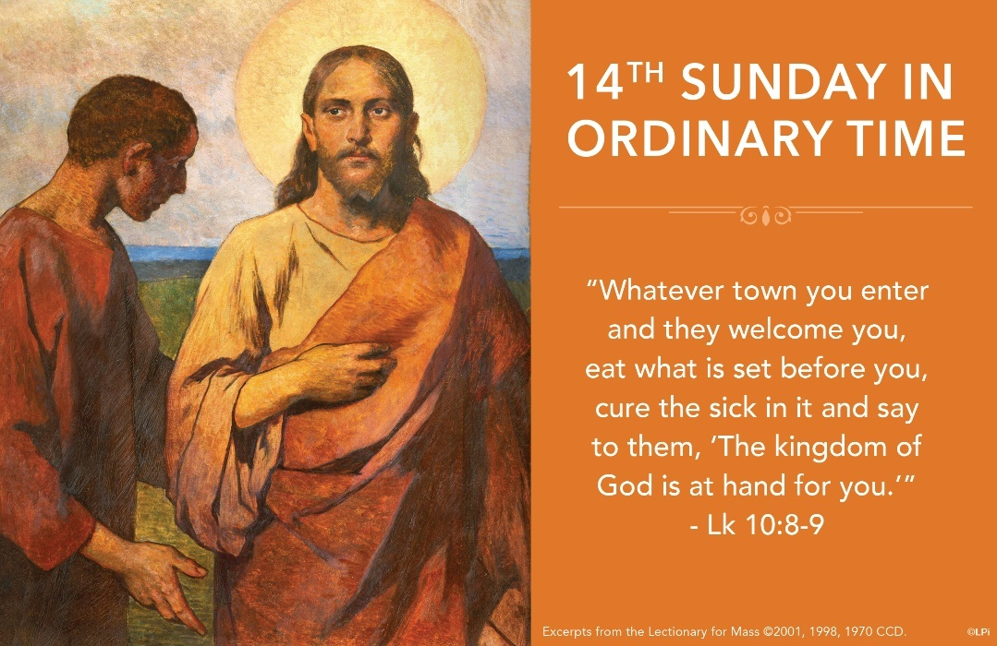
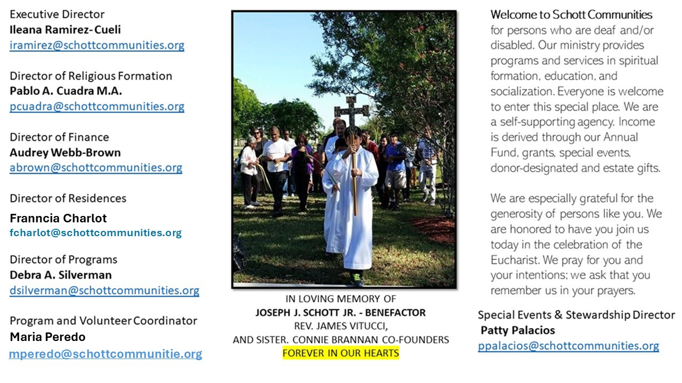

6 de julio de 2025
XIV Domingo del Tiempo Ordinario

La finalidad de este domingo es anunciar el Reino de Dios. Por ello, Dios envía a los discípulos de dos en dos. De esa forma es como se forma una comunidad misionera. Jesús los entrena para la misión, para ir, para salir fuera y mirar a los hermanos y hermanas en la periferia. ¿Qué necesitan? ¿Cómo viven? Es urgente que nos demos cuenta para participar en esta misión encomendada. La cosecha es abundante y los misioneros, pocos. “Rueguen, pues, al dueño de la cosecha que envíe obreros a su cosecha” (Lucas 10:2).
Esta petición de Jesús sigue en pie y nos invita a orar por nuestros sacerdotes, seminaristas, religiosos y religiosas que día a día trabajan para que el Reino de Dios crezca y reine la paz en sus comunidades. También tengamos presente en nuestra oración a los misioneros y misioneras laicos que luchan en silencio por esparcir la semilla del Evangelio entre los suyos. “Siempre debemos orar al dueño de la mies, que es Dios Padre, para que envíe obreros a trabajar en su campo, que es el mundo. Y cada uno de nosotros lo debe hacer con el corazón abierto, con una actitud misionera; nuestra oración no debe limitarse solo a nuestras peticiones, a nuestras necesidades: una oración es verdaderamente cristiana si también tiene una dimensión universal” (Papa Francisco). Nosotros, como bautizados, formamos parte de ese grupo misionero de Jesús. ¡Atrévete a ser un misionero comprometido!

July 6, 2025
14th Sunday in Ordinary Time
Luke 10:1-12, 17-20

In the days after the awful 2020 killing of George Floyd, a Catholic friend remarked, “Racism is today’s great evil. We should put all our energy into fighting it.” I admired her intuition that the church must stand firmly against evil. Amen, I thought. At the same time, something felt wrong. As months went by, I saw her steadily slide into bitterness and anger. Soon, despondency. She spoke of giving up the fight. Don’t we too wonder how to fight evil without losing our joy or energy?

Jesus’ words this week help. He says, “Rejoice not that you have power over demons, but that your names are written in heaven” (Luke 10:20). Notice the asymmetry in where he wants our focus: on the latter, not the former. Should we confidently embrace our God-given power to overcome evil? Absolutely. But even more so, we should emphasize the positive element of our relationship to God. It is tempting but dangerous to define ourselves by what we oppose. It is better to define ourselves by––to rejoice in––what we celebrate: in Jesus, God has written our names in heaven. This sustains our battles.

This week, our marching orders are: fight evil. But more deeply, rejoice that God knows and loves us personally, individually. We allow this joyful knowledge to undergird our fight against the darkness of our day. Then we enjoy long-term stability to be cheerful warriors, who never forget the reason for the contests we are called to fight and win: love.

— Father John Muir

St. Jude Chapel, Sunday, July 6th, 2025
Father Robert Bouffier
Celebrant

St. Michael Prayer
The prayer to St. Michael, composed by Pope Leo XIII, invokes the protection of the archangel Michael in the ongoing spiritual battle for the souls of all mankind. It is commonly said at the end of the rosary and by some parishes after the conclusion of Mass.


Christian Giving
June 29th, 2025
$

We sincerely thank you and bless you for your generosity.
A bequest is a powerful tool to help the Deaf or Disabled.

Mass Intentions
“For the repose of the Souls in Purgatory
Requested by Schott Communities


Follow us on Facebook
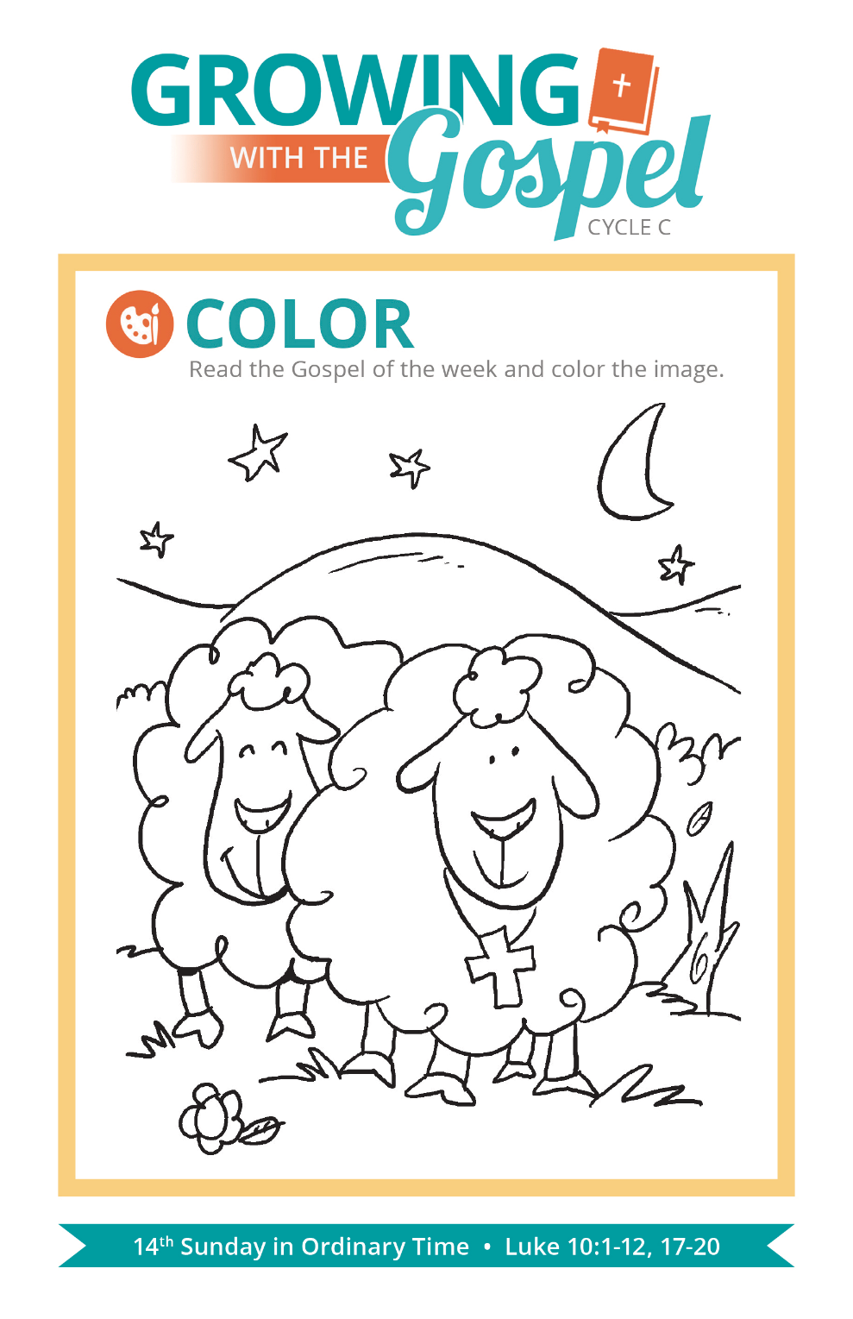
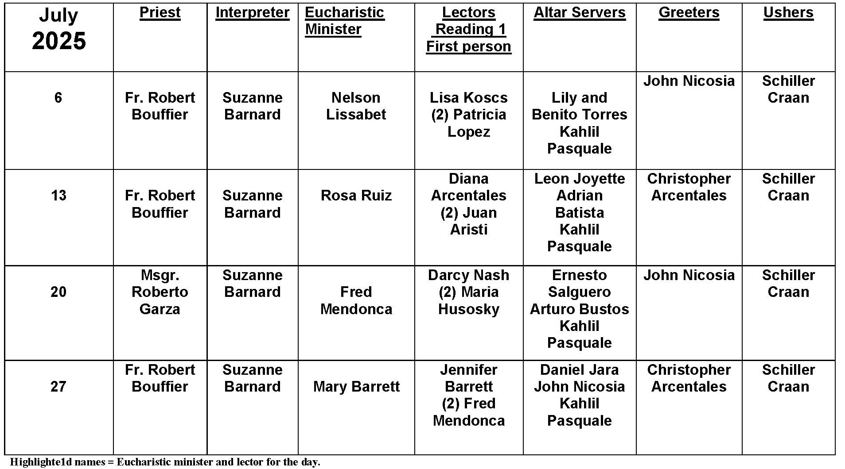
Carry Your Cross

Question:
As Catholics, we talk a lot about “redemptive suffering” and “carrying your cross.” What does that mean practically in daily life?

Answer:
When Jesus spoke these words, they would have sounded quite intense to his hearers. “Pick up your cross daily and follow me.” At the time, Jesus hadn’t yet been crucified. A cross was a Roman torture instrument. “Pick up the thing that tortures you the most,” Jesus seemed to say. Unfortunately, most of us have no real shortage of these in our life. To take up the cross isn’t to seek out new sufferings in our life. It’s to accept the life we have.

Of course, unjust or unhealthy circumstances should be rectified when possible. But there are always circumstances that remain out of our immediate control. It could be pain management, the defiance of our teenage child, or an unhealthy work environment … but you need the paycheck to pay the bills. In difficult circumstances, it can be easier to blame, complain, or daydream our way out of it. None of these are real solutions, since none of them accept the reality of the situation at hand. Those options only add to our suffering, since they damage relationships, fixate on the problem, or set up unrealistic expectations.

Instead, Jesus invites us to take up our cross — to look at the uncomfortable situation square in the eyes, take a deep breath, and do our best to be present to God’s grace in the moment. To love those in our path. To take things one step at a time.

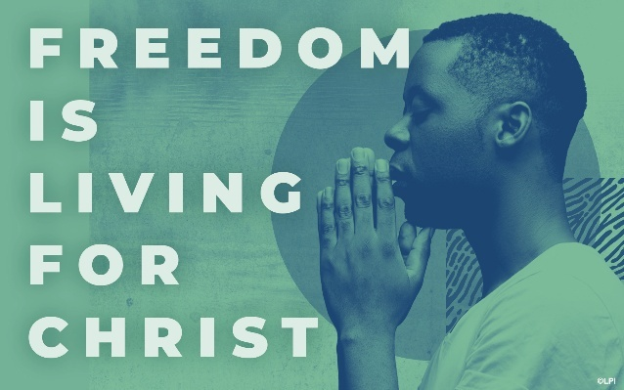
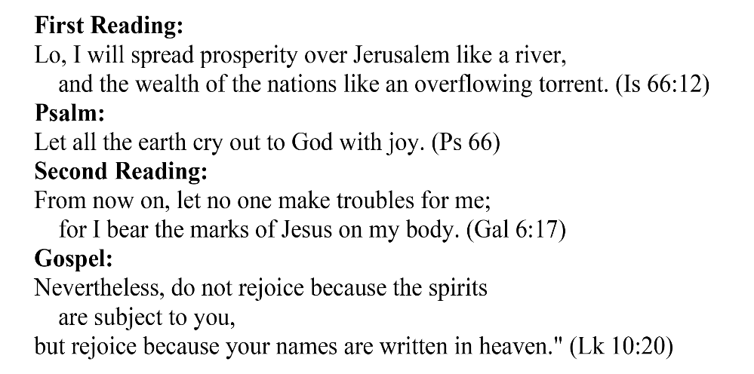
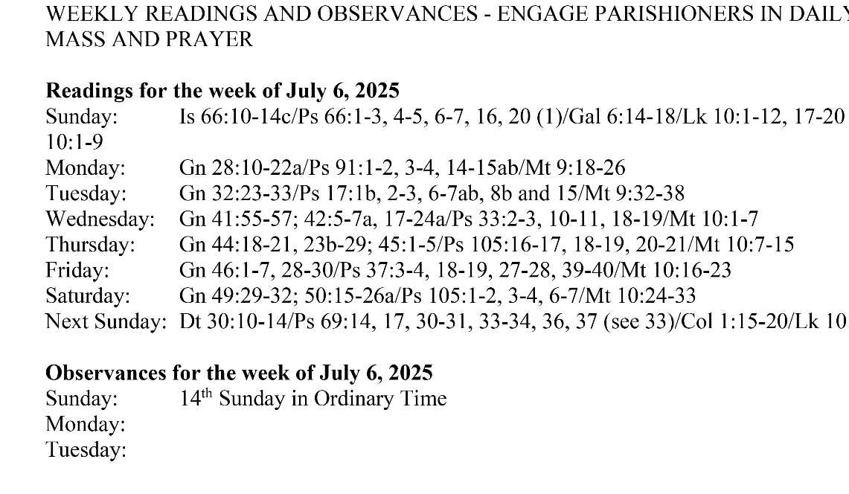
Are you in need of prayer? Do you have a prayer request? You can send your prayer requests to pcuadra@schottcommunities.org or call 954-434-3306 ext. 108

A copy of our prayer list can be found in the lobby of our chapel. To request a copy of our prayer list please email us at pcuadra@schottcommunities.org
To request a Mass please contact Pablo A. Cuadra at 954-434-3306 or e-mail at pcuadra@schottcommunities.org
Update: Celebrating a wedding anniversary soon? Let us know a week in advance and we can assist you with the renewal of your wedding vows.

Prayer to St. Michael the Archangel:
"St. Michael the Archangel, defend us in battle. Be our defense against the wickedness and snares of the Devil. May God rebuke him, we humbly pray, and do thou, O Prince of the heavenly hosts, by the power of God, thrust into hell Satan, and all the evil spirits, who prowl about the world seeking the ruin of souls. Amen"

