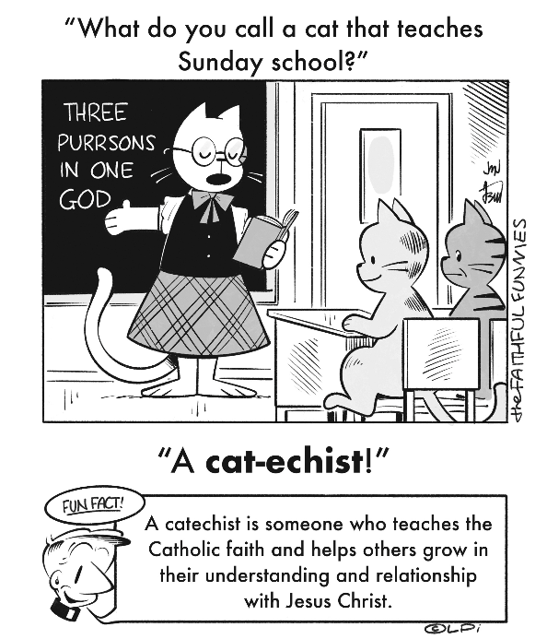
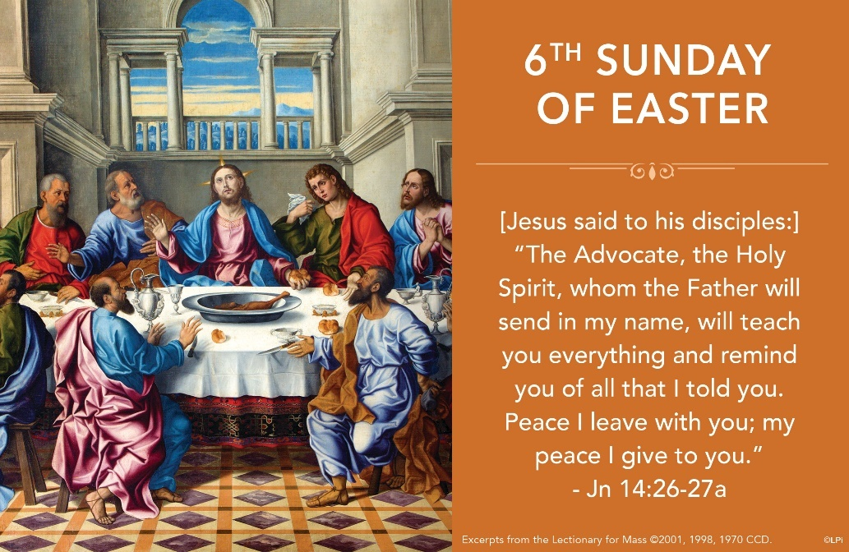
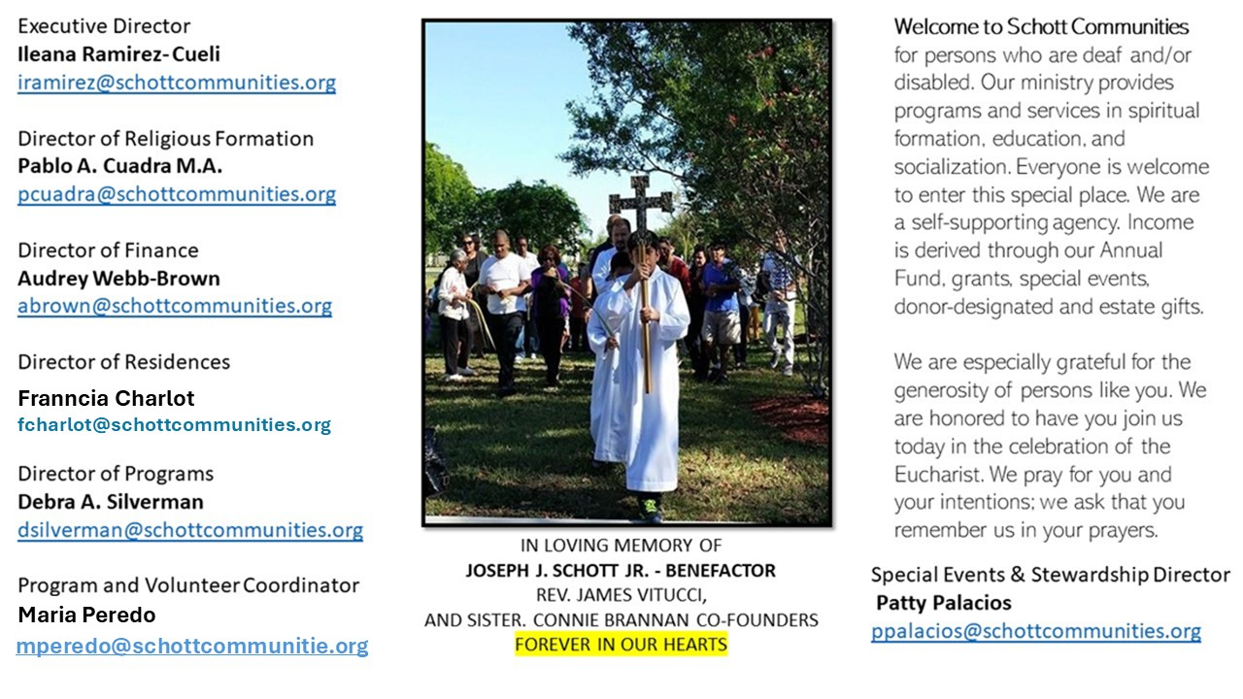

25 de mayo de 2025
VI Domingo de Pascua

El Espíritu de la verdad estará con nosotros. Es la promesa de Jesús, antes de su gloriosa Ascensión al cielo. “El corazón debe estar firme en el Espíritu Santo, un don que Jesús nos ha mandado. Todos nosotros, si queremos encontrar firmeza en nuestra vida entre las vicisitudes humanas que todos nosotros tenemos, debemos ir a Él. Él está en nuestro corazón, lo hemos recibido en el bautismo. Es el Espíritu Santo quien da firmeza al corazón en medio de las persecuciones, problemas, discusiones, envidias y celos” (Papa Francisco). Jesús, durante la Pascua, nos va dejando un testamento espiritual, una guía segura en nuestra vida. En él nos deja su promesa de esperanza y misericordia.
Jesús nos da un regalo grande que recibimos en el bautismo. Ese gran don es el Espíritu Santo. Somos su casa, su morada, y actúa en cada persona, conforme se le deja. ¿Lo crees? ¿Lo sientes? Jesús, lo promete e invita a que lo recibamos en nuestro corazón. “En adelante, el Espíritu Santo, el intérprete que el Padre les va a enviar en mi Nombre, les enseñará todas las cosas y les recordará todo lo que yo les he dicho” (Juan 14:26). Tenemos que llenarnos del amor de Cristo para poder llegar a ser verdaderos discípulos misioneros en el ambiente en que nos desenvolvamos. El Espíritu será nuestra ayuda y consuelo en la jornada.

May 25, 2025
6th Sunday of Easter
John 14:23-29

Jonathan Haidt’s 2024 book entitled “The Anxious Generation” argues that today’s kids are marked by significant increases in anxiety, as the title suggests. Smartphones, social media, economic uncertainty, the chaos of a global pandemic, fear regarding climate change, and the so-called “meaning crisis” all contribute to strikingly high levels of anxiety in young people today. I’m a bit older than this generation, but I feel it, too. The world can be too much to handle.

The Gospel this week offers a stunning solution for troubled souls. To his overwhelmed and anxious disciples, the risen Jesus says, “Peace I leave with you; my peace I give to you” (John 14:27). His peace is that of the one who was overwhelmed on the cross and then conquered death by the power of his divinity, his bond of love with the Father. He offers us this unshakeable peace.

Of course, mental illness does not magically disappear because of the risen Jesus. But he does walk with us and offer us his peace in the midst of our suffering. The peace the world gives is not like his because it is weak, uncertain, and self-generated. Jesus’ peace is strong, sure, and given as a gift from God. He gives it to us amid our anxiety. Will you receive it as a gift? I hope so. He wants to fill the hearts of this generation with his peace.

— Father John Muir

St. Jude Chapel, Sunday, May 25th 2025
Father Robert Bouffier
Celebrant

Hail Mary
The words of the Hail Mary — undoubtedly the most recognizable Catholic prayer after the Lord’s Prayer — are deeply rooted in scripture, but Catholics did not begin to utilize the Hail Mary prayer in its current form until around the 11th century.


Christian Giving
May 18th, 2025
$557

We sincerely thank you and bless you for your generosity.
A bequest is a powerful tool to help the Deaf or Disabled.

Mass Intentions
“For the repose of the Souls in Purgatory
Requested by Schott Communities


Follow us on Facebook
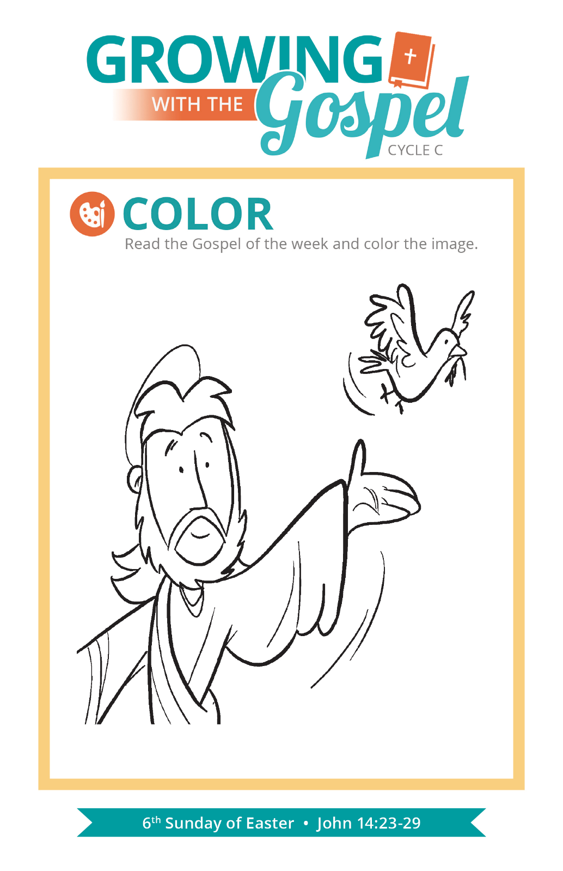
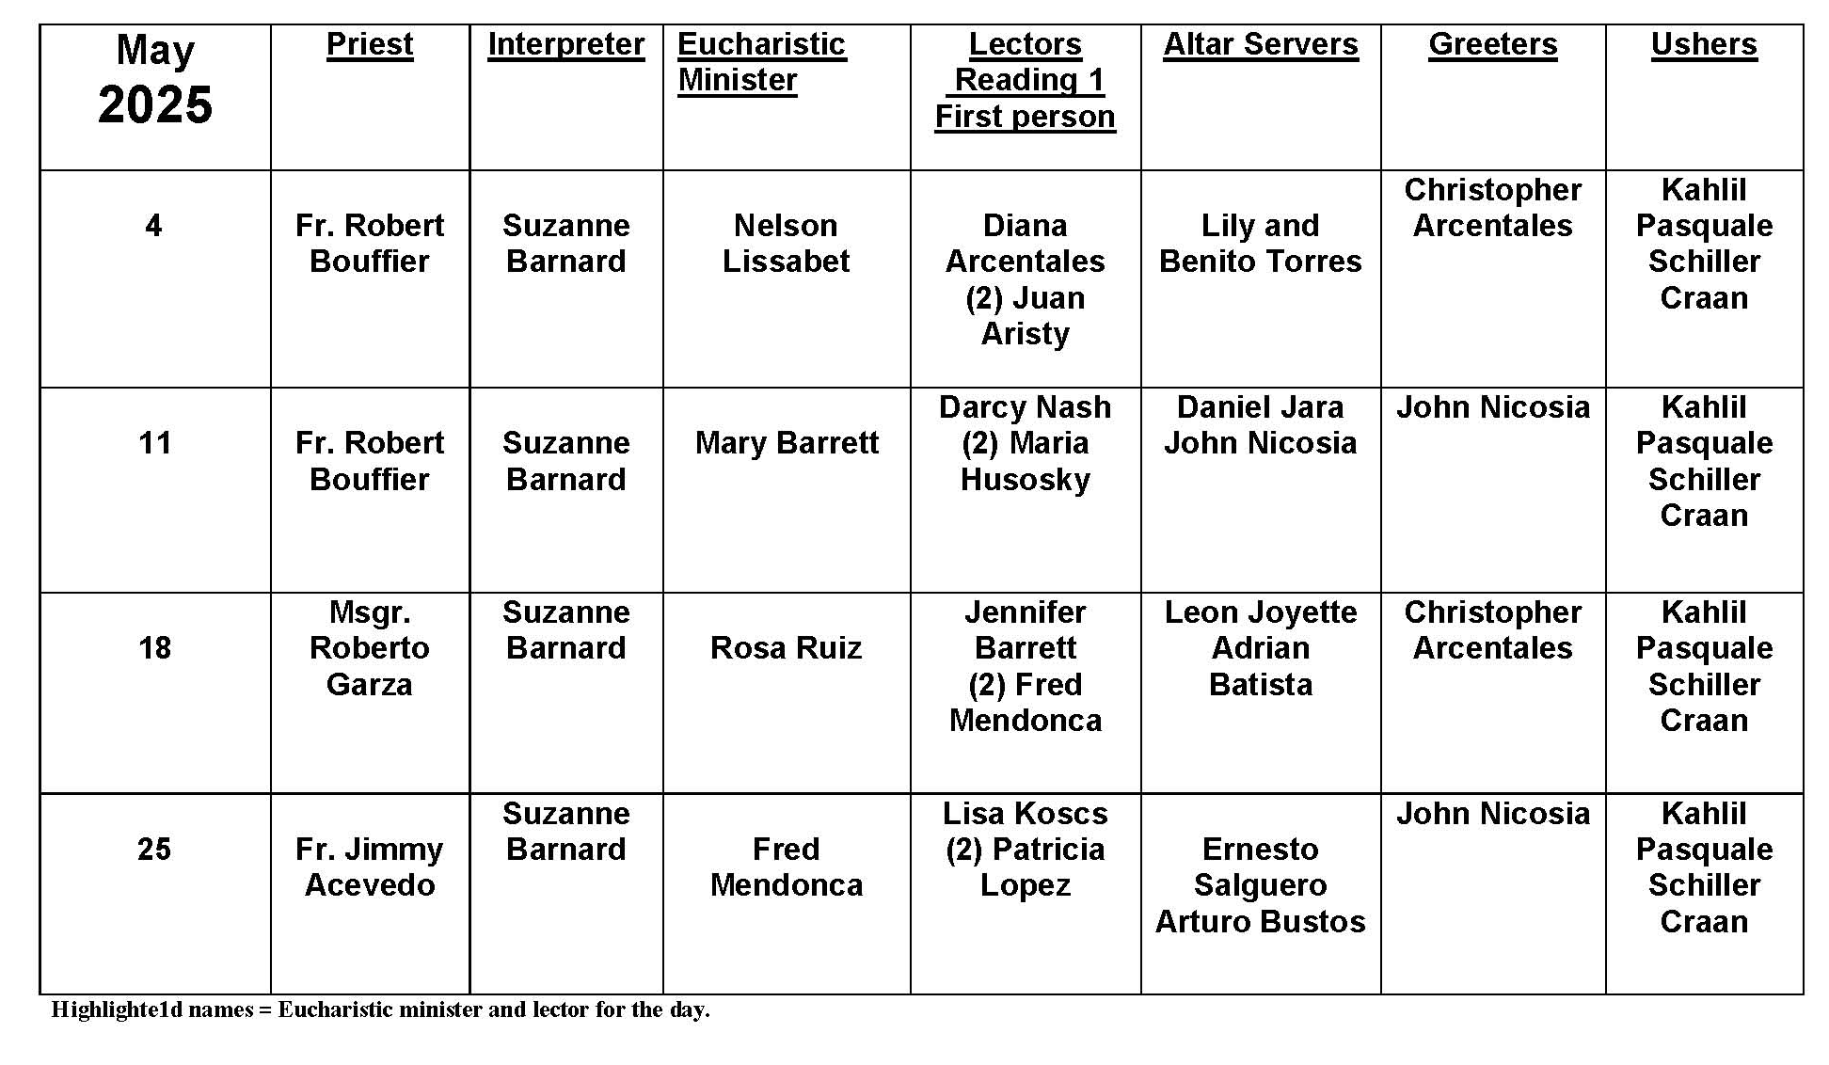
Sunday Mass
Question:
Why do Catholics need to go to Mass every Sunday?
Answer:
The heart of the Church’s instruction that we are to attend Mass on Sundays goes back to the Third Commandment: “Take care to keep holy the sabbath day as the LORD, your God, has commanded you” (Deuteronomy 5:12). Although the Jewish People celebrate the Sabbath on Saturday, the first generations of Christians began to observe the sabbath on Sunday, recognizing how important it is for Christians to celebrate the day that Jesus rose from the dead. As the United States Catholic Catechism for Adults observes, “Sunday extends the celebration of Easter throughout the year … It makes present the new creation brought about by Christ” (364).

The focus of our Sunday should be the celebration of the Eucharist in the Mass. This is our time to be formed by God’s Word and nourished at the table of the Lord, becoming prepared to live out and share our faith in the week that follows. In his encyclical, Dies Domini, Pope Saint John Paul II reminded us that Christians “cannot live their faith or share fully in the life of the Christian community unless they take part regularly in the Sunday Eucharistic assembly” (no. 81). This is why the Church teaches us that Sunday Mass is a non-negotiable part of being a Christian (see Catechism of the Catholic Church, no. 2192).

Beyond being a time of worship, we should also remember that Sunday is intended to be a day of rest, when we make time for recreation, for sharing meals, and enjoying the company of friends and family. Sunday is given to as a day to take stock of and enjoy the blessings that God has given us (see Catechism of the Catholic Church, no. 2187). Pope Francis reminds us, “The day of rest, centered on the Eucharist, sheds its light on the whole week, and motivates us to greater concern for nature and the poor” (Laudato Si’, no. 237).

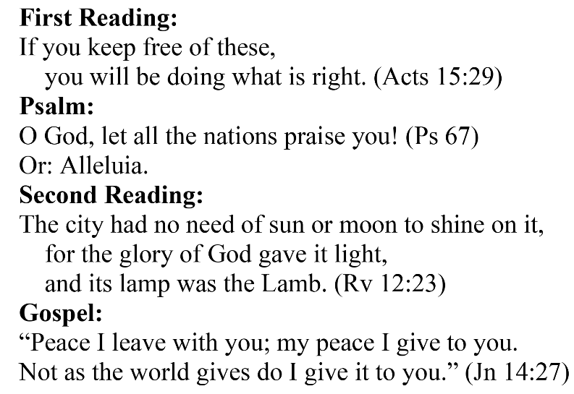
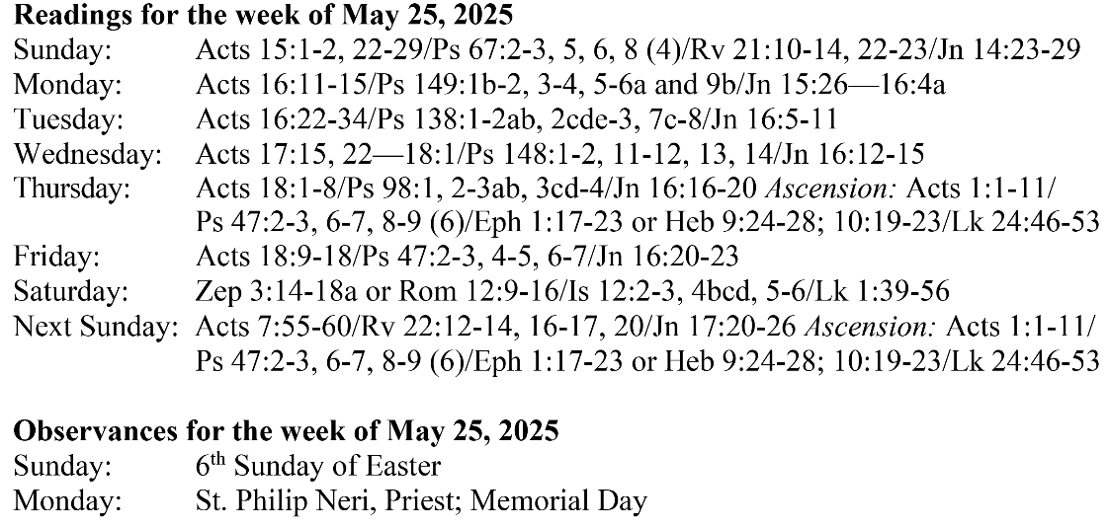

Are you in need of prayer? Do you have a prayer request? You can send your prayer requests to pcuadra@schottcommunities.org or call 954-434-3306 ext. 108

A copy of our prayer list can be found in the lobby of our chapel. To request a copy of our prayer list please email us at pcuadra@schottcommunities.org
To request a Mass please contact Pablo A. Cuadra at 954-434-3306 or e-mail at pcuadra@schottcommunities.org
Update: Celebrating a wedding anniversary soon? Let us know a week in advance and we can assist you with the renewal of your wedding vows.

Prayer to St. Michael the Archangel:
"St. Michael the Archangel, defend us in battle. Be our defense against the wickedness and snares of the Devil. May God rebuke him, we humbly pray, and do thou, O Prince of the heavenly hosts, by the power of God, thrust into hell Satan, and all the evil spirits, who prowl about the world seeking the ruin of souls. Amen"

