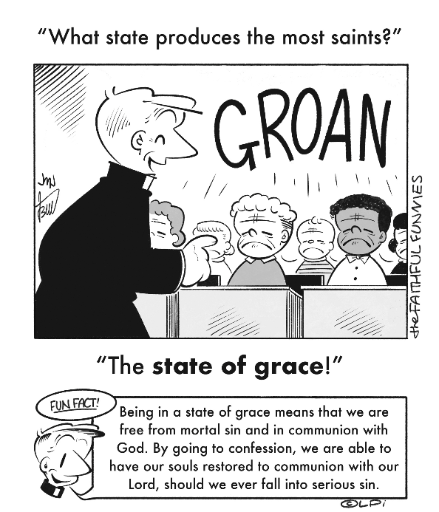
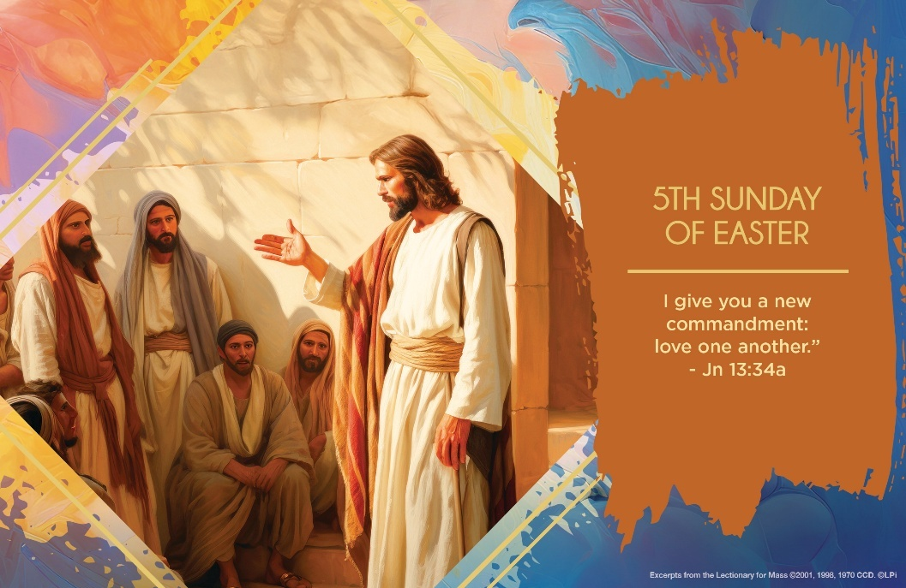
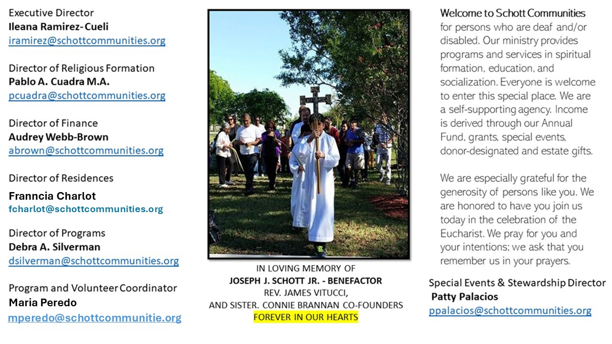

18 de mayo de 2025
V Domingo de Pascua
La palabra amor está muy trillada, es usada con mucha facilidad en nuestro lenguaje. Al decirla, quizá no pensamos en lo profundo de esta palabra. Hacemos tantas promesas de amor falsas. A la esposa, al esposo, a los hijos, a los amigos y a tanta gente le decimos que la amamos cuando en realidad no es cierto. En este Domingo de Pascua, Jesús nuevamente lanza su invitación al amor, a dar la vida por el ser amado. “Les doy un mandamiento nuevo: que se amen los unos a los otros. Ustedes deben amarse unos a otros como yo los he amado” (Juan 13:34). Y agrega una frase más para que quede bien cimentado en nuestros corazones el significado de la palabra amor: “En esto reconocerán todos que son mis discípulos: en que se aman unos a otros” (Juan 13:35).Esto es el amor evangélico; esto distingue mucho el significado de decir simplemente la palabra amor. El amor evangélico se vive en las dificultades más difíciles de la vida. Cuando los percances nos obligan a hacer cosas, aunque no queramos. Para así glorificarte en el sufrimiento de cualquier índole. Esta es la entrega que sublima tu Evangelio. Así es como se va aprendiendo a amar: la vida nos enseña a girar el corazón al amor. Reflexiona en lo siguiente: ¿En qué área de tu vida has experimentado el amor de Jesús? Si Jesús te dijera: “ama como yo te he amado”, ¿cuál sería tu respuesta? En concreto, solo Jesús puede ayudarnos a renovar nuestra forma de amar a los demás.

May 18, 2025
5th Sunday of Easter
John 13:31-35

I’ve always found it amazing that Jesus never says to his disciples the straightforward and bumper stickery words “I love you” or “I will always love you” (a la Dolly Parton’s song). Why doesn’t Jesus say, “I love you”?

Well, actually he does, but in particular ways. He says, “As the Father loves me, so I love you” (John 15:9) thereby rooting his love for us in the space of the Holy Trinity. This week he commands, “Love another as I have loved you” (John 13:34). He presents his love for us as a completed action which continues into the present moment. How has he loved us? By becoming one of us, one with us, and finally giving his life for us in his suffering on the cross. We weren’t there when he did that, but neither were his Apostles (except one). Still, that action is his great “I love you” to us.

His love is also hedged in a command: “Love one another.” So how can we practically follow it? The great St. John XXIII wrote in his diary that each day he followed this rule: “Only for today, I will do one good deed and not tell anyone about it.” The hidden nature of a good deed is a sign that it is truly loving. This week, take on St. John XXIII’s practical method of following Jesus’ great commandment of love. It’s a splendid way to say, “I love you.”
— Father John Muir

St. Jude Chapel, Sunday, May 18th 2025
Monsignor Roberto Garza
Celebrant

Hail Mary
The words of the Hail Mary — undoubtedly the most recognizable Catholic prayer after the Lord’s Prayer — are deeply rooted in scripture, but Catholics did not begin to utilize the Hail Mary prayer in its current form until around the 11th century.


Christian Giving
May 11th, 2025
$561

We sincerely thank you and bless you for your generosity.
A bequest is a powerful tool to help the Deaf or Disabled.

Mass Intentions
“For the repose of the Souls in Purgatory
Requested by Schott Communities


Follow us on Facebook
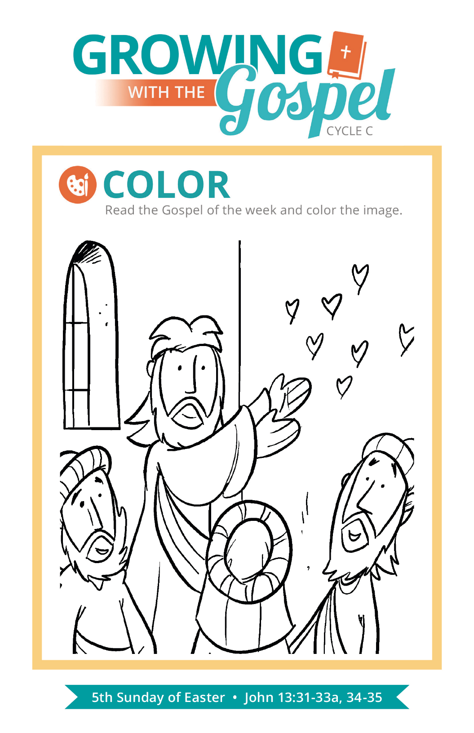
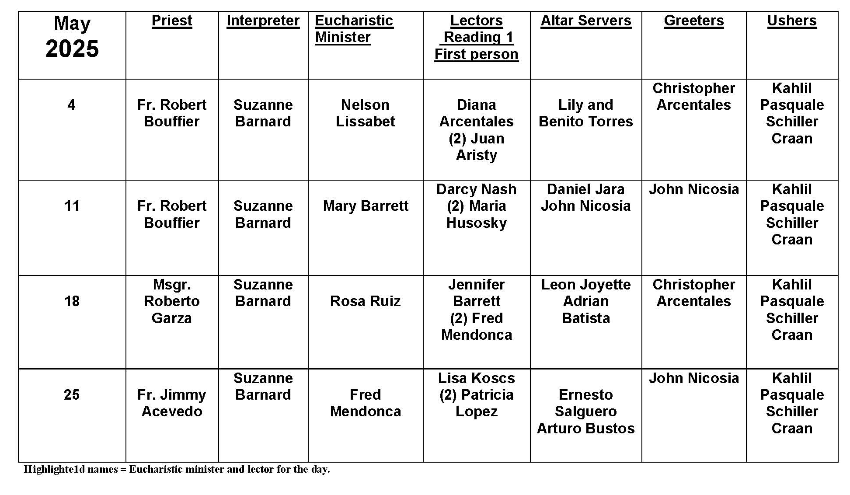
Good and Evil
Question:
If God is good, why is there evil in the world?
Answer:

The problem of evil is perplexing. If God is all-powerful and all-good, why doesn’t He stop bad things from happening? He must either not be all-powerful, or perhaps He’s not very good after all. Human beings have faced the possibility of evil since the very beginning of our existence. In granting us free will, God gives us the ability to make free choices. God does not force us into moral perfection. We are not forced to love Him or to love our neighbor. We must make the decision ourselves. This means, of course, that we have the ability to choose against love.

One small decision of selfishness, jealously, or pride may not seem so bad. But every decision — good or bad — is like a stone dropped into a still pond. The ripples extend much farther than the original stone. When decisions against love begin to compound, they affect families, neighborhoods, and nations. This is all the more reason for Christians to be faithful to our baptismal call to love one another as Christ has loved us!

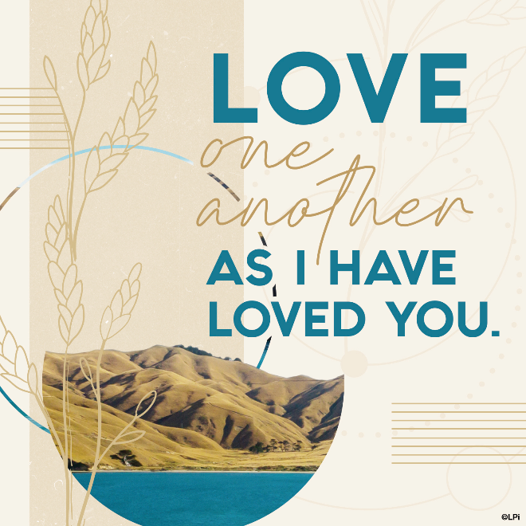
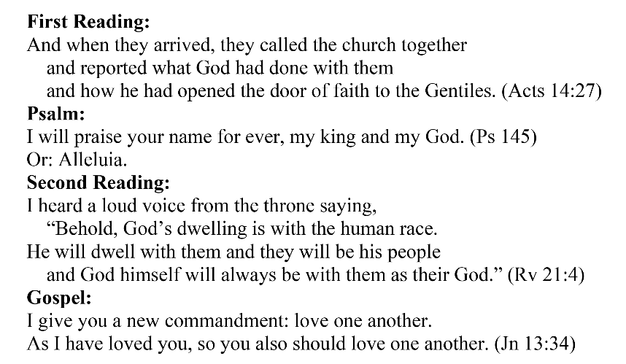
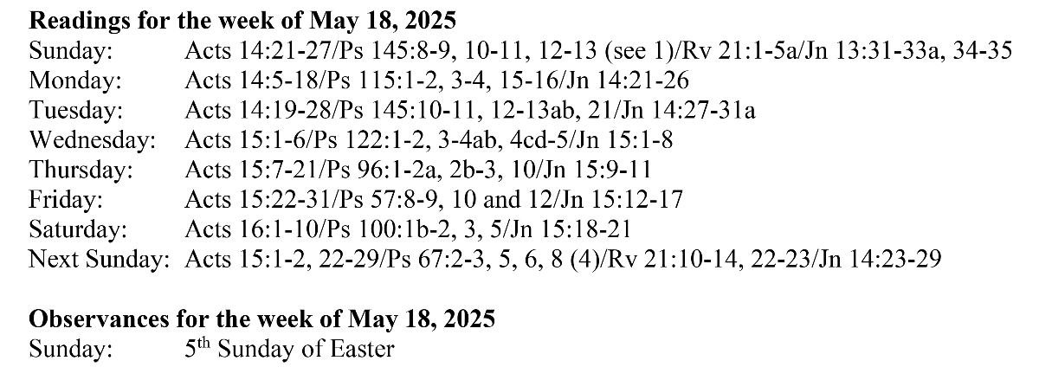
Are you in need of prayer? Do you have a prayer request? You can send your prayer requests to pcuadra@schottcommunities.org or call 954-434-3306 ext. 108

A copy of our prayer list can be found in the lobby of our chapel. To request a copy of our prayer list please email us at pcuadra@schottcommunities.org
To request a Mass please contact Pablo A. Cuadra at 954-434-3306 or e-mail at pcuadra@schottcommunities.org
Update: Celebrating a wedding anniversary soon? Let us know a week in advance and we can assist you with the renewal of your wedding vows.

Prayer to St. Michael the Archangel:
"St. Michael the Archangel, defend us in battle. Be our defense against the wickedness and snares of the Devil. May God rebuke him, we humbly pray, and do thou, O Prince of the heavenly hosts, by the power of God, thrust into hell Satan, and all the evil spirits, who prowl about the world seeking the ruin of souls. Amen"

