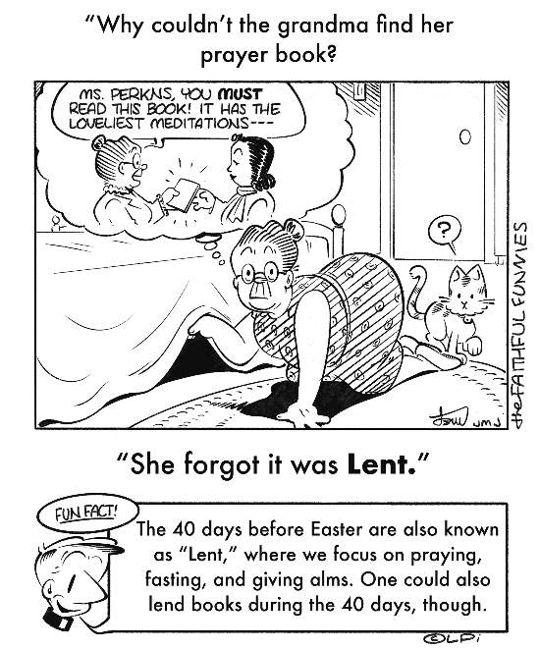
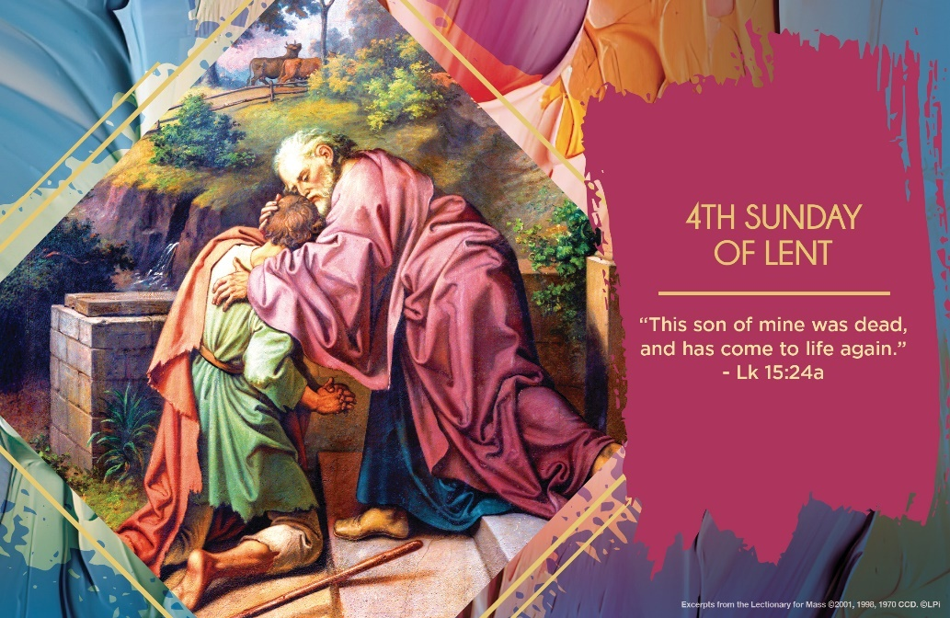
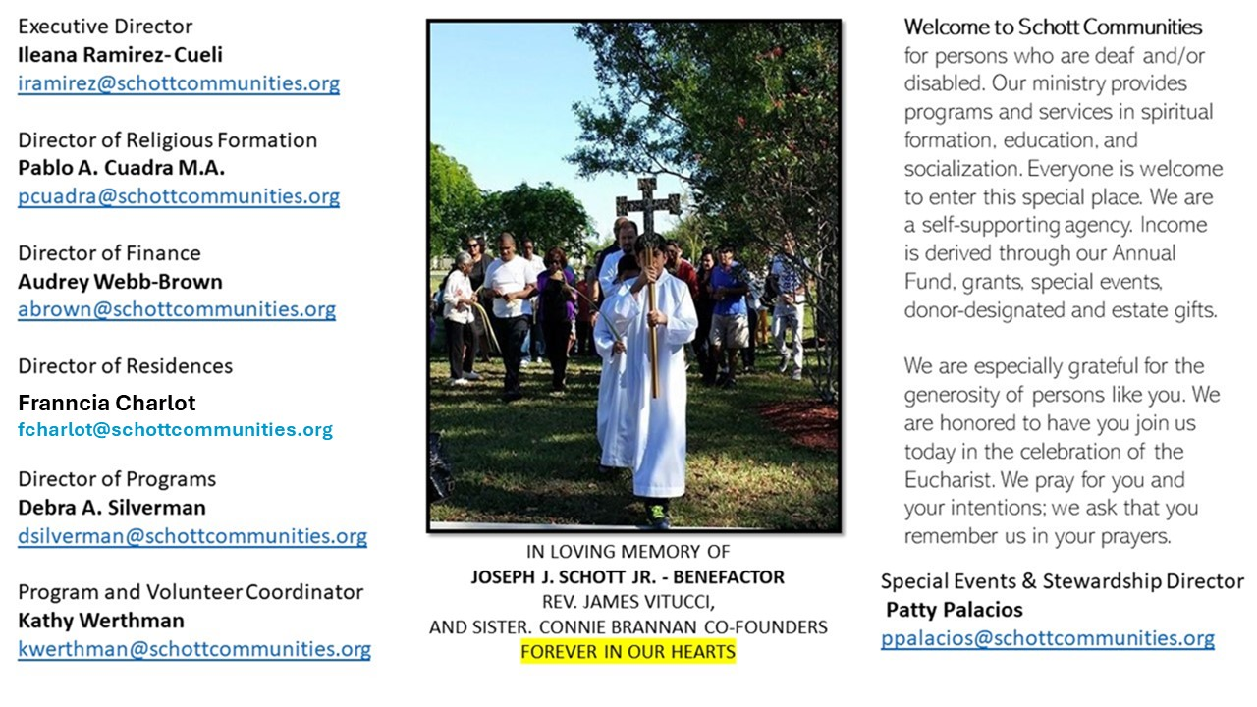

30 de marzo de 2025
4º Domingo de Cuaresma
Todos, quizá en algún momento de nuestra vida, hemos tenido la experiencia de jugar el papel de hijos-hijas buenos en la vida familiar. Pero, también hemos jugado el roll de no ser tan buenos como se esperaba. Entonces, esta parábola del hijo pródigo nos cae como anillo al dedo. ¿Qué sentimientos o recuerdos afluyen a tu mente al escucharla? ¿Sientes que el Padre es injusto con su hijo mayor? ¿Crees que ha consentido demasiado al menor de sus hijos? Cualquiera que sea nuestra respuesta, nos debe llevar a una reflexión profunda del amor incondicional de Dios para con sus dos hijos. Sin embargo, no perdamos el punto de vista de que Jesús cuenta esta parábola a publicanos y pecadores, y de cómo los fariseos y escribas criticaban a Jesús porque comía con ellos.
“Con la parábola del hijo pródigo Jesús nos cuenta que Dios nos espera siempre, igual que el padre, que espera el regreso de su hijo. Él nos deja libres, deja que nos equivoquemos y aprendamos, y de esta manera volver, al igual que lo hizo el hijo pródigo” (Papa Francisco). El Papa Francisco nos da la clave que debemos de llevar a cabo, aprender a volver cada vez que nos alejemos. No claudicar, seguir adelante y pedir perdón es de valientes. Aprender de los errores vividos y regresar para volver a un nuevo comienzo, pero bien acompañados de la gracia de Dios. Sentir fortaleza al escuchar: “Tú estás siempre conmigo y todo lo mío es tuyo” (Lucas 15:31).

March 30, 2025
4th Sunday of Lent
John 9:1-41
A man looking a bit downtrodden approached me as I filled my car’s gas tank. He asked, “May I share with you my testimony about how good God is?” “OK,” I skeptically answered. He went on to tell me that he had been an alcoholic and drug addict, and that God had healed him; now he was four years sober. He said, “I didn’t deserve it, but now I’m a different person. God is so good! Have a terrific Tuesday!” A few minutes later, as I drove away, I saw him smiling and handing a homeless person some money. I was confronted with a choice: either he was a total fraud or God had changed him. Something had happened to him, and it didn’t seem fake. Maybe it was God.
When Jesus heals the man born blind, the man becomes a challenge to everyone who meets him. They must decide. Is he the same blind person who they knew before? Who healed him and how? And what is the status of the one who can heal such infirmities? We shouldn’t be surprised at the storm of doubt, hatred and animosity that swirls around the healed man — so it often goes when Jesus heals someone even to this day.
Like we often do, the religious leaders confronting the healed man declare that God is not at work. They ask with mocking superiority and dismissive disdain, “You were born totally in sin, and are you trying to teach us?” (John 9:34). And they cast him out. When Jesus clearly works in our lives, in us or around us, we should accept it, and give praise and thanks for this wonderful manifestation of his goodness.

Lenten challenge: Think of one way the Lord has healed you. Perhaps he healed a form of selfishness, a physical ailment, or something else. This week, find a person to whom you can share that testimony, and share it. Don’t worry if they don’t accept it was God who did it.

— Father John Muir

St. Jude Chapel, Sunday, March 30th 2025
Father Jimmy Acevedo
Celebrant

Prayer of a Father’s Blessing
God who wills good things for your children,
Help me to trust that You will be faithful.
God who will not leave me,
Help me to seek You, too.
God who is ever-waiting for me,
Help me to run straight towards You.

Amen.


Christian Giving
March 23rd, 2025
$TBA

We sincerely thank you and bless you for your generosity.
A bequest is a powerful tool to help the Deaf or Disabled.

Mass Intentions
“For the repose of the Souls in Purgatory
Requested by Schott Communities


Follow us on Facebook
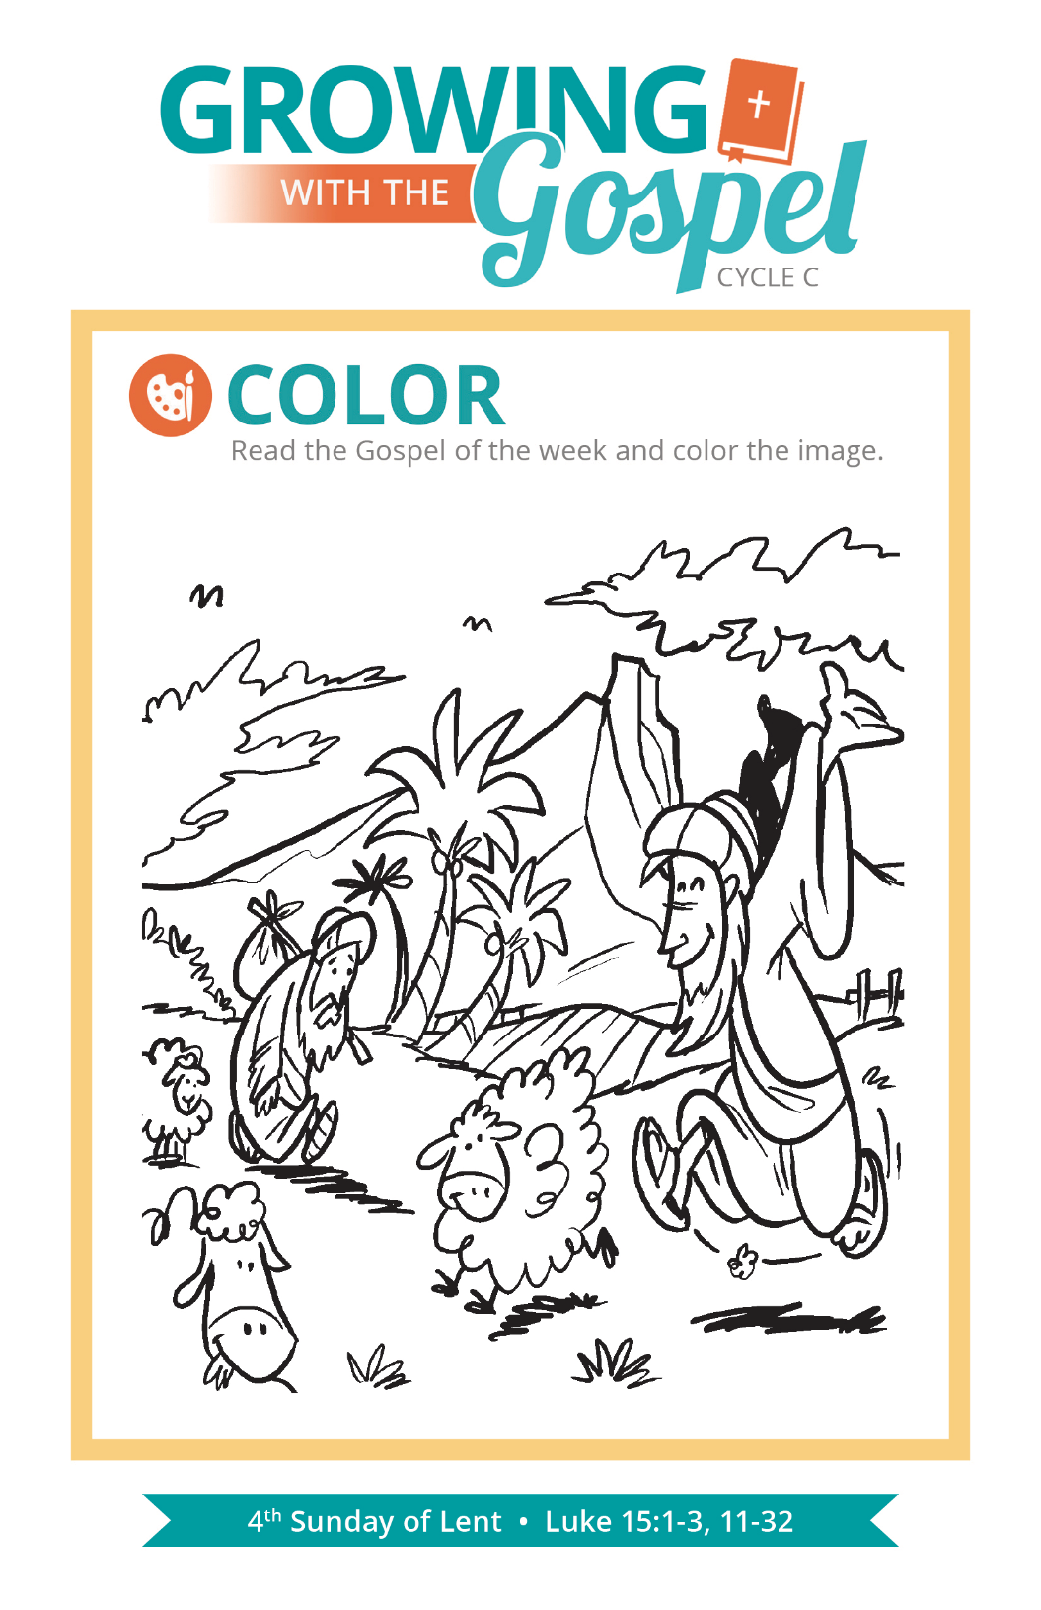
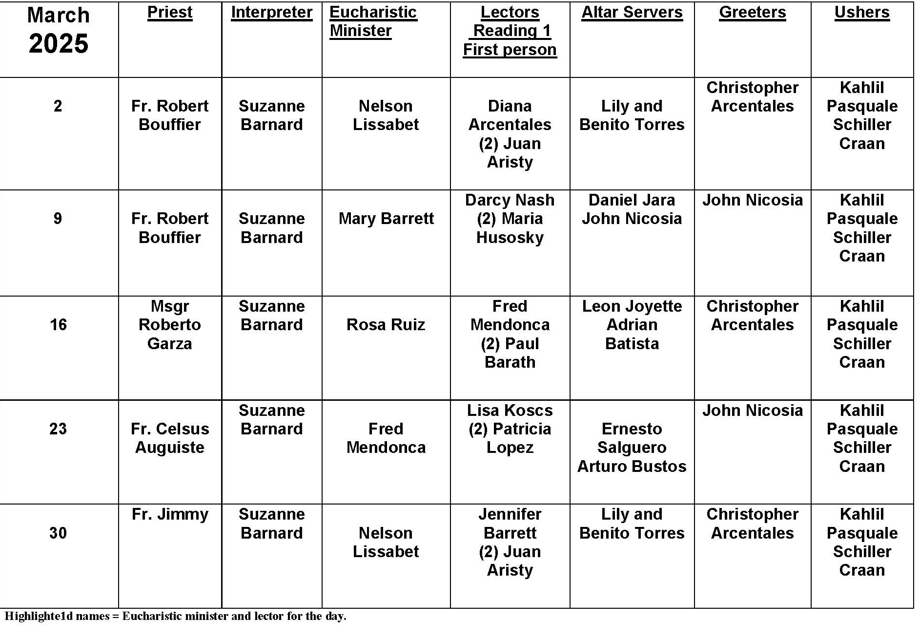
Lent

Question:
Lent always seems to help me renew my relationship with God and strengthen my religious practice. Do you have any suggestions as to what I could do to achieve that the rest of the year?

Answer:
The obvious answer may seem to be to do whatever you do during Lent all year round. But part of the power of Lent is that we focus as a community on renewing our faith and preparing for Easter. Our Lenten practices have a purpose and a goal. Therein lies the secret. When we focus our efforts on one virtue, or try to change one bad habit, or seek to deepen our understanding of one aspect of faith, we focus our efforts and give our full attention to what we are trying to accomplish. We tend to be more successful achieving our goals. More importantly, it has a ripple effect in our lives: one thing changes or is added to the spiritual mix of our lives and many aspects are changed.

All too often we leave our spiritual growth to chance and the practice of faith to habit, and then wonder why we have no sense of growth or progress. Think of it in terms of exercise. We walk, lift weights, bend and stretch to attain the maximum benefit from what we do. In addition, to keep those benefits, we eat healthful food and get enough vitamins and rest. Spirituality requires the same kind of attention: we pray, fast, read the Bible, receive sacraments, and do charitable work to maximize the benefits of practicing faith. Keeping Lent year round keeps us in spiritual shape!


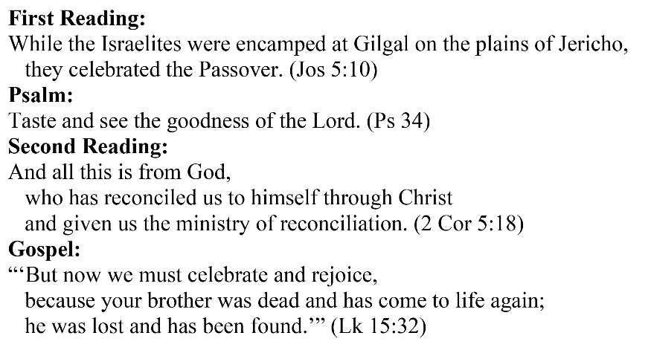
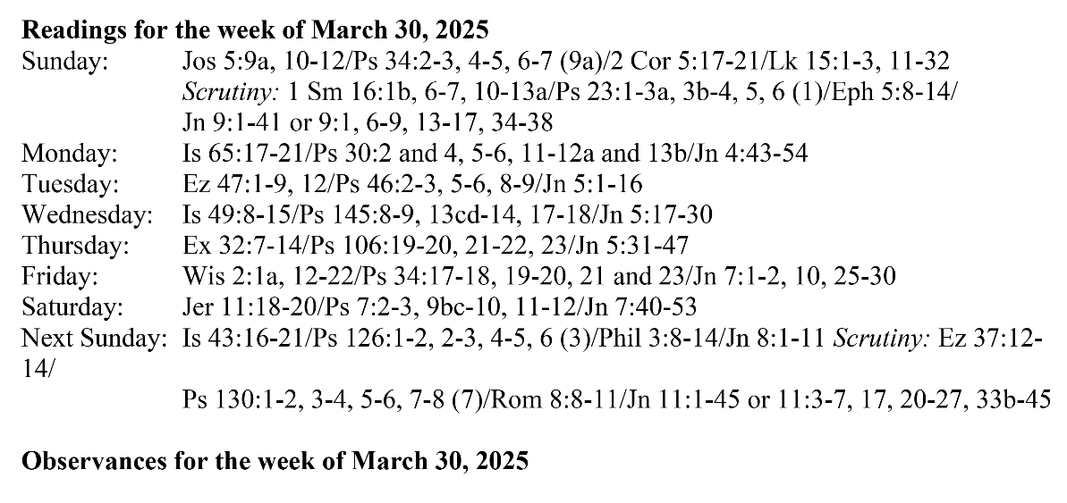
Are you in need of prayer? Do you have a prayer request? You can send your prayer requests to pcuadra@schottcommunities.org or call 954-434-3306 ext. 108

A copy of our prayer list can be found in the lobby of our chapel. To request a copy of our prayer list please email us at pcuadra@schottcommunities.org
To request a Mass please contact Pablo A. Cuadra at 954-434-3306 or e-mail at pcuadra@schottcommunities.org
Update: Celebrating a wedding anniversary soon? Let us know a week in advance and we can assist you with the renewal of your wedding vows.

Prayer to St. Michael the Archangel:
"St. Michael the Archangel, defend us in battle. Be our defense against the wickedness and snares of the Devil. May God rebuke him, we humbly pray, and do thou, O Prince of the heavenly hosts, by the power of God, thrust into hell Satan, and all the evil spirits, who prowl about the world seeking the ruin of souls. Amen"

