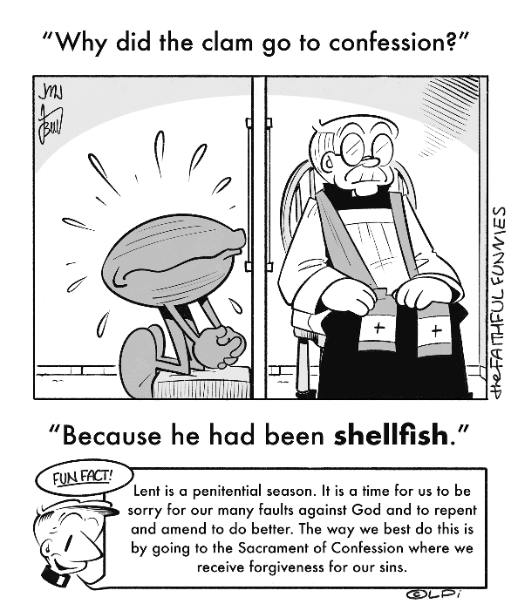
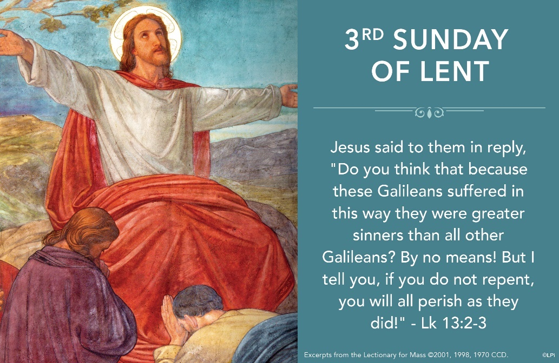
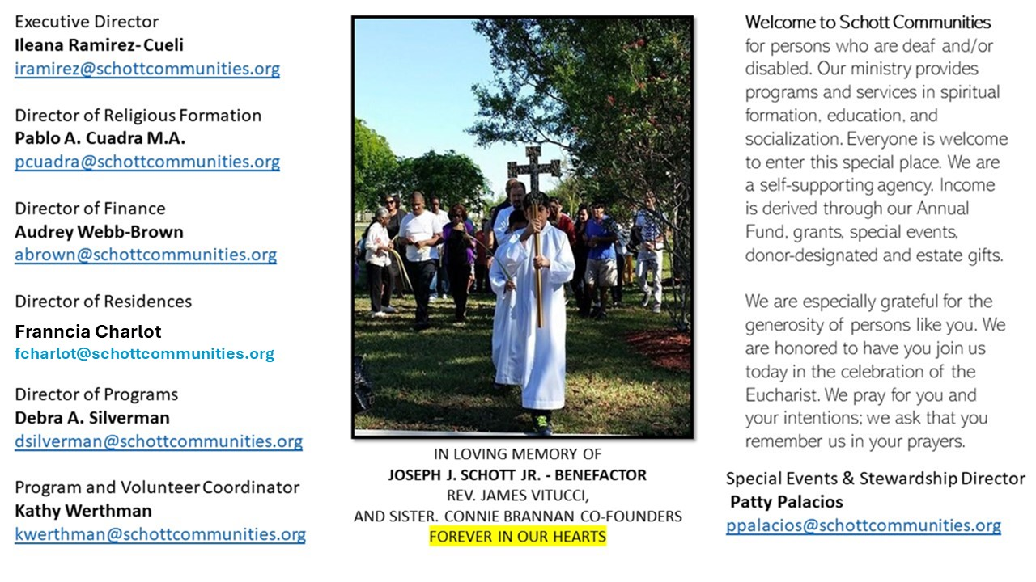

23 de marzo de 2025
3er Domingo de Cuaresma
En los desastres naturales, donde se pierden vidas humanas y algunos quedan vivos, nos sorprendemos y quizá pensamos, ¿Por qué estos se salvaron y los otros no? ¿Eran acaso mejores que los otros? ¿Fue un castigo para los que perdieron la vida? Sin embargo, sabemos que no es así. Nos quedamos como al principio, no hay respuesta. El Evangelio de hoy tiene momentos de reflexión profunda que implica que el corazón se convierta. Y la Palabra de Dios ayuda a madurar interiormente. La conversión es un proceso de madurar poco a poco en la fe, para enseguida dar frutos.
“La Cuaresma viene a despertarnos del letargo, de seguir adelante por inercia. Nos recuerda que podemos realizar algo nuevo en nosotros y en nuestro alrededor gracias a la bondad y misericordia de Dios, que siempre está dispuesto a perdonar” (Papa Francisco). Dios sigue esperando a que demos frutos buenos. Siempre nos tiene paciencia, una y otra ves nos espera. Cada año decide no cortar sino abonar y poner tierra nueva, y esperar. “Señor déjala un año más y mientas tanto cavaré alrededor y le hacharé abono. Puede ser que así de fruto en adelante y, si no, la cortas” (Lucas 13:8-9). Una nueva oportunidad para llevar a cabo lo que a Dios le gusta. Hacer justicia, hablar por los sin voz, dar tiempo de calidad a la familia y sobre todo ser menos irresponsables y menos violentos. Esas actitudes no nos llevan a ningún lado. ¡Dejemos que Dios nos abone en lo que necesitamos!

March 23, 2025
3rd Sunday of Lent
John 4:5-42

My childhood best friend was Xander Price. He was the fastest runner in school, an excellent baseball player and Jewish. Though his family wasn’t intensely religious, I felt totally at home with them despite our religious differences. Everything about their Judaism seemed to undergird and strengthen my own experience of being a Catholic. I knew they didn’t believe in Jesus like my family did, but I intuited somehow that Jesus was “hiding” in their religion. Like a cat moving under a blanket, ready to emerge at any moment, the Lord was hidden there in a special way.

In the Gospel for this third Sunday of Lent, Jesus says, “For if you had believed Moses, you would have believed me, for he wrote of me” (John 5:46). Stunning words, those. Moses wrote about Jesus. The way therefore that we come to know and believe in Jesus is to discover him lurking in Moses’ writings. The Hebrew Scripture is the wonderful womb in which Jesus gestates within a host of images: Adam, Isaac, David, Melchizedek, the Temple, sacrificed lambs, prophets and so on. Right now, in your parish’s OCIA program, soon-to-be baptized people are carefully studying where Jesus is in the writings of Moses, so that they may believe in him. This works for all of us, too, who wish to deepen our knowledge and love of Jesus.

Lenten challenge: Take some time to prayerfully study one of the images of Jesus listed above in the Old Testament. Identify which one you find compelling and consider why this is so. If you don’t know where to start, begin with the prophet Jeremiah as an image of Jesus.

— Father John Muir

St. Jude Chapel, Sunday, March 23rd 2025
Father Celsus Auguiste
Celebrant

Prayer of Lent
Dear God,

As I fast, may Your presence be my sustenance.
As I pray, continue to reveal Yourself to me.
As I give to others, may I know You even more deeply.
Amen.


Christian Giving
March 16th, 2025
$TBA

We sincerely thank you and bless you for your generosity.
A bequest is a powerful tool to help the Deaf or Disabled.

Mass Intentions
“For the repose of the Souls in Purgatory
Requested by Schott Communities


Follow us on Facebook
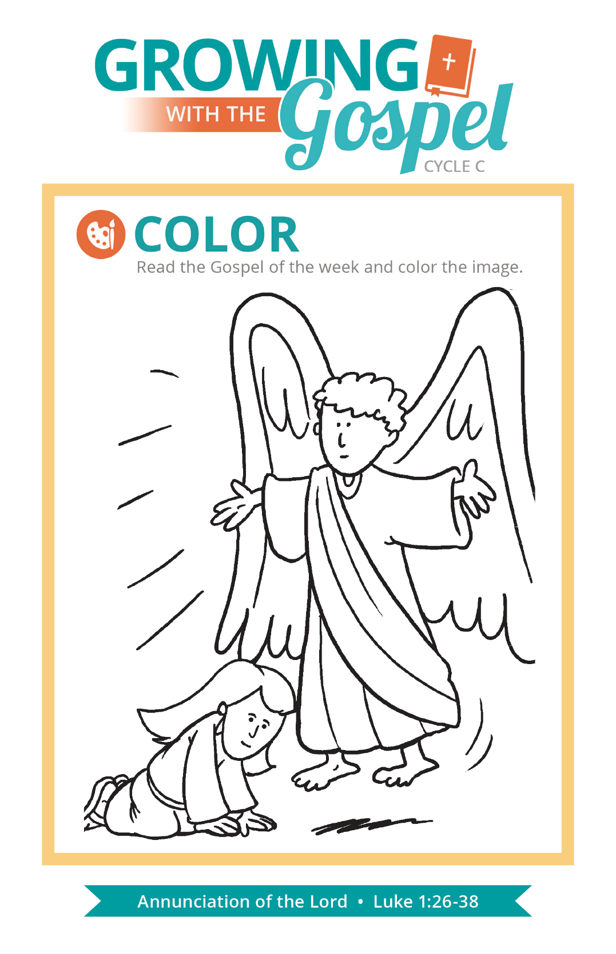
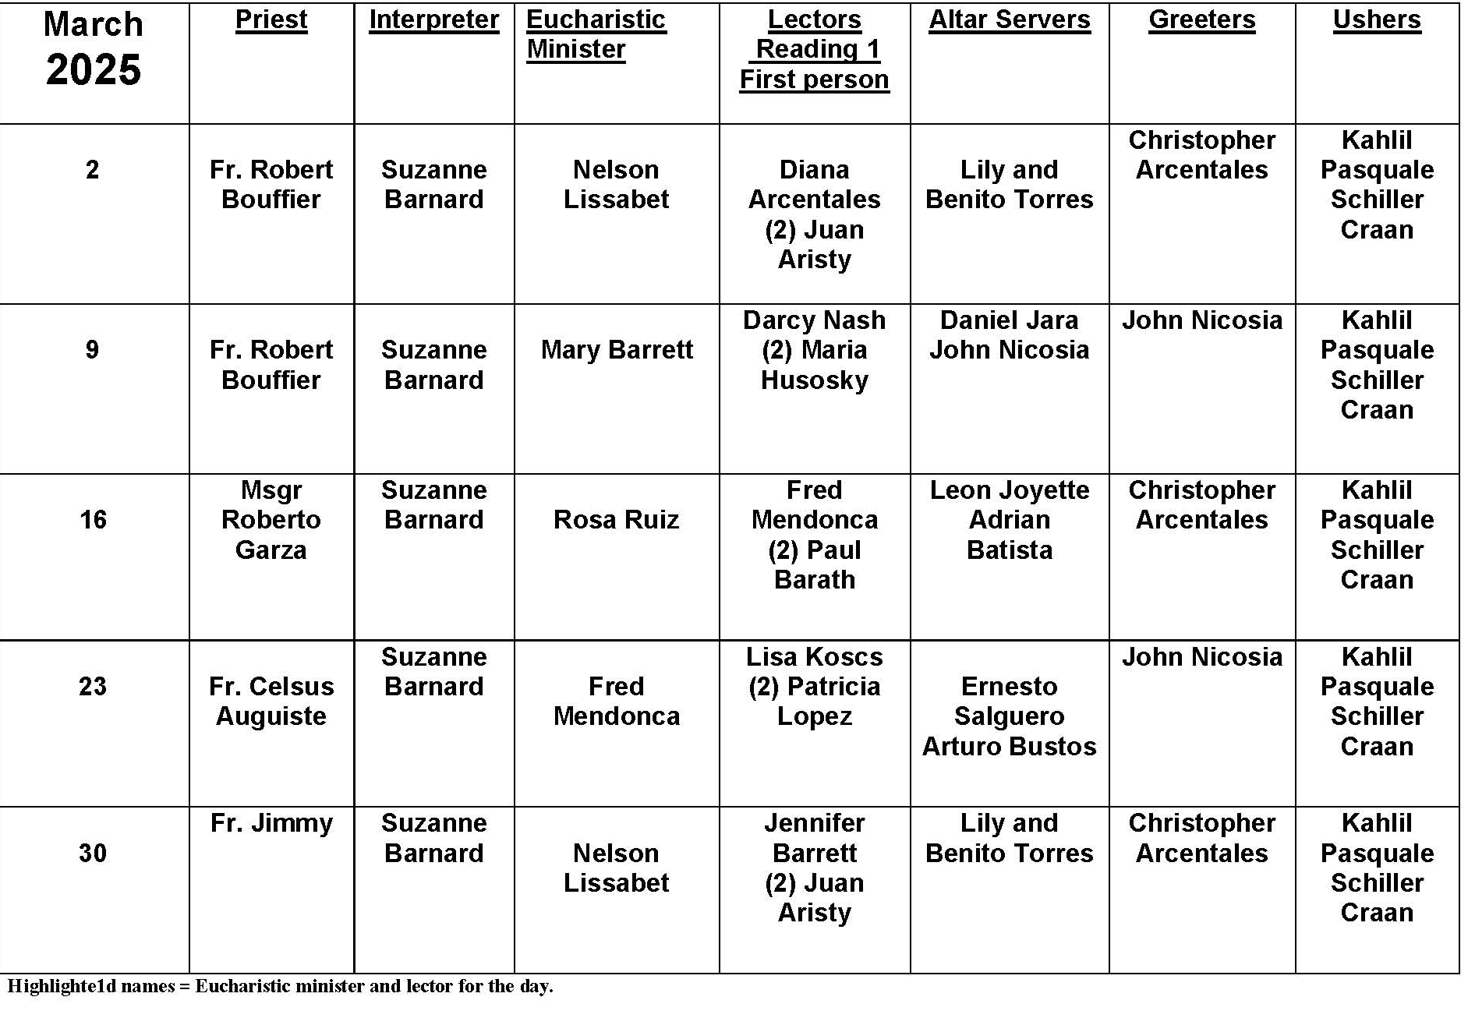
Mortal versus Venial Sin

Question:
What is the difference between mortal and venial sin?

Answer:
Sin is a deliberate thought, word, action, or omission contrary to God’s law. Since the beginnings of the Church, sin has been distinguished by its gravity. “Grave matter” is traditionally defined by the Ten Commandments. If a person commits a grave sin with full knowledge of the action’s evil and with the complete consent of their will, this is a mortal sin. The effects of mortal sin are grave – the loss of sanctifying grace, which can be restored by a fresh outpouring of God’s mercy in the sacrament of Reconciliation.

Venial sin does not fit one or more of these conditions (for example, a less serious matter still freely chosen or grave matter committed while under force or ignorance of God’s law). The effects of venial sin – while still damaging to the human heart and human society – are less severe. Even so, smaller sins build habits, which can obstruct our growth in virtue. When we are serious about following Jesus, we should do our best to avoid all sin, whether large or small!

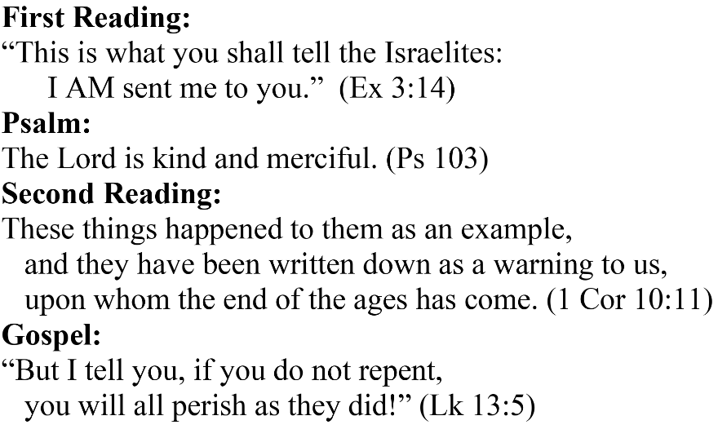
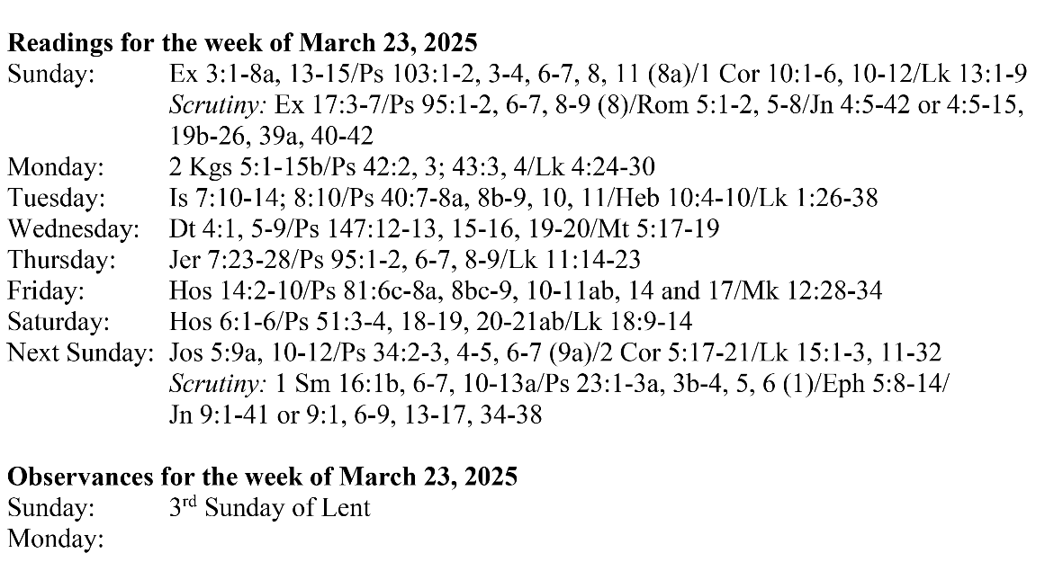
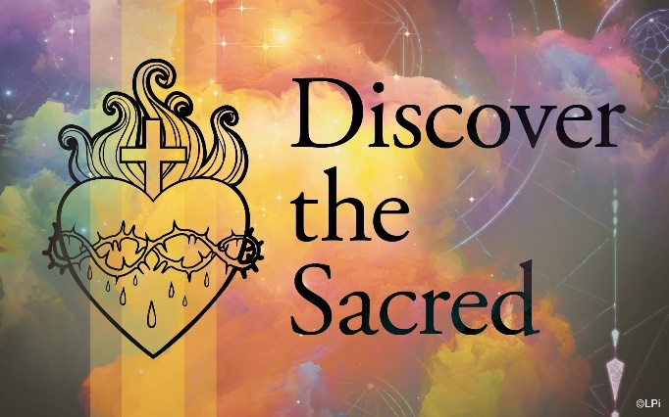
Are you in need of prayer? Do you have a prayer request? You can send your prayer requests to pcuadra@schottcommunities.org or call 954-434-3306 ext. 108

A copy of our prayer list can be found in the lobby of our chapel. To request a copy of our prayer list please email us at pcuadra@schottcommunities.org
To request a Mass please contact Pablo A. Cuadra at 954-434-3306 or e-mail at pcuadra@schottcommunities.org
Update: Celebrating a wedding anniversary soon? Let us know a week in advance and we can assist you with the renewal of your wedding vows.

Prayer to St. Michael the Archangel:
"St. Michael the Archangel, defend us in battle. Be our defense against the wickedness and snares of the Devil. May God rebuke him, we humbly pray, and do thou, O Prince of the heavenly hosts, by the power of God, thrust into hell Satan, and all the evil spirits, who prowl about the world seeking the ruin of souls. Amen"

