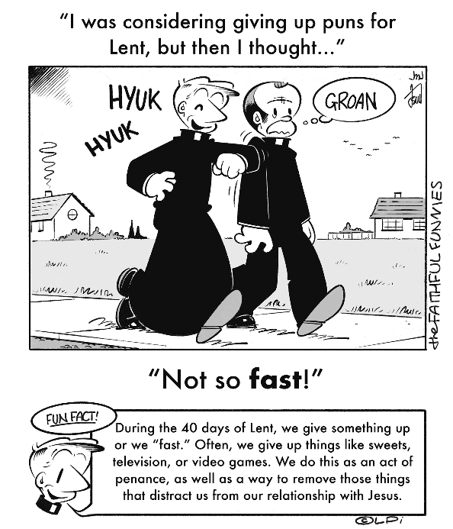
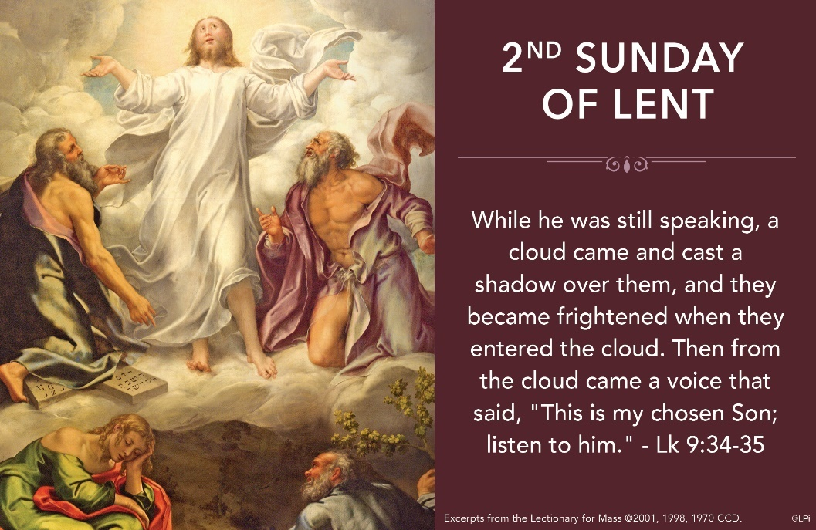
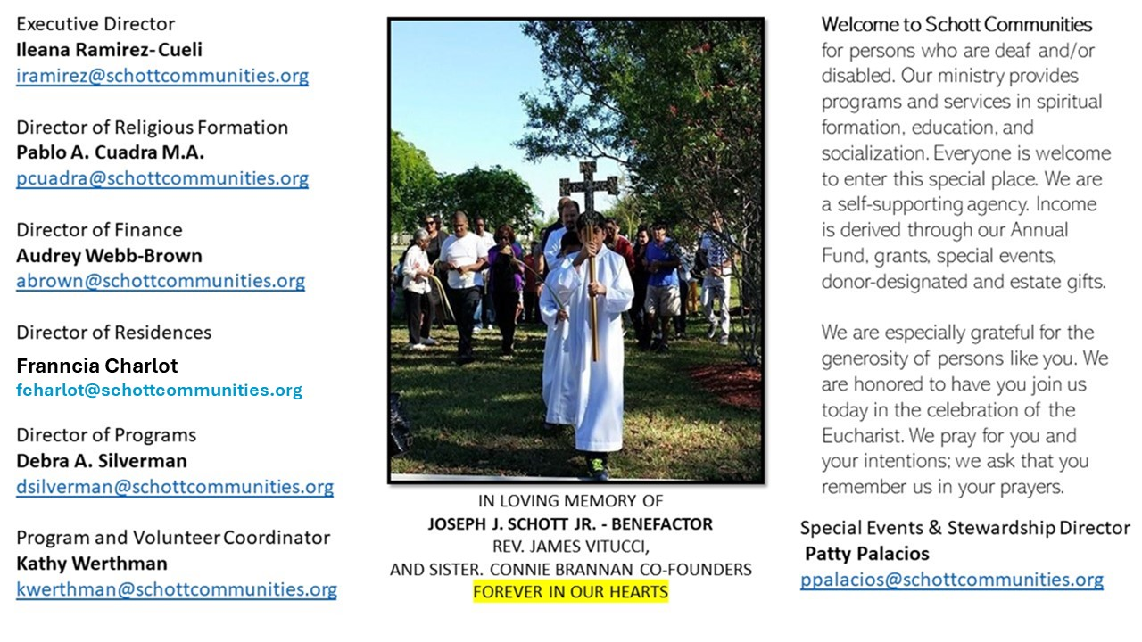

16 de marzo de 2025
2º Domingo de Cuaresma
¿Dónde está la presencia cercana y misteriosa de Dios en mi vida? ¿Dónde palpo esa relación de Jesús amigo cercano a mí? Estas preguntas nos pueden ayudar a comprender el misterio de la Transfiguración de este segundo Domingo de Cuaresma. Pedro, Santiago y Juan fueron testigos oculares de una presencia de Dios diferente a la que vivían todos los días con Jesús. De alguna manera, con esta experiencia se abren sus ojos y reconocen que con Jesús está presente el mismo Dios. Es por eso, que, Pedro desea quedarse para siempre en ese lugar: “Maestro, ¡qué bueno que estemos aquí! Levantemos tres chozas: una para ti, otra para Moisés y otra para Elías. Pero no sabía lo que decía” (Lucas 9:33).
Hoy es un día para abrir los ojos y dimensionar la grandeza de este gran evento en la vida de los discípulos, y también, en la vida nuestra. Jesús se transfigura para ellos en el monte y para nosotros se transfigura en cada Eucaristía, donde el pan se transforma en el Cuerpo de Jesús y el vino en su Sangre. Sin embargo, sin los ojos de la fe, no nos daremos cuenta de la presencia real de Cristo entre nosotros. Pensemos, en ¿qué otros momentos Jesús se ha transformado ante nosotros y hemos descubierto la presencia misteriosa de Dios? El Papa Francisco nos ayuda con lo siguiente: “El Padre proclama a Jesús su Hijo predilecto, diciendo: Escuchadlo. No podemos olvidarnos de escuchar a Jesús”.

March 16, 2025
2nd Sunday of Lent
Luke 9:28b-36

St. Thomas Aquinas said that friends share three things: time, possessions and secrets. For example, how do I know if you’re my friend? Well, let’s say we’ve been to Mexico together, you’ve tried my shaky attempts at pasta carbonara, and you know what ridiculous costume I wore in a music video I filmed in my early twenties. We, dear reader, are definitely friends. We’ve shared time, possessions and secrets.

How does friendship with Jesus develop? The same way. Jesus lives and eats with his disciples. Then he takes Peter, James and John to Mount Tabor and there reveals to them his deepest secret: his glorious, divine Sonship. The majesty of God shines from within his humanity in a way that goes beyond description. God the Father confirms this “secret,” saying, “This is my chosen Son, listen to him” (Luke 9:35). It’s all so precious that “they fell silent and did not at that time tell anyone.” Do we take time to be alone with Christ, to allow him to mystically share this “secret” with us as his dear friends?

Lenten challenge: This week, identify one time when you experienced an awareness of some specific aspect of Jesus — perhaps on a retreat, at Mass, in prayer or in an act of service. Spend ten minutes consciously re-living that experience in your heart. If you can’t recall one, set aside at least two hours this Lent as a mini retreat, either alone in nature or in the presence of the Blessed Sacrament. Focus on him and ask him to share the secrets of his heart with you. He will. Then, as his friend, share the secrets in your heart.

— Father John Muir

St. Jude Chapel, Sunday, March 16th 2025
Monsignor Roberto Garza
Celebrant

St. Cyril of Jerusalem

St. Cyril of Jerusalem was a bishop in the fourth century. His teachings on the Eucharist, among other topics, secured his place as a Doctor of the Church. Though his ministry was marked by estrangement, exile, and ultimately, reconciliation, he never lost his faith!


Christian Giving
March 9th, 2025
$TBA

We sincerely thank you and bless you for your generosity.
A bequest is a powerful tool to help the Deaf or Disabled.

Mass Intentions
“For the repose of the Souls in Purgatory
Requested by Schott Communities


Follow us on Facebook
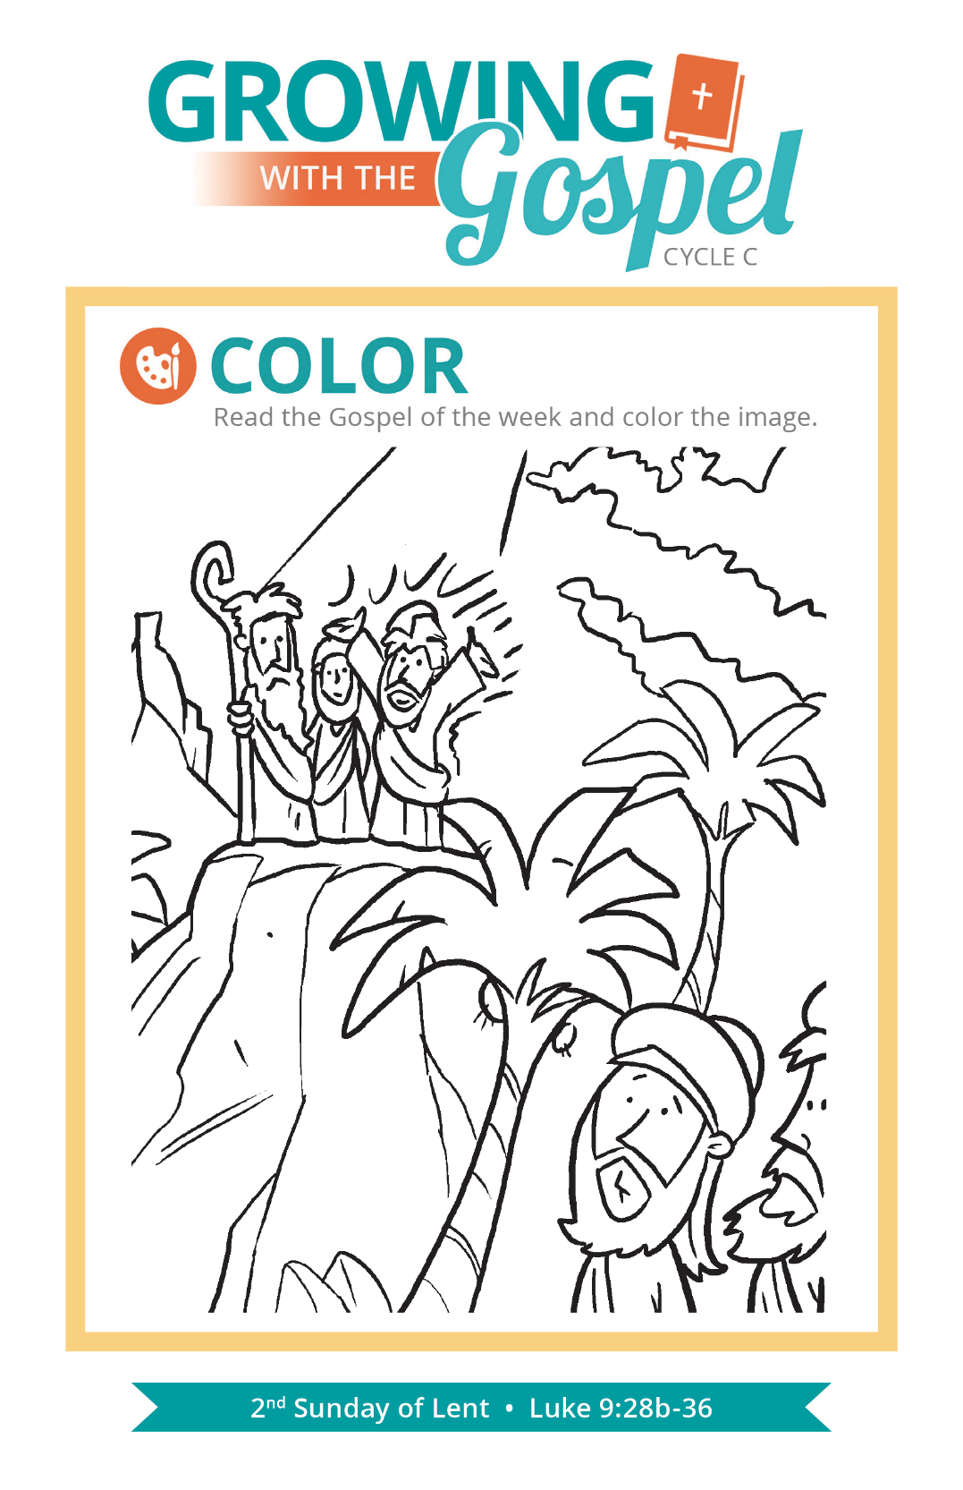
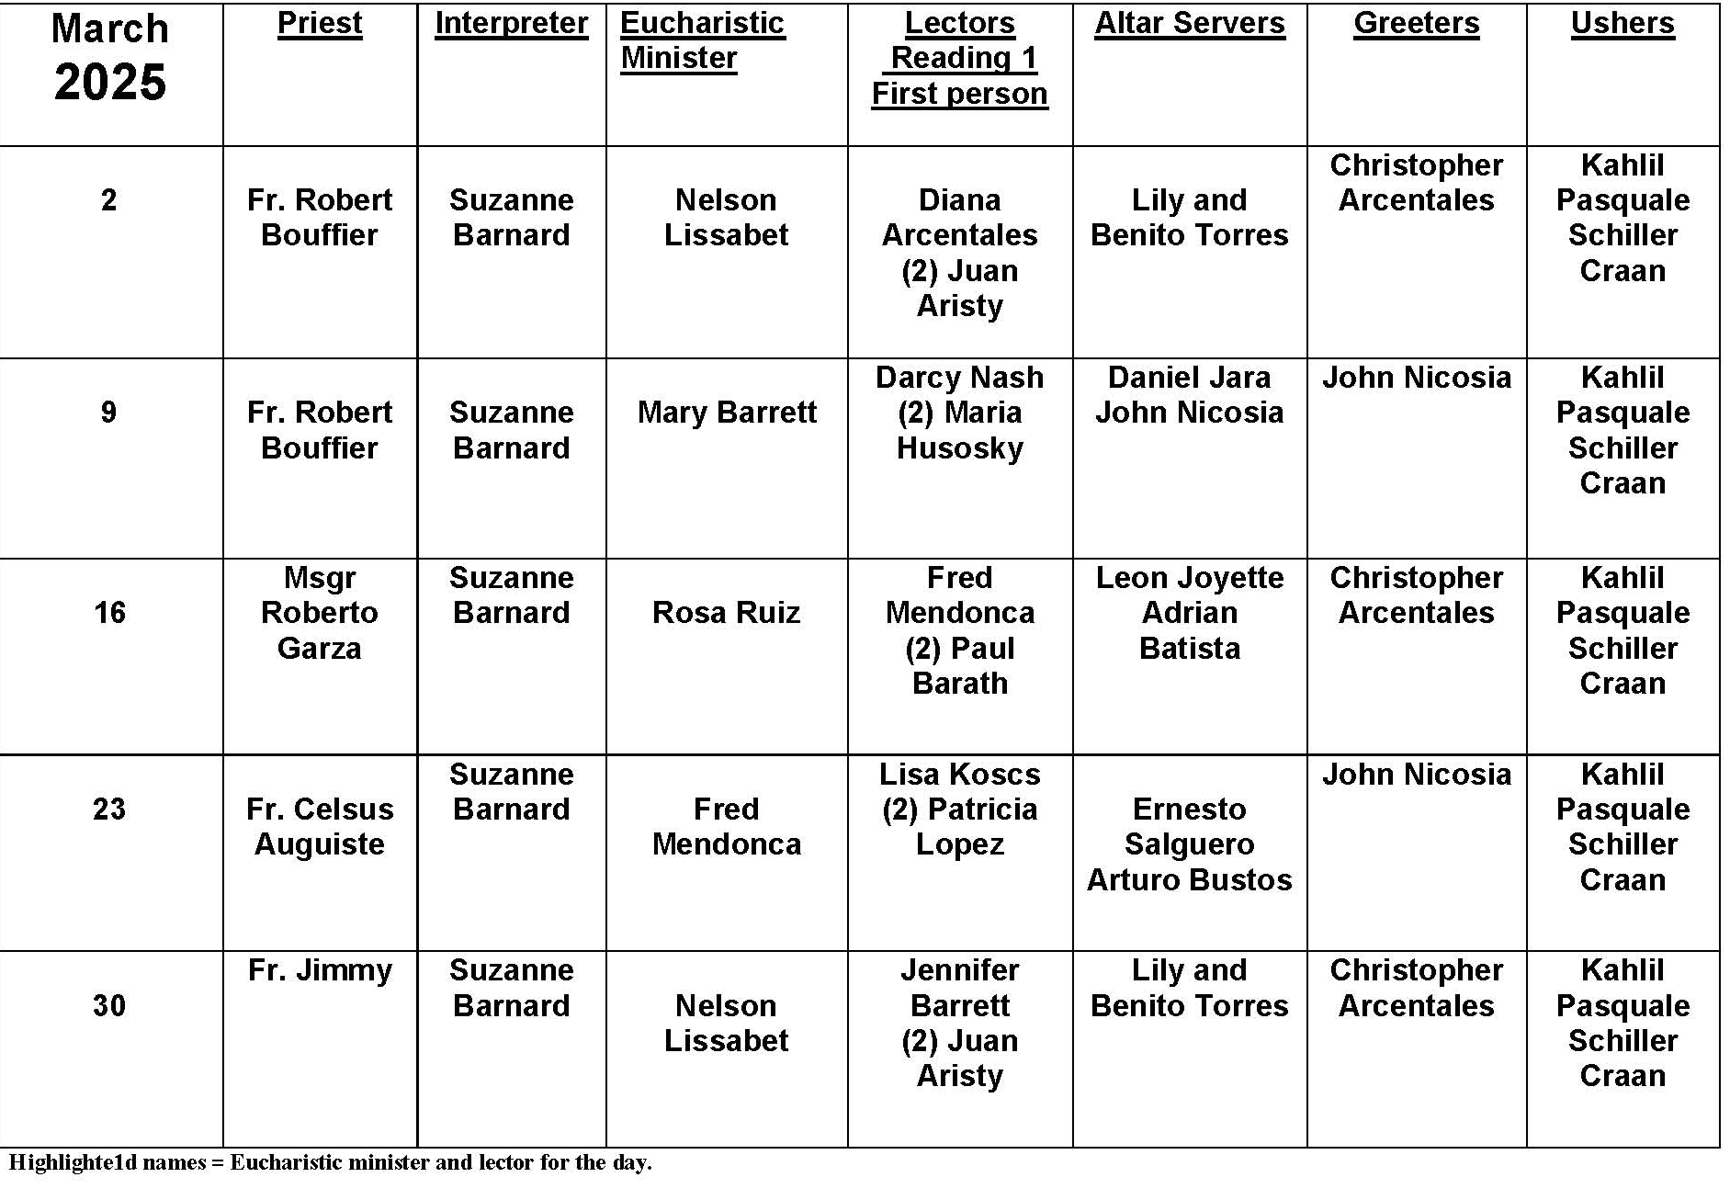
Lenten Reading

Question:
Can you recommend some good books for Lenten spiritual reading?

Answer:
On more than one occasion, a coach being interviewed about his team--successful or not--will be asked about the next step. The inevitable response includes something about getting back to basics. Reviewing the fundamentals of the sport strengthens performance and builds confidence.

The best Lenten reading takes us back to the fundamentals. If Lent is the time for the Church to be on retreat, then we should focus on the texts that help us deepen our understanding of our faith. Spend time reading one of the Gospels, and use a Scripture commentary to learn all you can about the passion of Jesus. Read about the lives of the saints, especially your patron saint and that of your parish. Perhaps there is some local candidate for sainthood, like Father Walter Ciszek, SJ, who wrote several faith-inspiring books. Finally, you can use the Catechism of the Catholic Church to learn more about the church's teachings and beliefs. The sections on prayer and the Mass are really great reflections. Focusing on the basics really helps us take another step forward in our faith. We have not only a better understanding of what we believe and practice, but also why we believe. With that belief comes the confidence we need to be better, more faithful witnesses to Christ.


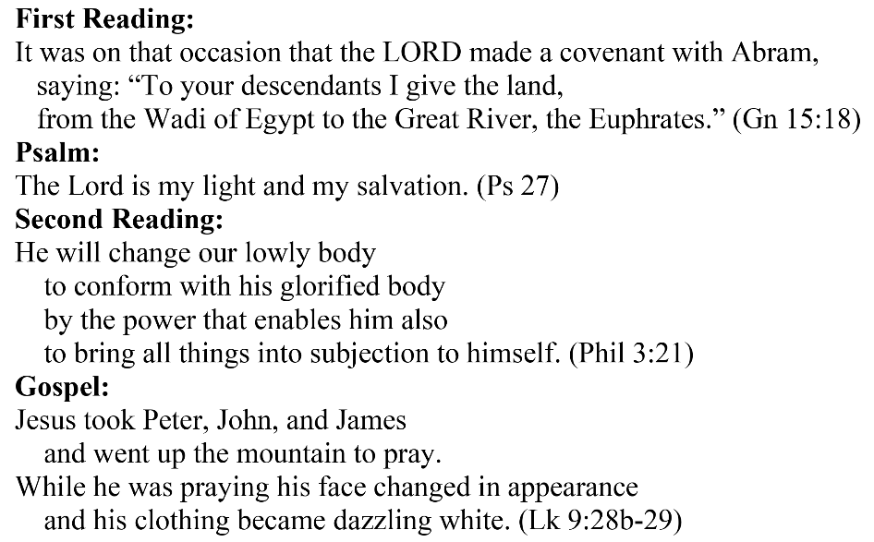
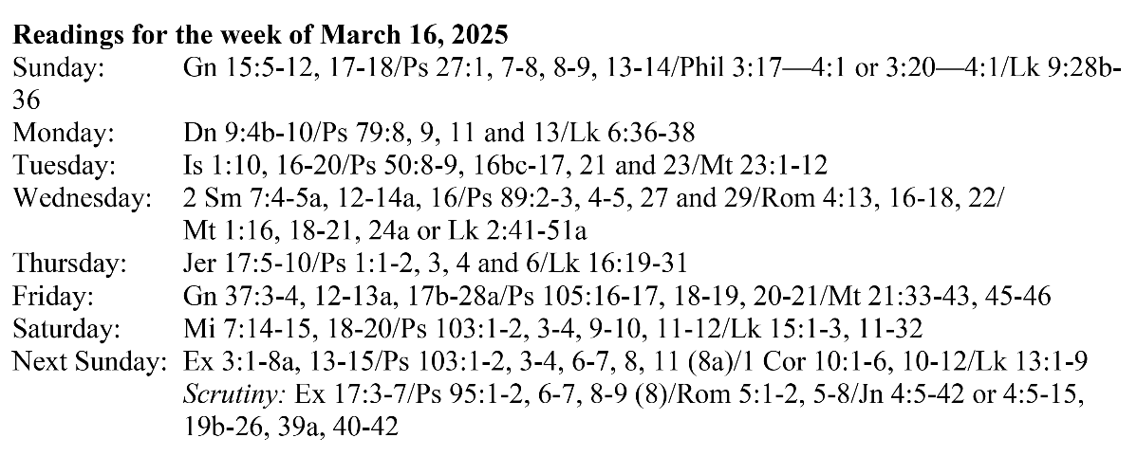
Are you in need of prayer? Do you have a prayer request? You can send your prayer requests to pcuadra@schottcommunities.org or call 954-434-3306 ext. 108

A copy of our prayer list can be found in the lobby of our chapel. To request a copy of our prayer list please email us at pcuadra@schottcommunities.org
To request a Mass please contact Pablo A. Cuadra at 954-434-3306 or e-mail at pcuadra@schottcommunities.org
Update: Celebrating a wedding anniversary soon? Let us know a week in advance and we can assist you with the renewal of your wedding vows.

Prayer to St. Michael the Archangel:
"St. Michael the Archangel, defend us in battle. Be our defense against the wickedness and snares of the Devil. May God rebuke him, we humbly pray, and do thou, O Prince of the heavenly hosts, by the power of God, thrust into hell Satan, and all the evil spirits, who prowl about the world seeking the ruin of souls. Amen"

