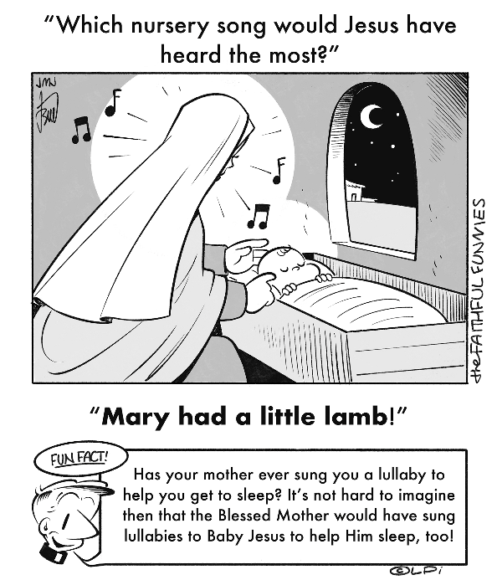
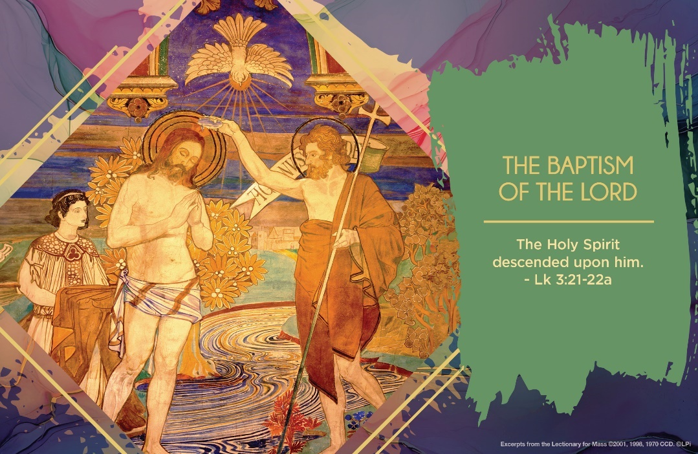
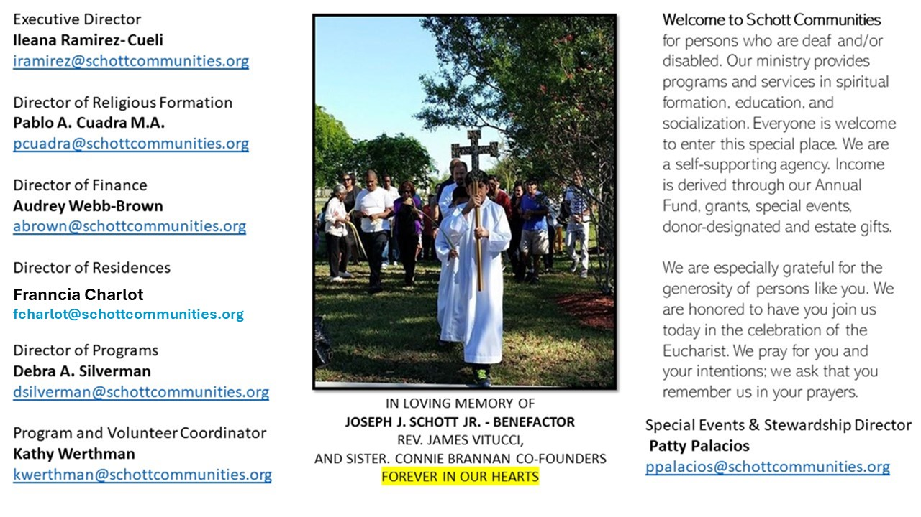

12 de enero de 2025
El Bautismo del Señor
Si pudiéramos recordar nuestro propio Bautismo, tal vez sentiríamos algo muy especial sobre la invitación de Dios a sentirnos predilectos hijos e hijas amados por Dios. Ahí, en la pila bautismal, ese día tan especial, recibimos el Espíritu Santo. Ojalá, hoy estemos dispuestos a escuchar en nuestro corazón las mismas palabras que Jesús escuchó en el Rio Jordán: “Tú eres mi Hijo, hoy te he dado la vida” (Lucas 3:22). Pidamos al Señor que nos ayude a sorprendernos y llenarnos de asombro y alegría, con las cosas pequeñas que Dios pone en nuestro camino cotidiano; sabiendo que el Espíritu Santo nos guía y lleva a tener una relación personal con Dios.
De cada uno depende que la semilla sembrada el día de nuestro Bautismo germine y crezca, dando frutos en abundancia para el bien propio, de la familia y de la comunidad. La vida entera de Jesús fue ser reflejo del Padre y hacer su voluntad; siempre fue su prioridad. ¿Qué hago yo para para reflejar que Dios existe en mí? ¿De qué modo hago su voluntad en mis acciones? “El Bautismo es el más bello y magnifico de los dones de Dios… lo llamamos don, gracia, unción, iluminación, vestidura de incorruptibilidad, baño de regeneración, sello y todo lo más precioso que hay” (Catecismo de la Iglesia Católica, numeral 1243). Señor, abre mis ojos y mis oídos a tu Palabra para escuchar tu voz y poner en práctica tu amor.

January 12, 2025
The Baptism of the Lord
Luke 3:15-16, 21-22

In my second year of theology studies, I went to confession to a priest visiting the seminary for a three-day retreat. My heart wasn’t in it. I was going through the motions. I confessed my sins and waited for his response. The priest said, “For your penance, I’d like you to go into the chapel and repeat the words ‘You are my beloved Son, with you I am well pleased’ (Luke 3:22) until they mean something to you.” Easy penance, I thought.

But to my surprise, I struggled to say those words. I sensed a strong interior resistance blocking them. How could God be well-pleased with me? He couldn’t be, I thought. A battle within me ensued. Two hours later, the resistance vanished, and I found myself able to speak, and claim as my own, those marvelous words. I emerged from the chapel with a new, deep, peaceful conviction that I was indeed God’s beloved son.

Those words are a precious gift from heaven to all of us. Jesus’ baptism, which we celebrate this week, offers them to us. Are we willing to receive these words anew? Many things can block this deepening of our baptismal identity: failings, sins, disappointments, traumas, problems, and so on. Yet God’s love is always greater. This week I challenge you to prayerfully repeat these words over yourself — or perhaps over someone you’re struggling to love — until those words find a home in your heart.

— Father John Muir

St. Jude Chapel, Sunday, January 12th, 2024
Father Celsus Auguiste
Celebrant

St. Hilary of Poitiers, Bishop and Doctor of the Church | January 13
Born a pagan, St. Hilary (c. 315 – c. 367) studied philosophy and the meaning of life, eventually making his way through the bible. He became a convert and was appointed bishop of Poitiers in 353. Sometimes referred to as the Hammer of the Arians, St. Hilary defended the Nicene Creed against a popular heresy, Arianism. He was exiled to Phrygia for opposing Roman emperor Constantius II, who preferred the heresy which denies Christ’s divinity. From Phyrgia St. Hilary fought with his pen, zealously writing against the heresy.


Christian Giving
January 5th, 2024
$TBA

We sincerely thank you and bless you for your generosity.
A bequest is a powerful tool to help the Deaf or Disabled.

Mass Intentions
“For the repose of the Soul of Sean Donnelly”
Requested by Ann Donnelly


Follow us on Facebook
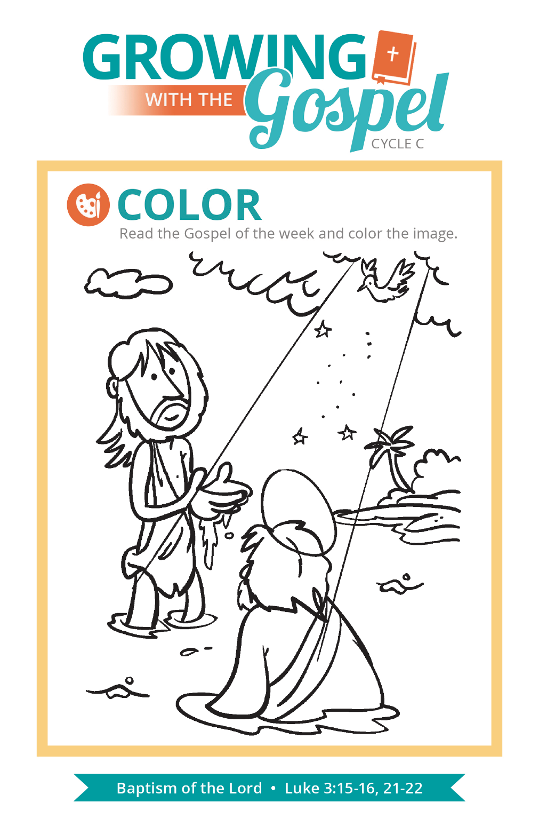
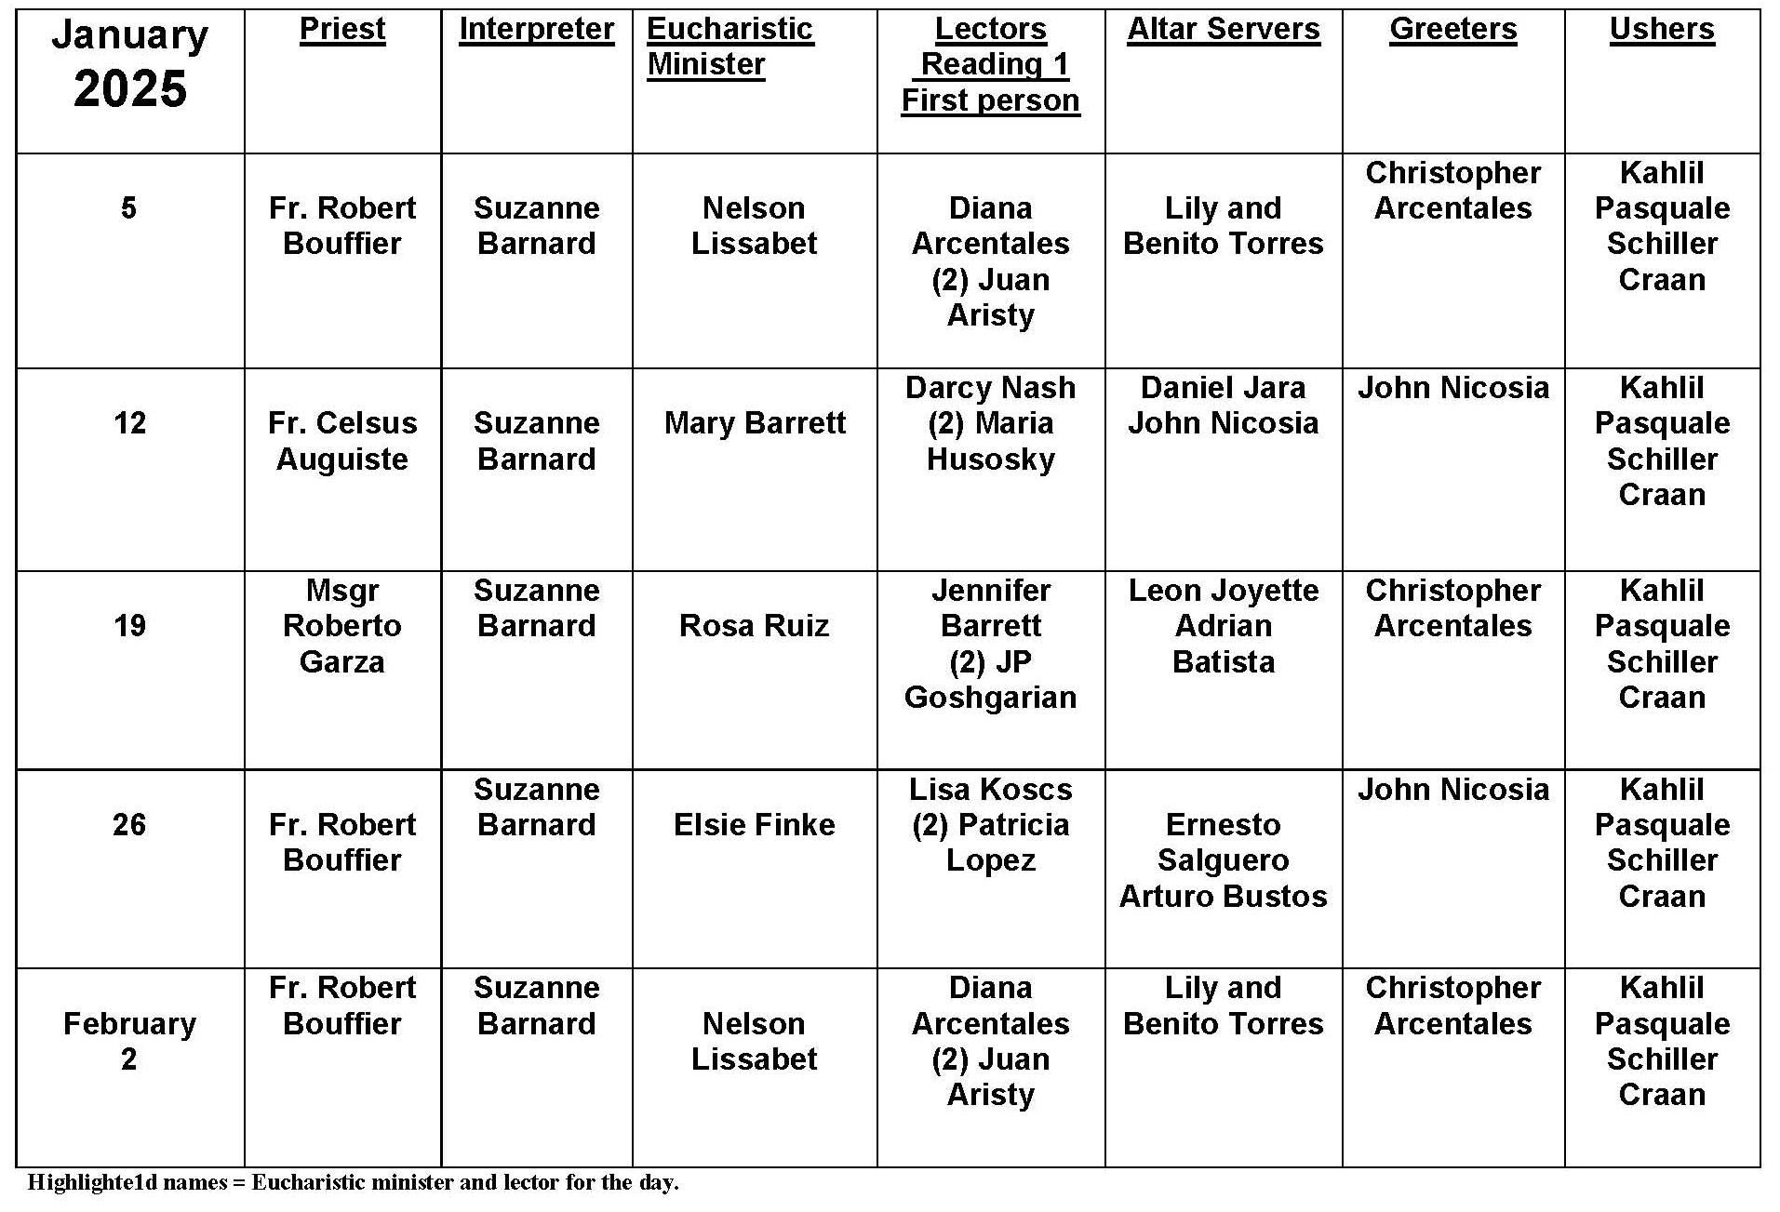
Baptismal Bib

Question:
At my grandson’s Baptism, the priest put a bib on the baby. I do not remember seeing this before. Why is this done? Is it something new?

Answer:
When an adult is baptized, there is a part in the ceremony when the newly baptized is vested in a white garment. It is symbolic of the changes that baptism brings in the life of the baptized as they are freed from the bonds of sin and brought into the saving grace of Christ. Realities that are so profound are symbolically presented so that we might better grasp and understand them.

Infants are often dressed in a baptismal dress, which is the baptismal garment. In some places, the bib is used as a kind of baptismal garment. At the place in the ceremony where the investiture takes place, the bib is used. Some are poncho-like and fit over the baby's head. Others are simply placed on the baby's chest. If the baby is dressed in a white garment, nothing else is needed. The prayer says it all: “See in your white garment the outward sign of your Christian dignity ... bring that dignity unstained into the everlasting life of heaven.” In baptism, we are given our purpose and goal in life as believers and this is symbolized by the white garment.

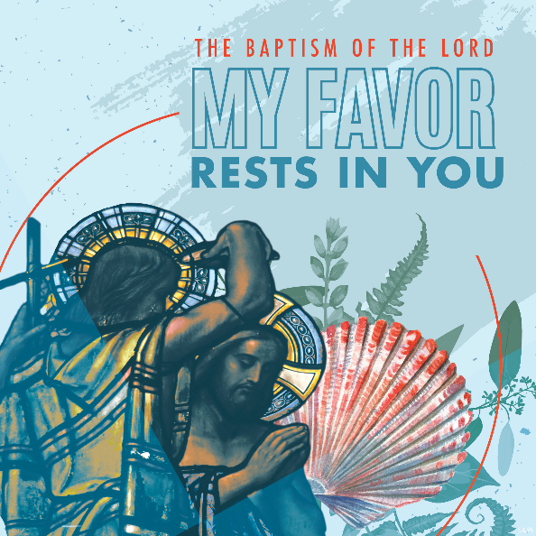
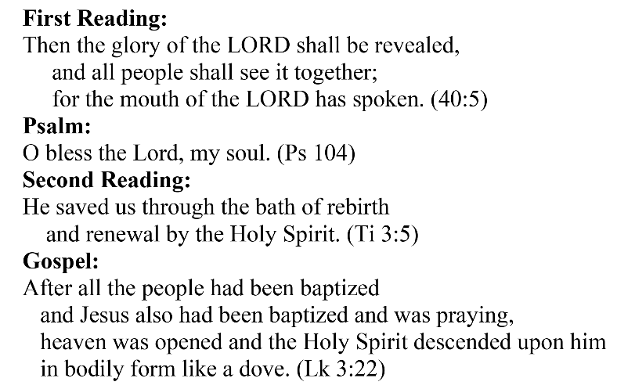
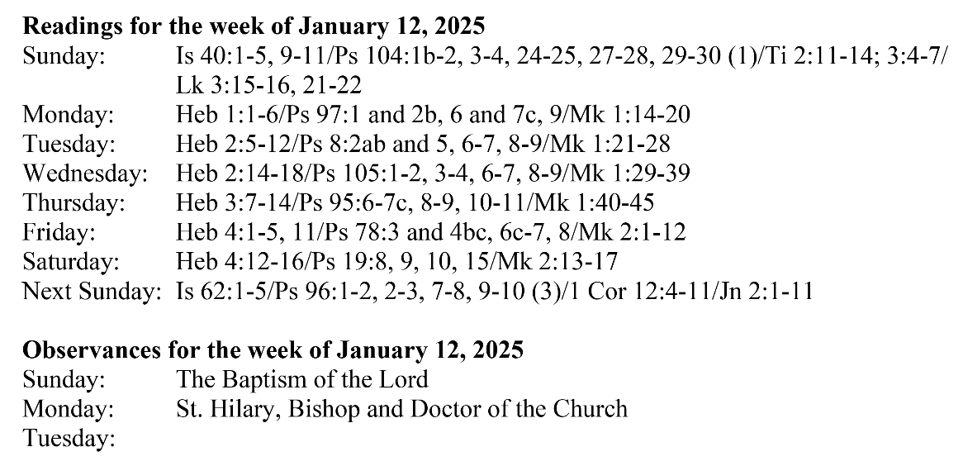
Are you in need of prayer? Do you have a prayer request? You can send your prayer requests to pcuadra@schottcommunities.org or call 954-434-3306 ext. 108

A copy of our prayer list can be found in the lobby of our chapel. To request a copy of our prayer list please email us at pcuadra@schottcommunities.org
To request a Mass please contact Pablo A. Cuadra at 954-434-3306 or e-mail at pcuadra@schottcommunities.org
Update: Celebrating a wedding anniversary soon? Let us know a week in advance and we can assist you with the renewal of your wedding vows.

Prayer to St. Michael the Archangel:
"St. Michael the Archangel, defend us in battle. Be our defense against the wickedness and snares of the Devil. May God rebuke him, we humbly pray, and do thou, O Prince of the heavenly hosts, by the power of God, thrust into hell Satan, and all the evil spirits, who prowl about the world seeking the ruin of souls. Amen"

