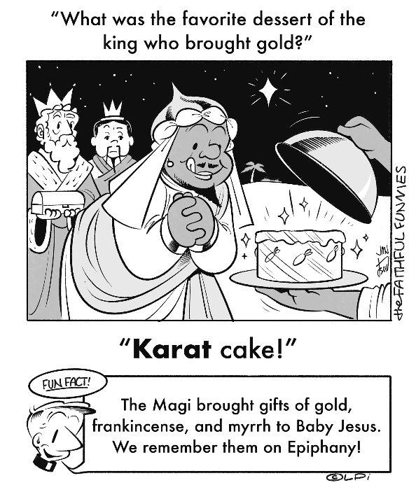
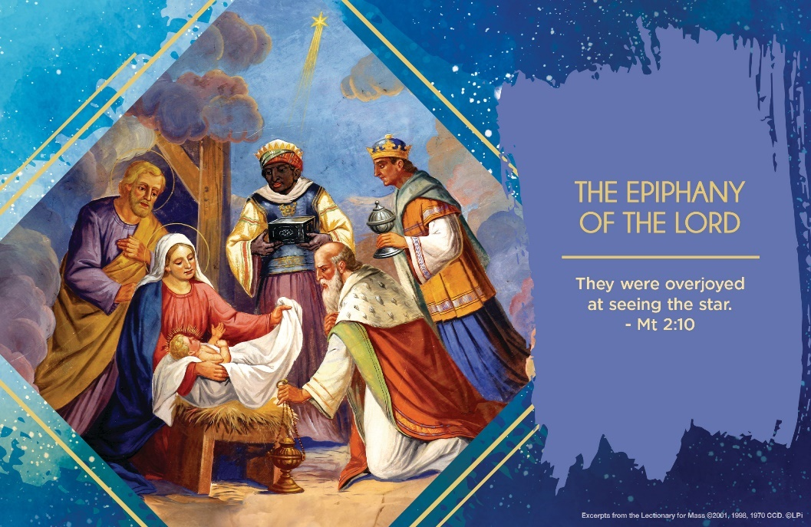
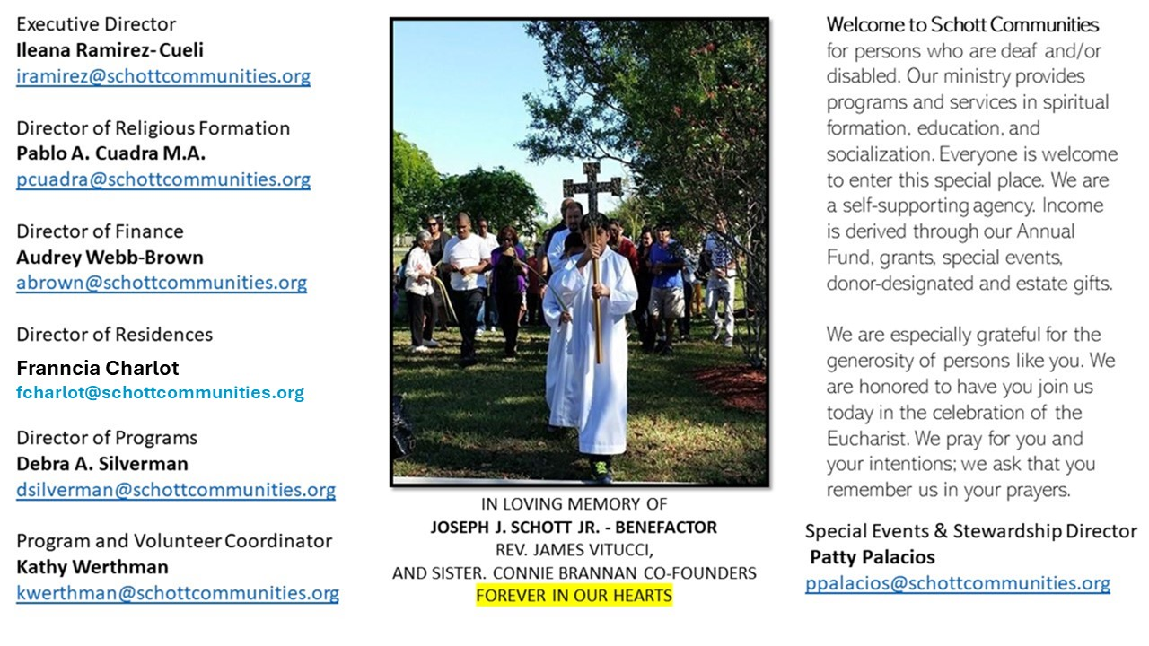

5 de enero de 2025
La Epifania del Señor

Estamos aún en un ambiente navideño, la alegría perdura todavía en nuestro corazón y en el ambiente. El Evangelio nos narra que los Magos, obedeciendo la voz de su conciencia y guiados por una estrella, se ponen en marcha. Deseaban reconocer a Dios para ofrecerle sus regalos de oro, incienso y mirra. Después de investigar y preguntar, se aseguran de continuar el camino. Su esfuerzo no fue en vano, ellos fueron capaces de encontrarlo: “Al entrar a la casa vieron al niño con María, su madre; se arrodillaron y le adoraron” (Mateo 2:11). ¿Cuáles han sido mis esfuerzos en esta Navidad para encontrar a Dios? ¿A quien he preguntado para ser guiado y llegar a Él?
Para ver el misterio de Dios, debemos prepararnos. Esto implica movimiento, bondad, y sencillez. Solo así, experimentaremos la grandeza de Dios y lograremos ver nuestra pequeñez. Callar y percibir el ambiente del Evangelio de esta Liturgia es esencial para una limpieza del corazón. Es tiempo de abandonar la terquedad de nuestra vida, la desconfianza e hipocresía que a veces tenemos guardada como Herodes. “Se dejaron guiar por el impulso de la luz celeste y mientras acompañaban con atenta contemplación la luz que los precedía, eran guiados al conocimiento de la verdad por el esplendor de la gracia” (San León Magno, Primer sermón de la Epifanía). Todos estamos invitados y tenemos derecho de mirar al cielo como los Magos y buscar la estrella que nos guía en el camino: ¡Jesús!

January 5, 2025
The Epiphany of the Lord
Matthew 2:1-12

Have you ever wondered why the magi had gold, frankincense, and myrrh? Matthew’s Gospel tells us, “Then they opened their treasures and offered him gifts of gold, frankincense, and myrrh” (Matt. 2:11). Why are these things their “treasures”? One possible answer is they were magicians and astrologers, and these three items were the tools of their questionable trade. In offering them to Christ, they demonstrate that they will cease using such items to predict or control life. They place this baby-king, the God of Israel, at the center of their lives, and not their own devices of control, manipulation and prediction.

Isn’t that what we need to do, too? Consider, for example, the magical power of money, symbolized by the magi’s gold. Seemingly whatever we ask of money, it does. It wields a god-like power over the world. It can predict the future by guaranteeing better outcomes for us — which is why it is such a tempting alternative to trusting in God. The problem is such absolute trust in money enslaves us to the economic forces that make money so powerful. In paying homage to Jesus with “gold” (i.e., tithing), we participate in his authority over (and therefore freedom from) the magical sway of money.

What things in your life do you use to predict or control your future? What in your life seems to give you power over the world? Those are your treasures. Are you tired of feeling enslaved to them? Find a way to open them and give them to Christ, and you will be freer.

— Father John Muir

St. Jude Chapel, Sunday, January 5th, 2024
Father Robert Bouffier
Celebrant

St. John Neumann | January 5

St. John Neumann, patron saint of educators, immigrants, and sick children, was the first male saint to be canonized from the USA. An immigrant himself, he expanded Catholic education in his region from 2 schools to 100 & ministered in 6 different languages!


Christian Giving
December 29th, 2024
$TBA

We sincerely thank you and bless you for your generosity.
A bequest is a powerful tool to help the Deaf or Disabled.

Mass Intentions
“For the repose of the Souls in Purgatory”
Requested by Schott Communities


Follow us on Facebook
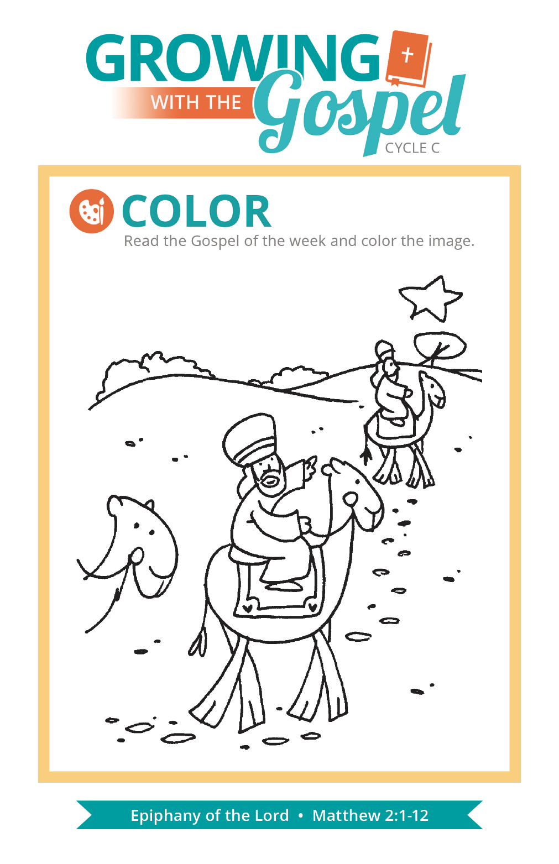
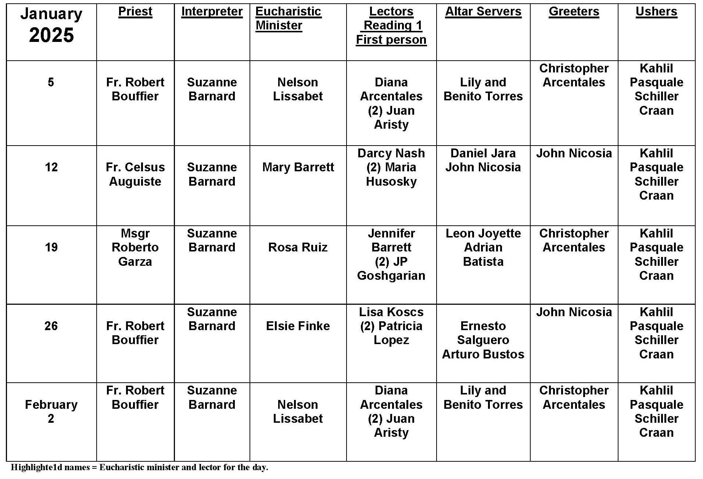
Epiphany
Question:
Besides the Wise Men, what is significant about the Epiphany?
Answer:
Epiphany means “manifestation,” or public display. The feast is usually celebrated January 6. In the US, it is celebrated on the Sunday nearest to January 6. It originates from a story unique to Matthew (2:1-12). Magi from the East come to offer homage to the newborn King, presenting him with gifts of gold, frankincense, and myrrh.
This part of Matthew’s infancy narrative differs from Luke’s account of the birth of Jesus. In Luke there are no Magi, star, nor gifts. Luke has Jesus being born in a stable after Mary and Joseph’s long travel from Nazareth to Bethlehem. Matthew seems to have the family living in a house in Bethlehem, where the Magi find them.
Why these differences? They stem from the needs and concerns of the audience the authors were addressing, as well as the theological stance of each author. Knowing the original intention helps get at the correct interpretation of the text.
Since Matthew was writing primarily to a Jewish community, his concern was to show that Jesus did not come just for Jews, but for Gentiles as well. From his very birth, Jesus not only manifests himself to Jews, but also to Gentiles, who are prominently included in the manifestation, symbolized by the Magi and their journey. This is the most significant aspect of the feast of Epiphany. How do you manifest Jesus to all with whom you come into contact?

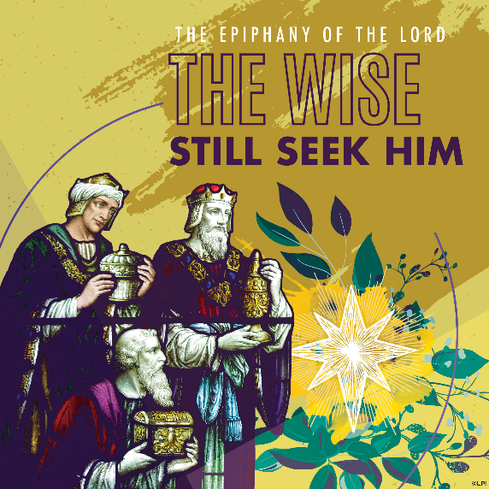
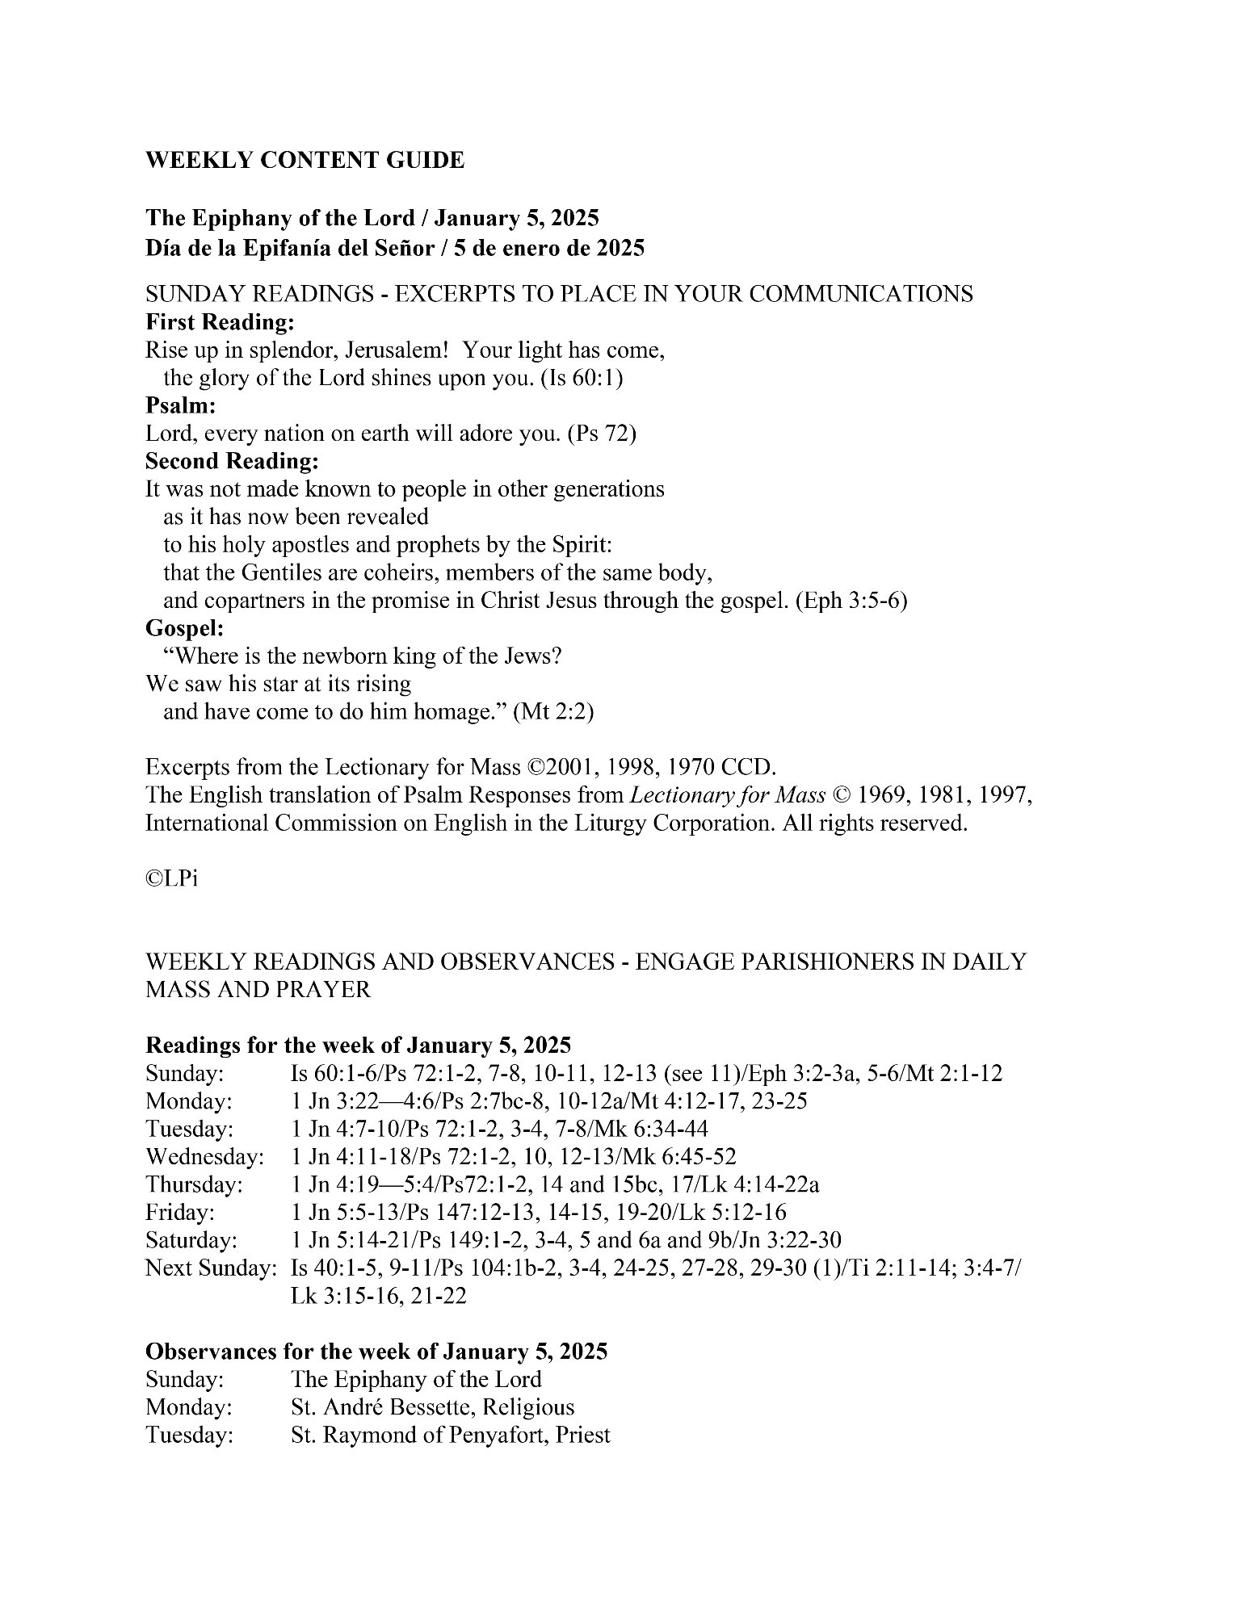
Are you in need of prayer? Do you have a prayer request? You can send your prayer requests to pcuadra@schottcommunities.org or call 954-434-3306 ext. 108

A copy of our prayer list can be found in the lobby of our chapel. To request a copy of our prayer list please email us at pcuadra@schottcommunities.org
To request a Mass please contact Pablo A. Cuadra at 954-434-3306 or e-mail at pcuadra@schottcommunities.org
Update: Celebrating a wedding anniversary soon? Let us know a week in advance and we can assist you with the renewal of your wedding vows.

Prayer to St. Michael the Archangel:
"St. Michael the Archangel, defend us in battle. Be our defense against the wickedness and snares of the Devil. May God rebuke him, we humbly pray, and do thou, O Prince of the heavenly hosts, by the power of God, thrust into hell Satan, and all the evil spirits, who prowl about the world seeking the ruin of souls. Amen"

