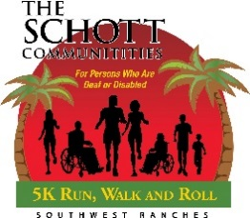

As part of our Schott Communities 2024 Run, Walk & Roll, scheduled for Saturday, October 19th, a limited number of booths will be available to reserve at a cost of $100 each. This will include a pop-up canopy, table and two chairs. Sorry, no electrical access is available. Reserve your space now for this exciting fundraiser. If you have any questions, please contact Patty Palacios at 954/434-3306 ext. 110 or at ppalacios@schottcommunities.org.

Name: __________________________________ Phone: ___________________________

Company Name: __________________________ Email: ______________________________

Address: ___________________________________________________________________

City: __________________________________________ ST: _____Zip: _____ __________

Credit Card Number: _______________________ AmEx /Master /Visa/ Discover
(Please circle card type.)

Expiration Date: ________________________Verification Code #: _____________________
Payment must be received two weeks prior to the event to ensure your reserved space.

Please send your payment to Schott Communities 6591 South Flamingo Road, Cooper City FL 33330.
Checks should be payable to Schott Communities. If you want to pay by credit card directly, please call our office at 954-434-3306 Att. Audrey Brown.

REQUESTS WILL BE HONORED IN THE ORDER THAT THEY ARE RECEIVED.
THANK YOU FOR YOUR SUPPORT!

Schott Communities 6591 South Flamingo Road Cooper City, FL 33330-3915

Schott Communities is a nonprofit 501(c)3 agency
providing services, programs, and a residential community for persons deaf or disabled.

